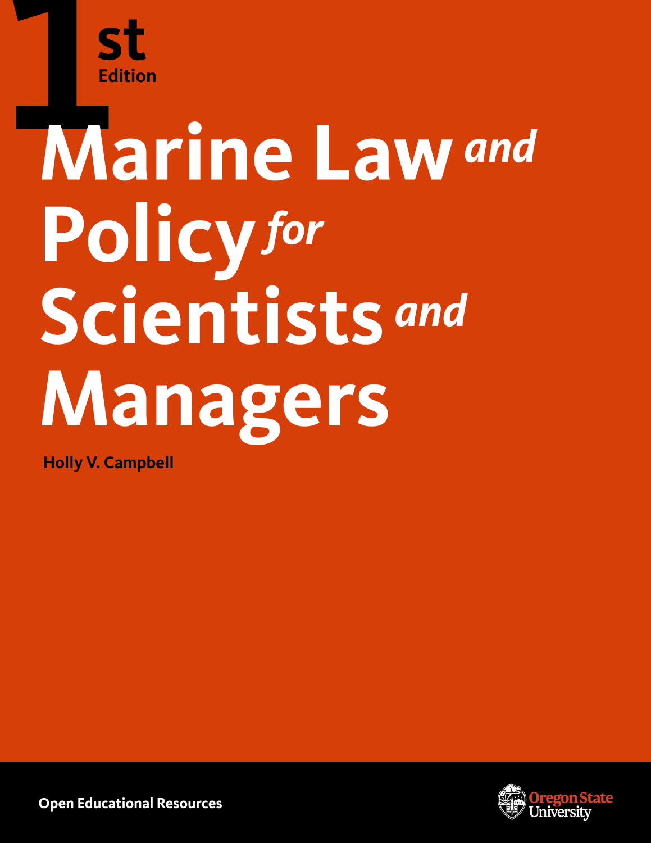

Marine Law and Policy for Scientists and Managers

Marine Law and Policy for Scientists and Managers

Holly V. Campbell
Oregon State University
Corvallis, OR

Marine Law and Policy for Scientists and Managers Copyright © 2019 by Holly V. Campbell is licensed under a Creative Commons Attribution-NonCommercial 4.0 International License, except where otherwise noted.
Publication and ongoing maintenance of this textbook is possible due to grant support from Oregon State University Ecampus.
Suggest a correction (bit.ly/33cz3Q1)
Privacy (open.oregonstate.education/privacy)

Contents
- Table of Contents
- Acknowledgements
- Preface
- Main Body
- Unit 1 - Our Public Oceans
- Unit 2 - Management of Protected Marine Species
- Unit 3 - Managing Through Specially Designated Areas
- Unit 4 - Our Fisheries
- Unit 5 - Regulating Ocean Impacts
- Unit 6 - Introduction to International Fisheries Management
- Unit 7 - Current Problems in American Ocean Management: Illegal, Unreported, and Unregulated (IUU) Fishing
- Unit 8 - U.S. Management of Offshore Energy
- Unit 9 - Coastal Management in the United States
- Unit 10 - Restoring Marine Environments: The Roles of Innovative Regulatory, Planning and Human Dimensions Tools
- Unit 11 – The Future of Ocean Management
- Appendix of Unit Resources
- Creative Commons License
- Recommended Citations
- Versioning

1

Table of Contents
Acknowledgements
Preface
Introduction
Unit 1 Our Public Oceans
Unit 2 Management of Protected Marine Species
Unit 3 Managing Through Specially Designated Areas
Unit 4 Our Fisheries
Unit 5 Regulating Ocean Impacts
Unit 6 Introduction to International Fisheries Management
Unit 7 Current Problems in Ocean Management: Illegal, Unreported, and Unregulated Fishing (IUU Fishing)
Unit 8 U.S. Management of Offshore Energy
Unit 9 Coastal Management in the United States
Unit 10 Restoring Marine Environments: The Roles of Innovative Regulatory, Planning and Human Dimensions Tools
Unit 11 The Future of Ocean Management
APPENDIX OF UNIT RESOURCES

2

Acknowledgements
The author wishes to express heartfelt thanks to Oregon State University Extended Campus, and particularly to Ms. Dianna Fisher, Director of Open Oregon State, and her staff; to Professor Denise Lach and Ms. Sherry Faller-Crowson of the School of Public Policy, and Professor Selina Heppell and Ms. Ann Leen of the Department of Fisheries and Wildlife for their support and for the opportunity to provide this open educational resource for non-lawyers and future marine management professionals. Finally, thanks to my ocean law colleagues worldwide, students present and former, and my generous mentor Professor Richard Hildreth, Frank E. Nash Professor and Director of the Ocean and Coastal Program, University of Oregon School of Law, a distinguished authority on ocean law for whose encouragement the author is grateful.

3

Preface
The author approaches marine law based on a lifelong appreciation of planetary systems and the importance of ocean science, effective marine resource management, and from the perspectives of student, teacher, research consultant, and scholar of ocean law and policy.
Marine law is a vast and diverse field of evolving statutes, regulations, cases, common law precedent and practice that takes several years (and many volumes) to master. There are excellent, exhaustive treatises on the topic that serve as a resource for legal professionals who wish to become expert in the field.
This open educational resource is designed for use by undergraduate and graduate ocean science, natural resource, fisheries and wildlife, and environmental policy students enrolled in a ten-week academic quarter. The purpose of this project is to provide students and non-law professionals with a freely accessible, clearly written guide to support engaging and effective learning. As such, the book serves as a gateway and an invitation to become a well informed, committed and involved ocean citizen as well as to explore the field beyond our course study.

Unit 1 - Our Public Oceans

Our Public Oceans

Contents
Introduction
The Public Trust Doctrine
Boundaries: Coastal Waters, the Territorial Sea, and the Contiguous Zone
The Exclusive Economic Zone or EEZ
The Roles of Federal and State Government in American Ocean Management
A Closer Look at Offshore Uses and Players

Introduction
The oceans cover some three-quarters of the Earth. The United States (U.S.) alone governs an ocean area—consisting of both water and land below the surface–over three million square miles, more extensive than the fifty states’ land area. U.S. management spans fisheries, wildlife, energy and minerals, telecommunications, shipping and transportation, weather prediction, military training and national security on behalf of the people of the U.S., who are the ocean’s owners. Even single-sector management, such as fisheries, is complex and involves many different laws and government players that have the challenging goal of balancing conservation with resource harvest or extraction. Many different agencies and personnel are involved in ocean law and policy; many former students are now professionals within this fascinating management mosaic. Let’s get started on our quest to develop a foundation for ocean law knowledge by beginning to understand how things fit together.
Collectively, the oceans are estimated by the United Nations to represent assets equivalent to the seventh largest economy in the world. Within a single nation, such as the United States, the coasts and oceans represent a vast and diverse wealth in terms of living and nonliving resources, jobs, recreation and cultural amenities. The ocean economy is complex and difficult to measure. According to the US Ocean Commission’s 2004 Final Report, values that are critical but evade measure include intangibles such as “clean water, safe seafood, healthy habitats, and desirable living and recreational environments,” a lack of information the Report says have prevented full appreciation by Americans of the economic importance of oceans and coasts. The Report also notes, for comparison, that while the US spends $100 million annually on economic research on agriculture, ocean-related employment (two million jobs, $117 billion) is 1.5 times than agricultural employment (2000) and the economic output of the ocean economy in 2000 was 2.5 times larger than that of agriculture.

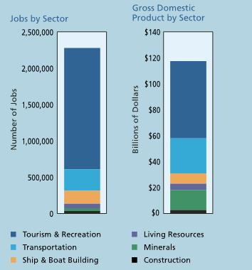

Figure 1.1 The national Value of the oceans,
A major feature of the ocean economy pertinent to ocean law study is that the nations’ oceans are owned by its citizens.
The Public Trust Doctrine
One of the most interesting and unique management aspects of the oceans is that they are ours and cannot be privately owned. This has several important implications for how we take care of, use, and impact ocean ecosystems and marine resources. For public ownership of the oceans, we have an ancient legal doctrine to thank: the Public Trust Doctrine. The Public Trust Doctrine began as part of the Institutes of Justinian, a Byzantine Roman emperor who codified (made into law) the concept in the year 533. The Institutes had the force of law, and in fact served as the learning materials for first year law students for hundreds of years! Justinian’s laws included, for our purposes, that no one could own the air, shoreline (seaward of the high water mark), the sea bed, oceans waters, running rivers or the resources of animals therein. The sovereign holds these resources in trust for the people of the nation.

This Public Trust carries affirmative legal duties, the same as any form of modern trust, as in a family trust managed by a financial institution. The Public Trustee (the sovereign government) has the duty to conserve and protect the contents of the Trust: the duty not to commit waste of the Trust’s resources, and so forth.
The Public Trust Doctrine eventually became part of English common law, the basis for our own case law in the United States. Far from remaining a static or stale ancient doctrine, the conceptual framework of the Public Trust continues to evolve. The most important thing you need to remember for our explorations in this course is that the public maintains a powerful and defensible legal interest in coastal waters (where the sovereign trustee is the coastal state government), the oceans, their ecosystems and their resources (living and nonliving). For example, if a coastal state leases a parcel of its seabed for the purpose of anchoring a device to harvest ocean energy such as from wind or waves, on behalf of its citizens the state must collect a fair rent through a lease. Similarly, for activities in federal waters petroleum companies must, under law, provide a “fair return in value” of resources extracted from the outer continental shelf to the American people via the United States Treasury, because these are public resources that government manages on the public’s behalf.
Boundaries: Coastal Waters, the Territorial Sea, and the Contiguous Zone
In the United States, there are 35 coastal states — we include the states bordering the Great Lakes. In most cases, each coastal state manages its waters out to three nautical miles off shore (a nautical mile is the equivalent of 1.508 geographic miles). The three-mile zone is commonly understood to derive from the practical necessity of defending the coastline—three miles is the distance a cannon could be effectively fired in the nation’s colonial period.
There are narrow exceptions (Florida’s Gulf coast and Texas have nine-mile limits, as does Puerto Rico) due to particular historical foundations. If you are interested in geographical boundaries and would like to learn more, take a look at the U.S. Ocean Commission’s report: “An Ocean Blueprint for the 21st-Century, Primer on Ocean Jurisdictions: Drawing Lines in the Water.”
Each state governs the resources within its state waters in accordance with the Coastal Zone Management Act (CZMA) of 1972 (16 United States Code [abbreviated USC] Sections [marked §§ 1451-1464, Chapter 33).
The next boundaries to be aware of are the US Territorial Sea, and the adjacent Contiguous Zone (the boundary is 24 miles off shore). Be aware that the term territorial sea can be confusing because the states can use the term to describe coastal state waters (the three-mile zone). However, the US Territorial Sea extends to 12 nautical miles and pre-dates the Truman Proclamation (Proclamation 2667, see http://cclme.org/viewcontents/?f=1-USCFR-truman.txt (1945) asserting US jurisdiction beyond the (previous) twelve-mile limit to the United States’ adjacent continental shelf.
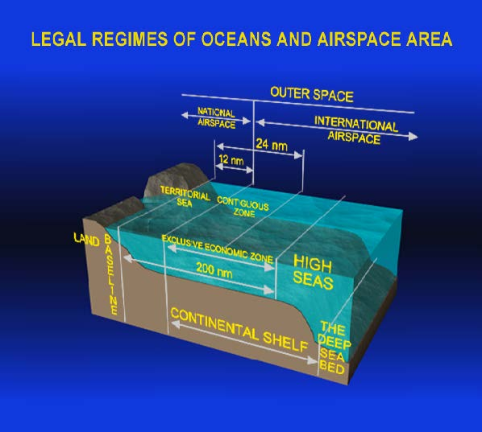
The Exclusive Economic Zone or EEZ
President Ronald Reagan established the United States’ Exclusive Economic Zone (EEZ, 200 nautical miles off shore) by Proclamation 5030 following international law and custom (established by the United Nations Convention on the Law of the Sea, UNCLOS) in 1982. The 200-mile zone encompasses United States national waters.
To view Proclamation 5030, see here. For further background on the EEZ, browse here.
It is staggering to realize the management and law enforcement implications of the US’ EEZ’s vast area, which includes not only the range within 200 miles of our continental coastline but also the 200-mile zone surrounding Hawai’i and United States Territories (Guam, Northern Mariana Islands, Wake Island, Howland and Baker Islands, Midway Islands, Johnston Atoll, Palmyra Atoll, Kingman Reef, Jarvis Island, American Samoa, Navassa Island, Puerto Rico, and the US Virgin Islands). The coastline of the US is 13000 miles long; the area within the US’ EEZ is roughly 3.4 million square nautical miles. Within this area lay vast living and nonliving resources including fisheries, wildlife, seabed minerals, and energy potential (including wind and wave energy).
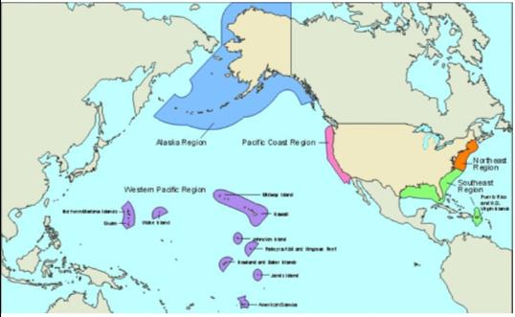
Figure 1.4 Illustration depicting the Exclusive Economic Zone of the United States. From the
.
Under international law, each nation has affirmative mandatory legal duties, beginning with conservation, in the seabed and water column within its EEZ. What rights does the Exclusive Economic Zone impart to the United States? There are three major categories of rights that nations possess in their EEZs. These sovereign rights include exploration/exploitation (but not over-exploitation) of living and nonliving resources, jurisdiction for law enforcement (domestic and international), and other rights defined by international law. Regulatory rights include marine scientific research, and prevention of pollution and dumping. Finally, within their EEZs nations have the right to create artificial islands or other structures with 500-meter safety zones. Unit 6 will discuss responsibilities and rights embodied in UNCLOS as it pertains to international fisheries management within nations’ EEZs.
The open ocean beyond each nation’s EEZ is known as the high seas, or international waters.
Historically, oceans all over the world were freely open to navigation and fishing for all, under a doctrine called Mare Liberum (Latin for “Freedom of the Seas”). This concept appears in a book published in 1609 by Dutch jurist Hugo Grotius. Grotius’ claim was, in part, made in order to justify Dutch exploration of the East Indies.
Today, key points to keep in mind relevant to freedom of navigation, the Territorial Sea, and the EEZ include: 1) a federal navigation servitude derived from the commerce clause within the United States Constitution, the customary right of innocent passage, and 2) a nation’s right to enforce its laws and protect its economic interests. Navigation is so critical to the public interest, that the federal government can order structures that impede navigation removed without compensation under the navigation servitude, the authority governing navigation in all navigable waters. States may also claim state navigation servitudes in state waters under their police power. While state servitudes vary slightly, the main idea is that no compensation is due landowners if structures were removed for a public purpose, including access to riparian areas or for navigation. State navigation servitudes are subject to the supremacy of the federal servitude.
Freedom of navigation is still a customary right, but has been necessarily curtailed by modern international law. Prior to the US’ establishment of a 200-mile EEZ, it was fairly common to see fishing fleets from other nations from shore with the naked eye. Civilian (not military) foreign vessels may travel (a right known as innocent passage) through the 12-mile Territorial Sea or even the EEZ if they obey applicable laws and are not interfering with the sovereign nation’s economic rights. The EEZ prioritizes fishing, as all other economic activities, to US vessels.
Beyond the nation’s 200-mile EEZ lay the high seas. The high seas are interesting as a topic for research and discussion in terms of international law, exploration, scientific research, conservation, piracy (including illegal, undocumented, and unregulated, IUU fishing) and law enforcement. A good place to learn more about the high seas is by viewing a TED talk by expert Kristina Gjerde. The United States Coast Guard is tasked with law enforcement in US waters and on the high seas. For a detailed summary of the topic generally, see the paper by Commander Jeffrey Randall, USCG, Ready for Future? The US Coast Guard and 21st Century Law Enforcement on the High Seas at http://brook.gs/2bFmSiB. For more information on fisheries law enforcement on the high seas, take a look at this site http://www.fao.org/newsroom/en/focus/2004/47127/article_47140en.html hosted by the United Nations Food and Agriculture Organization (FAO).
The Roles of Federal and State Government in American Ocean Management
Coastal states maintain jurisdiction in their coastal waters and resources, subject to preemption by the federal government in constitutionally reserved jurisdictional areas that historically include navigation (via the navigation servitude), energy, commerce, international treaties, military matters and national security. State police powers extend to persons, geographic areas, and resources within their boundaries, which include coastal waters.
Under the Coastal Zone Management Act’s consistency provisions, activities offshore that require a federal permit (referred to as federally permitted activities) must be consistent with the adjacent state’s coastal management plan. States may even assert concurrent jurisdiction in activities or resources beyond their own coastal waters (including federally permitted activities in adjacent states’ waters) if they can show the activities will foreseeably impact their own waters, resources or citizens. An example of when a state might assert jurisdiction is for the siting of an offshore energy facility adjacent to the state but outside the three nautical mile zone.
With regard to fisheries management, state programs maintain licensing for sport and commercial fisheries within their waters and also regulate mariculture (fish farming) within their waters. If the federal regional fisheries management agency does not have a management plan for certain fish species, states may even regulate their licensed vessels in the relevant fishery outside of the three-mile line.
State fish and wildlife agencies police state coastal waters to enforce fisheries laws. In the case of species that are also federally managed, such as endangered species and marine mammals, law enforcement is a joint effort, led by federal enforcement officials.
As we will see in the unit on fisheries management, states also participate in the eight national regional management councils by having a seat at their regional decision-making table. Particularly more recently, coastal states are leading in management innovations in fisheries management, ecosystem-based management, and the establishment of marine protected areas, as well as coastal zone management and conservation, convening ocean science boards and other advances.
In state waters, coastal state and federal managers also collaborate with regard to species protected under federal law, particularly under the Endangered Species Act and Marine Mammal Protection Act.
Finally, states work together with federal authorities on matters involving coastal water quality management: assessing pollutants, prioritizing water quality issues, reporting, and enforcing standards under the Clean Water Act of 1972 (33 USC §1251 et seq.). States may prohibit the dumping of ballast water containing invasive species in their waters, or prohibit ships from dumping sewage under Section 402 of the CWA regulating discharges from discrete sources or pipes (the National Pollutant Discharge Elimination System, NPDES, 33 USC §1342) as well as the Rivers and Harbors Act. Other examples of cooperative state and federal management will be discussed.
A Closer Look at Offshore Uses and Players
The view from any beach in the United States (including those of the five Great Lakes: Lakes Eerie, Huron, Michigan, Ontario, and Superior included in NOAA’s coastal management programs) seems uncluttered and unencumbered. Ocean law study involves becoming aware of the many activities, uses, laws and regulations, and management entities involved offshore.
The governments involved range from coastal counties (and even cities in certain instances), state agencies, and federal agencies. Among them, they share various significant responsibilities of governing living and nonliving resources from the shore, within the state coastal zone, and federal waters beyond, representing public and private access, coastal development, forestry, fishing, conservation, recreation, public health, mineral resources such as sand and gravel, and protecting coastal communities from coastal hazards. The following diagram, from the Oregon Territorial Sea Plan, provides a glimpse into how these responsibilities are organized and distributed within a specific coastal state context as an example.
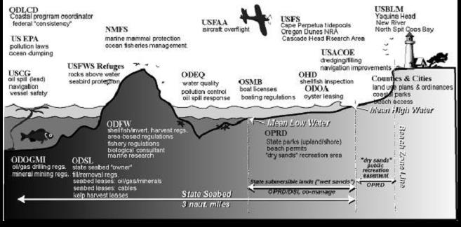
Figure 1.5 Illustration of the Range of Agency Programs and Authorities in State Territorial Sea and Ocean Shore: Oregon, from

Key to the Acronyms in Figure 1.5
Left to Right in the Illustration:
- ODLCD: Oregon Department of Land Conservation and Development
- USEPA: United States Environmental Protection Agency
- USCG: United States Coast Guard, also in charge of drug interdiction
- ODOGMI: Oregon Department of Geology and Mineral Industries
- NMFS: National Marine Fisheries Service (of NOAA)
- USFWS: United States Fish and Wildlife Service (within the US United States Department of the Interior, or DOI)
- ODFW: Oregon Department of Fish and Wildlife
- ODSL: Oregon Department of State Lands
- USFAA: United States Federal Aviation Administration
- ODEQ: Oregon Department of Environmental Quality
- OSMB: Oregon State Marine Board
- OPRD: Oregon Parks and Recreation Department
- USFS: United States Forest Service (within the US Department of Agriculture or USDA)
- USCOE: United States Army Corps of Engineers (USACE, the Corps; within the Army)
- OHD: Oregon Health Department
- ODOA: Oregon Department of Agriculture
- USBLM: United States Bureau of Land Management (within the United States Department of the Interior, or DOI)

An appendix of Resources at the end of the book contains additional details about these agencies (see resources for unit one) as well as other information pertinent to ocean law.

Unit 2 will discuss the regulation and management of specific species under the Endangered Species Act and Marine Mammal Protection Act.

Unit 1 Study Questions
- What are some contemporary implications of public ownership of the oceans and their resources?
- Why do you think we maintain the Public Trust Doctrine? What is the Trust property being protected? Who is the Trustee in state waters? Who is the Trustee in federal waters?
- Who are the Trust beneficiaries?
- What might be some effects if areas of the ocean were to be opened to privatization?
- Can you think of analogies to how the ocean is managed from land management?
- When President Reagan issued Executive Order 5030, what did the United States gain? What are some of the implications for law enforcement and resource management of an area that is larger than the land area of the fifty states? What are the significant differences between land and ocean management?
Unit One Appendix

Unit 2 - Management of Protected Marine Species

Management of Protected Marine Species

Contents
Introduction
The Endangered Species Act of 19 (ESA)
The Marine Mammal Protection Act of 19 (MMPA)

Introduction
In 2018, 2300 species are listed as threatened or endangered (1625 domestic, and 675 foreign) under the Endangered Species Act (ESA) according to the National Oceanic and Atmospheric Administration (NOAA) Fisheries (also called the National Marine Fisheries Service, NMFS).
Two federal agencies share the administration of the ESA and the Marine Mammal Protection Act (MMPA). The Secretary of the Interior, through the US Fish and Wildlife Service (USFWS), administers the list of threatened and endangered species under ESA and also oversees CITES (the Convention on International Trade in Endangered Species of Wild Fauna and Flora). The USFWS manages land and freshwater species as well as eight marine mammal species. The Secretary of Commerce, through (NOAA/NMFS) is in charge of determining listing or delisting for marine species and anadromous fish (species that go back and forth between fresh and salt waters during their life cycles; examples are steelhead and salmon). NMFS currently has jurisdiction over 161 threatened or endangered marine species (including 65 foreign species).
With regard to both the ESA and the MMPA, there is federal preemption. The term means that, under the Supremacy Clause of the United States Constitution states are subject to and must obey federal law; in order to prevent conflict with state agencies or conflicting laws, the requirements of ESA and the MMPA are paramount, their policies rule management or enforcement questions pertaining to endangered and marine mammal species. Importantly, however, the ESA (in §6(f)) encourages state law to be more protective; the ESA also contains provisions for cooperation with state partners. Also, in cases where the MMPA is more restrictive than the ESA, the MMPA’s protections take precedence.
The Endangered Species Act of 1973, 16 USC § 1531 et seq.
In the Endangered Species Act opening statutory section,
(a) Findings The Congress finds and declares that—
(1) various species of fish, wildlife, and plants in the United States have been rendered extinct as a consequence of economic growth and development untempered by adequate concern with conservation;
(2) other species of fish, wildlife, and plants have been so depleted in numbers that they are in danger of or threatened with extinction;
(3) these species of fish, wildlife, and plants are of esthetic, ecological, educational, historical, recreational, and scientific value to the Nation and its people; … (https://www.law.cornell.edu/uscode/text/16/1531)
Two agencies administer the ESA: the US Fish and Wildlife Service under the Secretary of Interior (USFWS, species of birds, land animals, and freshwater animals, polar bears, walrus, manatee, sea otter, and sea turtles when on land) and the National Oceanic and Atmospheric Administration, under the Secretary of Commerce (NOAA, anadramous and marine species including fisheries, marine turtles when they are in the ocean).
Under the Act, “threatened” means a species is likely to become endangered in the foreseeable future. “Endangered” means the species is at risk of extinction throughout all of its range, or a significant portion of its range (SPR), which the Act does not define. To fill the gap, in 2014 NMFS and USFWS issued a policy guidance, after public notice and comment, to provide more precise meaning to SPR.
“Range,” under the guidance refers to the geographical area where the species is found at the time of listing. SPR, which only comes into play in certain situations, means that there is an area that contributes so substantially to the species’ overall viability that
“without the individuals in it, the species as a whole would be in danger of extinction (meriting an endangered status), or likely to become so in the foreseeable future (meriting a threatened status) (NOAA Fisheries).
In other words, if a species is threatened or endangered wherever it occurs, it will be listed as such (no need for the SPR guidance). The purpose of the new policy, while the agencies expect it to be applied infrequently, is to afford species ESA protection before “large-scale declines or threats occur throughout the species’ entire range.” (June 27, 2014 NOAA/USFWS Policy Guidance on SPR). The SPR guidance has important implications for Distinct Population Segments (DPS).
Key provisions of the ESA include Sections 4, 6, 7, 8, 9, 10 and 11.
Pertinent ESA Sections, adapted from NOAA Fisheries, which contains a concise description of the procedural process for listing.
Under ESA Section 4, listing decisions must be based solely on any one of five factors and the best scientific and commercial information available.
- The species’ habitat or range is at risk of present or threatened destruction, modification, or curtailment.
- The species is over-utilized for commercial, recreational, scientific, or educational purposes.
- The species is threatened or endangered due to disease or predation.
- Existing regulatory mechanisms are inadequate.
- The species’ continued existence is affected by other natural or human-caused factors.
ESA Section 4 covers the process and deadlines for the listing of threatened and endangered species (16 USC §1533; refer to the procedural flow graphic in the appendix of Resources for Unit 2).Section 4 of the ESA requires the identification of habitat when the species is listed (unless such habitat is undetermined, in which case critical habitat must be identified within one year) critical to the species’ recovery, thus helping focus conservation activities and funding. There are rare exceptions. If the cognizant Secretary concludes that factors, including national security or economic cost of critical habitat designation are greater than the benefit to the species in question, areas may be excluded or simply not designated. The exception applies if even identifying critical habitat could worsen a threat to the species (16 USC § 1533(b)(2); https://www.law.cornell.edu/uscode/text/16/1533) Recovery plans, described in 16 USC 1533(f), must incorporate three factors: site-specific management actions to achieve the species’ conservation and survival, objective and measurable criteria that, once met, would allow the species to be delisted, and time and cost estimates to implement the necessary measures.In conjunction with Section 7’s consultation between agencies, critical habitat designation also helps ensure, overall, that federal agencies are required to broadly consider the effects of their actions, avoiding actions that “are likely to destroy or adversely modify critical habitat.” Examples of such activities Section 4 seeks to prevent include “water management, flood control, regulation of resource extraction and other industries” ensuring that federally permitted activities do not inadvertently conflict with habitat goals (February 11, 2016 Rule).ESA Section 7(a)(2) contains consultation provisions. Consultation, begun as early as possible in the initial phases of a federally permitted activity (for example, construction of a dam) is intended to allow the involved agencies and non-federal project proponent more thorough consideration of resource conservation needs. This proactive approach can decrease the necessity for major project modifications later in the process. If a listed species is present, and that species or a designated critical habitat, will not likely be adversely affected by the activity then the consultation concludes. The consultation statutory time limit is 90 days; regulations provide for an extra 45 days for USFWS to prepare a biological opinion.The biological opinion contains an analysis of whether the activity will likely have an adverse effect on the listed species or critical habitat. If adverse effects are likely, the opinion must further include any alternatives that are reasonable and prudent sufficient to allow the project to advance.If the proposed project could result in an “incidental take” of the listed species but not to the extent of jeopardizing the species’ existence, the USFWS must include a statement noting that in the opinion effectively authorizing an incidental take. However, according to USFWS, the agency may include an incidental take statement in either a jeopardy or non-jeopardy opinion. In short, the legally imposed but collaborative process of Section 7 ESA consultation prevents foreseeable adverse impacts by promoting project design modifications to avoid negative effects. (For more information, see https://www.fws.gov/endangered/esa-library/pdf/consultations.pdf)

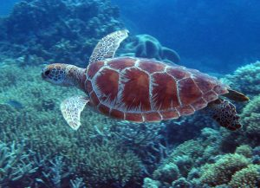

Along with Section 4, Section 10 of the ESA is perhaps the most controversial of the statute’s provisions and governs how the federal government reviews and issues permits for activities that could in a “taking” of a threatened or endangered species.The law defines a taking (in Section 3, Definitions, at 16 USC § 1532 (19)):The term ‘take’ means to harass, harm, pursue, hunt, shoot, wound, kill, trap, capture, or collect, or to attempt to engage in any such conduct.
The regulations define harm (50 CFR 17.3) as ‘an act which actually kills or injures wildlife. Such an act may include significant habitat modification or degradation where it actually kills or injures wildlife by significantly impairing essential behavioral patterns, including breeding, feeding, or sheltering.’In the course of ordinary activities, avoiding harm to wildlife can be challenging. On land, Section 10 is frequently seen in development situations where listed species are present. Section 10 is available to landowners, states, Tribes, counties, and companies to obtain permits for “incidental” takes, that is, takes that could occur in the ordinary course of otherwise legal activities. With regard to Section 10 permits in conjunction with development, landowners must have an approved habitat conservation plan (HCP) that includes the evaluation of likely impacts on the listed species, steps to avoid the impact (or to minimize or mitigate the impact) and a statement of funding set aside to ensure the steps are followed.In the ocean, as on land, instances requiring Section 10 permits to take a listed species require the consideration of alternatives that would result in lower impacts. In 2016, the Ninth Circuit Court of Appeals decided a case dealing with the ESA and similar provisions within the Marine Mammal Protection Act in the context of cetaceans and US Navy sonar during training missions. The case (Natural Resources Defense Council, Inc. vs. Pritzker, 828 F.3d 1125, Ninth Cir. July 15, 2016) eloquently presents the difficulty of the analyses of harm and balancing that the ESA requires, and the exacting process that the ESA and MMPA require agencies to conduct. The Pritzker case will be discussed at the end of the unit.The Marine Mammal Protection Act of 1972 (16 USC Ch. 31)The MMPA focuses on identification of species of concern and the promotion of ecosystem protection, research, and international cooperation.
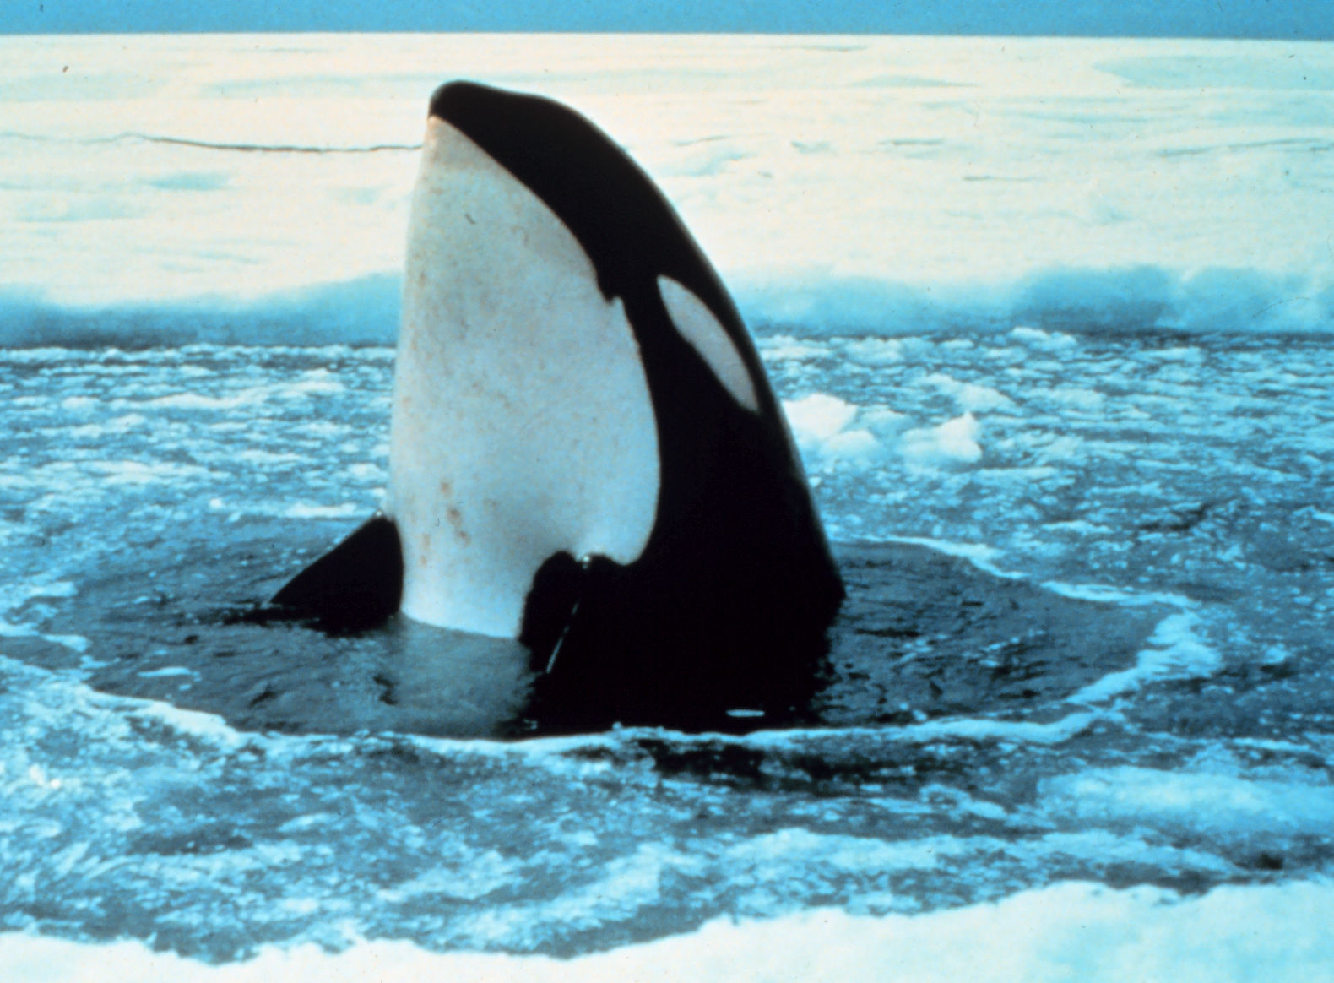
In the Marine Mammal Protection Act opening statutory section, Sec. 2 The Congress finds and declares that—(1) certain species and population stocks of marine mammals are, or may be, in danger of extinction or depletion as a result of man’s activities;
(2) such species and population stocks should not be permitted to diminish beyond the point at which they cease to be a significant functioning element in the ecosystem of which they are a part, and …they should not be permitted to diminish below their optimum sustainable population. Further measures should be immediately taken to replenish any species or population stock which has already diminished below that population. In particular, efforts should be made to protect essential habitats, including the rookeries, mating grounds, and areas of similar significance for each species of marine mammal from the adverse effect of man’s actions….(https://www.law.cornell.edu/uscode/text/16/1361)
Marine mammal management is consolidated under federal agency management. The MMPA works in concert with the ESA. The prohibition on “taking” in the MMPA transfers the burden of proof from agency managers on the conservation side of the equation to the party requesting a permit for incidental take, who must demonstrate that the activity it plans to undertake will not cause harm to the species. Important definitions include the following. MMPA (16 usc § 1362(13)) defines take as:“to harass, hunt, capture, or kill, or attempt to harass, hunt, capture, or kill any marine mammal.” The associated enforcement regulations add detail to the statutory definition (see 50 CFR § 18.3). Interestingly, the Act prohibits feeding marine mammals in the wild an addition that NMFS added in 1991 to curb this practice among tour boat companies. The original Act and regulations did not define harass, which in 1994 clarified that harassment includes section (18)(A):…any act of pursuit, torment, or annoyance which—
(i) any act that injures or has the significant potential to injure a marine mammal or marine mammal stock in the wild; or
(ii) any act that disturbs or is likely to disturb a marine mammal stock in the wild by causing disruption of behavior patterns, including, but not limited to, migration, breathing, nursing, breeding, feeding, or sheltering.
16 USC § 1362(18)(A).Military training has special relevance to marine mammal protection. The MMPA dedicates special harassment language with regard to this important activity in section (18)(B).In the case of military readiness activity….or a scientific research activity conducted by or on behalf of the Federal Government…the term ‘harassment’ means—
(i) any act that injures or has the significant potential to injure a marine mammal or marine mammal stock in the wild; or
(ii) any act that disturbs or is likely to disturb a marine mammal stock in the wild by causing disruption of behavior patterns, including, but not limited to, migration, breathing, nursing, breeding, feeding, or sheltering to a point where such behavioral patterns are abandoned or significantly altered. [emphasis added]
Incidental (unintended) take occurring during commercial fishing is covered by special permits from the Marine Mammal Authorization Program. Nonfishing activities also require permits. Examples include US military training, offshore energy development (including alternative energies), construction projects, and scientific research. Special permits are provided for Alaskan natives (who participate in co-management) for taking for purposes of traditional subsistence, clothing, and so forth. Just as with the nation’s fisheries, NOAA Fisheries conducts stock assessments for marine mammals, provides additional management details (https://www.fisheries.noaa.gov/topic/laws-policies#marine-mammal-protection-act). The US military is not required to obtain permits for taking during actual combat or times of war. Preparing for real-life engagements at sea requires training expeditions; for the US Navy, submarine use of sonar is part of that training. Since marine mammals communicate across vast distances, military sonar has the potential to interfere with communication as well as to cause harm to these animals’ hearing (specifically at levels at, or higher than 180 decibels (dB) referred to as Level A harassment, 16 USC § 1362(18)(B), (C); however exposure to levels less than 180 dB (16 USC § 1362(18)(B), (D) ‘can cause short-term disruption or abandonment of natural behavior patterns’ (Pritzker 2016). These behavioral disruptions can cause affected marine mammals to stop communicating…,to flee or avoid an ensonified area, to cease foraging…, to separate from their calves, and to interrupt mating. LFA sonar can also cause heightened stress responses from marine mammals. Such behavioral disruptions can force marine mammals to make trade-offs like delaying migration,…reproduction, reducing growth, or migrating with reduced energy reserves. (Pritzker 2016)
In 2016, the United States Ninth Circuit Court of Appeals reviewed the steps that NOAA Fisheries must follow before granting an incidental take permit under the MMPA for military readiness training. The case is instructive (and worth reading, see Unit 2 Resources) because it demonstrates the law’s rigorous standards in the context of an important and necessary activity in pursuit of national security.(Natural Resources Defense Council, Inc. vs. Pritzker, 828 F.3d 1125, Ninth Cir. July 15, 2016) Brief SynopsisIn 2012, the National Marine Fisheries Service (NMFS or NOAA Fisheries) approved a Final Rule (77 Fed. Reg. 50290, Aug. 20, 2012) specifically dealing with incidental take permits in conjunction with peacetime uses of Low Frequency Active (LFA) sonar for five years (as 16 USC § 1371(a)(5)(A)(i) provides). Claiming that the 2012 Rule did not adequately require the “least practicable adverse impact (16 USC § 1371(a)(5)(A)(i)(II)(aa))” on marine mammals, the plaintiffs sued to enforce this statutory mandate within MMPA. The lower court (United States District Court for Northern California) granted summary judgment to the agency. Upon review, the Federal Ninth Circuit Court of Appeals reversed. Specifically, the Ninth Circuit noted the following in its holding: The 2012 Rule failed to contain means for effecting the least practicable adverse impact on marine mammals, stocks, and habitats, as required by law. Second, the Ninth Circuit found that the agency mistakenly conflated the two necessary standards (least practicable adverse impact, and negligible impact (16 USC § 1371(a)(5)(A)(i)(I)) and that, before authorizing any incidental take, both standards must be independently analyzed.Under the regulation implementing MMPA, negligible impact is defined as an impact resulting from the specified activity that cannot be reasonably expected to, and is not reasonably likely to, adversely affect the species or stock through effects on annual rates of recruitment or survival (50 CFR § 216.103). If the agency finds that a proposed activity will have negligible impact, it still must separately consider mitigation measures to reduce effects of the activity to the least practicable adverse impact (15 USC § 1371(a)(5)(A)(i)-(II) considered a stringent standard.Third, the Court noted that the agency was obligated to take areas of the ocean signified as “biologically important” by its own scientists into account when reviewing permit applications, whether or not the agency judged the existing data for those areas as sufficient—the agency was to rely on the data it presently has. The Court remanded the case for further proceedings.An appendix of Resources at the end of the book contains additional information relevant to protected species management (see resources for unit two).Unit 3 will discuss the tools for selecting and setting aside special geographic areas for species protection, management and conservation.
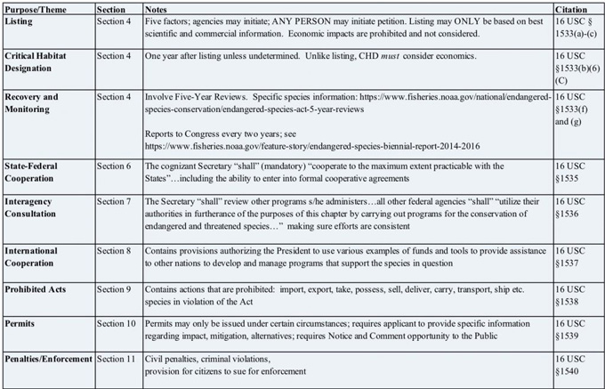
Purpose/Theme | Section | Notes | Citation
Listing | Section 4 | Five factors; agencies may initiate; ANY PERSON may initiate petition. Listing may ONLY be based on best scientific and commercial information. Economic impacts are prohibited and not considered. | 16 USC § 1533(a)-(c)
Critical Habitat Designation | Section 4 | must | 16 USC § 1533(b)(6)(C)
Recovery and Monitoring | Section 4 | https://www.fisheries.noaa.gov/national/endangered-species-conservation/endangered-species-act-5-year-reviews | 16 USC § 1533(f) and (g)
State-Federal Cooperation | Section 6 | The cognizant Secretary “shall” (mandatory) “cooperate to the maximum extent practicable with the States”…including the ability to enter into formal cooperative agreements | 16 USC § 1535
Interagency Consultation | Section 7 | The Secretary “shall” review other programs s/he administers…all other federal agencies “shall” “utilize their authorities in furtherance of the purposes of this chapter by carrying out programs for the conservation of endangered and threatened species…” making sure efforts are consistent | 16 USC § 1536
International Cooperation | Section 8 | Contains provisions authorizing the President to use various examples of funds and tools to provide assistance to other nations to develop and manage programs that support the species in question | 16 USC § 1537
Prohibited Acts | Section 9 | Contains actions that are prohibited: import, export, take, possess, sell, deliver, carry, transport, ship etc. species in violation of the Act | 16 USC § 1538
Permits | Section 10 | Permits may only be issued under certain circumstances; requires applicant to provide specific information regarding impact, mitigation, alternatives; requires Notice and Comment opportunity to the Public | 16 USC § 1539
Penalties/Enforcement | Section 11 |  | 16 USC § 1540

Unit 2 Study Questions
- Would simply listing species as threatened or endangered alone under ESA be enough?
- What are some proactive examples of management of species to avoid listing in the first place?
- Does the ESA include international species protection? What is the relationship of ESA to the Convention on International Trade in Endangered Species of Wild Fauna and Flora (CITES)?
- Articulate the difference between the analytical steps that NOAA Fisheries must undergo before authorizing an incidental take under MMPA. Why does the difference matter?
Unit Two Appendix

Unit 3 - Managing Through Specially Designated Areas

Managing Through Specially Designated Areas

Contents
Introduction
Ecosystem Based Management (EBM)
Incorporating EBM and Prioritizing Conservation Objectives in Marine Planning

Introduction
Rocky reefs support a wide variety of species quite different from those that depend on sand flats. The coastal ocean teems with abundance and biodiversity and is a nursery for brooding and rearing for many species, including economically valuable fish, which, in their adult stages, are important for supporting commercial fisheries. The open ocean supports an entirely different complement of living organisms. The deep ocean contains unique species adapted to extreme conditions, including life on hydrothermal vents.
Ecosystem-based management pertains to a movement toward holistically understanding the ocean as a system, rather than a collection of species to exploit and manage. Species prefer certain types of ocean habitats, and cannot survive without the food and shelter that their particular ecosystems provide. Conceptually, then, the ocean is many different ecosystems nested into one large and dynamic system.
Advances in our understanding of the inseparability of habitats and the species that depend on them are reflected in contemporary environmental law (protection of habitat, ESA, Unit 2) and science alike. Technology, including ocean sampling, monitoring (both shipboard and satellite), and the spatial information provided by sophisticated Geographic Information Systems and Science (GIS) continue to support the revolution from single-species management to higher resolution ecosystem-based management. Now we can see the forest for the trees, to revise an old expression.
Ecosystem Based Management (EBM)
There are many different definitions of ecosystem-based management (EBM). Here are two useful descriptions. The first is from the United Nations Educational, Scientific, and Cultural Organization (UNESCO) in 2009. The entire report is available at msp.ioc-unesco.org
an integrated approach to management that considers the entire ecosystem, including humans. The goal of ecosystem-based management is to maintain an ecosystem in a healthy, productive and resilient condition so that it can provide the goods and services humans want and need. Ecosystem-based management differs from current approaches that usually focus on a single species, sector, activity or concern; it considers the cumulative impacts of different sectors.
This concept of EBM emphasizes connectivity between all systems (the ocean, atmosphere, and land) necessarily founded upon protection of the whole: structure, functions, and processes. The UNESCO vision recognizes that human dimensions are part of ecosystems: social, economic, and governance structures are also integrated into ecological systems. Finally, because we cannot realistically focus on the entire system at once, EBM is place-based, necessitating adapting the approach to specific ecosystems and their human impacts or influences.
A major concept in support of robust EBM (universally, not just in marine settings) is adaptive management. Informed decision-making moves forward with caution, even when data are incomplete. NOAA describes adaptive management in the following passage (NOAA 2018)
Adaptive management is an essential aspect of EBM; it is a way of managing the dynamic nature of ecosystems in the face of uncertainty by considering a broad range of influences within a region, including external influences, factors, and stressors. To increase effectiveness, adaptive management is often based on an open and mutually agreed upon process for monitoring and assessing the outcome of management actions; a process that allows for mid-course corrections to achieve desired outcomes.
Adaptive management also takes into account socioeconomic considerations, stakeholder participation, conflict resolution, legal and policy barriers, and institutional challenges. Being adaptive requires people and institutions to be flexible, innovative, and highly responsive to new information and experiences. Adaptive management succeeds when there are clear linkages among information, actions, and results and a strong climate of trust among partners. Considering local, state, federal, and international actions and sharing data are also critical to success.
At least three major points stand out in regard to EBM.
First, adaptive management is a priority. According to McLeod and Leslie (2009), ecosystem-based management in the ocean context requires a transition in focus from purely monitoring conventional indicators to including the monitoring of changes in processes (such as those that impact biodiversity) in order to understand reasons for the change.
Second, EBM realistically involves identifying and confronting potential resource tradeoffs. A prime example exists in establishing a management area where lower harvest levels are permitted in order to allow fish species to rebound. Explicitly considering trade-offs in a transparent decision-making process is intended to reduce surprises (unintended consequences) over time that could be damaging to ecosystems and their functions, and heighten tension and confusion among stakeholders. Trade-offs can be examined through a variety of options. One option involves assigning different values to the functions of the system (financial values “monetized” or non-monetized). Another approach is known as the ecological endpoints approach that measures production functions within a system. This approach uses two kinds of functional relationships (supply functions, or ecological production functions, or demand functions, an approach that analyzes relevant aspects of a user group, such as commercial or recreational fishing).
Third, holistic systems management anticipates cooperation and collaboration between governing entities. This is sometimes known as vertical or horizontal EBM. Vertical EBM is the coordination for consistent management from the bottom up, or the top down. Imagine vertical EBM as information sharing and planning across nested but discrete governance entities; for example, consistent cooperation and coordination throughout coastal city, county, state, region, national and international entities.
By contrast, horizontal EBM describes the collaboration and cooperation between entities at comparable governance levels: for example, in Oregon (as in many states), six to nine state agencies may be involved in a coastal decision. At the federal level, similarly several agencies may consult with each other over an ocean management decision, also consulting the appropriate state and regional authorities. Horizontal EBM can and often does include industry sectors as well. For example, the siting of an offshore alternative energy facility can include consultation with several different agencies at the state and federal levels, as well as a variety of permits and permit conditions. While each agency has individual (and complementary, sometimes overlapping or joint) legal and public resource stewardship responsibilities, they must coordinate their review and licensing of the proposed energy facility.
The energy-siting example would involve placing artificial structures in the ocean, requiring the designation of a certain kind of special area. The vast majority of special area management decisions are made in conjunction with restoring, maintaining or preserving areas important for species life stages, biodiversity, or other aspects of habitat structure and function. Each management area must be founded according to its species, resources, needs, stresses, and intended management purposes and goals.
Incorporating EBM and Prioritizing Conservation Objectives in Marine Planning
As long ago as 1972, Congress established the National Estuarine Research Reserve (NERR) System (in the Coastal Zone Management Act). This program can perhaps be seen as an early example of ecosystem thinking. The Reserve system contains 1.3 million acres and 29 estuaries where fresh water systems interact with salt water. The purpose of the program, administered by NOAA Office for Coastal Management, is to promote stewardship through research and education. Through the program, Congress recognized that estuaries are unique, economically critical environments that contain abundant ecosystem functions and services, including habitat (food, nesting, migration corridors, breeding) nurseries for important fisheries, water filtration, and buffering from coastal storms. The national reserves are collaboratively managed with coastal states. (NOAA Office of Coastal Management 2018)
Within Section 320 of the federal Clean Water Act, Congress established complementary non-regulatory estuary conservation program overseen by the US Environmental Protection Agency: the National Estuary Program (NEP). NEP protects water quality and ecosystems in 28 estuaries, managed by individual Comprehensive Conservation and Management Plans (CCMPs). The NEP is centered on collaborative public involvement; the priorities and objectives in the CCMPs are community based: determined by stakeholders spanning local, city, state, federal, private and nonprofit sectors according (EPA 2018).
A prime example of EBM-influenced spatial planning from a coastal state can be seen in the Commonwealth of Massachusetts. In 2008, Massachusetts passed the Oceans Act (Session Laws, Acts 2008, Chapter 114). In 2009, the state passed the Ocean Management Plan, where one of the key planning purposes was for the proper siting of offshore wind energy. By engaging powerful fishing interests, the environmental and recreation communities, among other stakeholders, Massachusetts underwent an offshore planning and mapping process that took several years to complete.
The Massachusetts map reflects an off-limits area, two wind energy areas, and a multi-use area. The general division and labeling of offshore space was based on directing new ocean development away from ecologically sensitive areas (termed SSU for special, sensitive, or unique), in order to decrease competition and conflict between ecosystems and human uses of the areas. Logically, then, the planning and mapping process was preceded by data-gathering toward the establishment of an inventory of species and habitats offshore, but also including evaluations of resource areas most promising (and suitable) for wind energy.
Massachusetts revised the 2009 offshore maps in 2015. The data, process documents, and 2015 edition of the Ocean Plan are available at mass.gov. Volume 1 contains information relevant to management and administration; Volume 2 features the baseline assessment and science framework.
Two core habitats for whales (the North Atlantic Right Whale, and the Humpback Whale) were both increased based on data (effort-corrected sightings dating back to 1970 and running through 2014), using the adaptive management approach described above as a key part of EBM. North Atlantic Right Whales are protected under the ESA, MMPA, and Canada’s Species At Risk Act because they are among the most endangered in the world.
As a practical application of EBM, marine planning is flexible and adaptable. While it requires a major investment of time, funding, expert technical staff, scientific inquiry, and community involvement, marine planning is essential to marine conservation and the future provision of ecosystem services to society, particularly as resources shrink and human populations grow. The oceans seem vast to us, but they are not limitless. As with all Earth systems, oceans are dynamic and undergoing constant change. Impacts on the oceans from a warming planet make proactive, science-based marine planning more urgent. A major conservation-focused aspect of marine planning involves the establishment of marine protected areas worldwide.
Marine Protected Areas (MPAs) generally describe a wide range of levels of protection (including no-take areas known as marine reserves). In 1999, the International Union for the Conservation of Nature (IUCN) defined an MPA as:
any area of intertidal or subtidal terrain, together with its overlying water and associated flora, fauna, historical and cultural features, which has been reserved by law or other effective means to protect part or all of the enclosed environment (Kelleher and Phillips 1999).
In the United States (by Executive Order 13158), a marine protected area is:
any area of the marine environment that has been reserved by Federal, State, territorial, tribal or local laws or regulations to provide lasting protection for all of the natural and cultural resources therein.
As defined by the World Wildlife Fund (WWF), an MPA is
An area designated and effectively managed to protect marine ecosystems, processes, habitats, and species, which can contribute to the restoration and replenishment of resources for social, economic, and cultural enrichment.
Just as with habitat protection on land, connectivity is crucial; linking MPAs multiplies positive outcomes. Most species move, many migrate long distances, and all species use particular areas when breeding or rearing young.
MPAs are conservation centered, with levels of protection that are permanent and constant. Areas may be designated as closed to human activity altogether, or allow one or more activities such as diving, or even limited fishing.

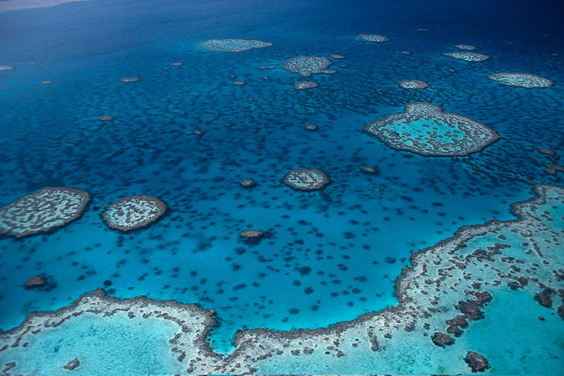

United States waters cover 1.4 times the nation’s terrestrial area. As of 2017 (NOAA publication, Conserving Our Oceans, One Place at a Time) in the US, more than 12oo MPAs cover more than 3.2 million square kilometers—26% of US waters. Commercial fishing is prohibited in 23% of the US protected area. Only 3% of all MPAs in US waters provide the highest level of protection by banning all extractive uses. From 2005-2016, the quantity of area protected in the US increased by more than 20 times.

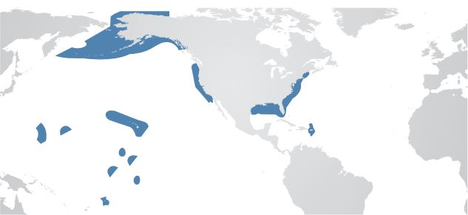

Figure 3.2 Graphic depicting locations and coverage of US Marine Protected Areas.
As EBM continues to be refined, the approach is major tool for holistic ocean planning around the world. Advancing the application of EBM spatially across eight national regions, NOAA is developing a program of integrated ecosystem assessments (IEAs). The initial eight regions are tied to eight Large Marine Ecosystems (LME).
Thirty years ago, the concept of LMEs was developed by NOAA and the University of Rhode Island as a means to implement EBM approaches to LME systems. Of the 64 global LME, 11 are in the US EEZ (NOAA Office of Science and Technology 2018). NOAA defines a large marine ecosystem is defined as “large areas of ocean space (200,000 km2 or greater) adjacent to the continents in coastal waters where primary productivity in generally higher than open ocean areas.” (NOAA 2018 (inactive link as of 05/21/2021))

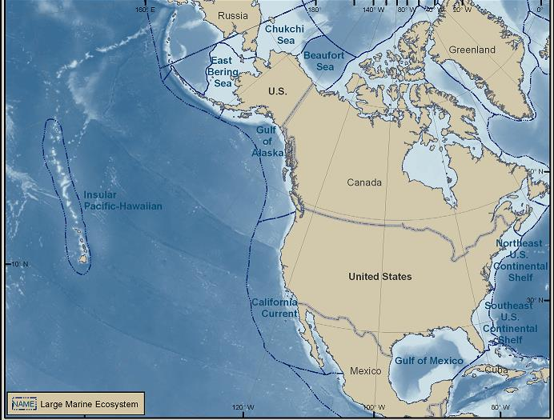

Integrated Ecosystem Assessments (IEAs) collect essential information to inform better management decisions. Below are examples of data gathered or tools included in an IEA.

Data Examples
ASSESSMENTS
Status and trends of ecosystem condition
Ecosystem services
Activities or elements constituting stressors

PREDICTIONS
Future condition of the ecosystem under stress if no action taken
Future condition under variety of management options or scenarios
Evaluation of potential for success of various management options
NOAA Fisheries 2018

Designing and finalizing an IEA to determine ecosystem status involves deriving outputs from five different modules of indicators (spatial and temporal) illustrated below.

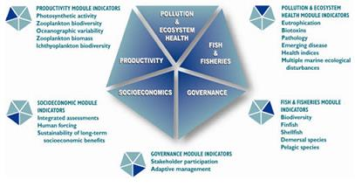

Figure 3.4 Indicators that go into an Integrated Ecosystem Assessment (
(inactive link as of 05/21/2021)). Currently, IEA work is unfolding in five of the regions: Alaska Complex, California Current, Gulf of Mexico, Northeast US Shelf, and the Pacific Islands. As the IEA program grows, the agency will move on to add assessments for the Caribbean, Great Lakes and Southeast US Shelf (NOAA 2018).
The appendix of Resources at the end of the book contains additional details relevant to managing through specially designated areas (see resources for unit three).

Unit 3 Study Questions
- What does Ecosystem Based Management require to be effective? Robust?
- What are the benefits of managing the marine environment through specially designated areas?
- Theorize and describe examples of technical or economic issues that managers could confront in stewardship of specially designated areas.
- From the perspective of managing present and future (often competing) human uses and impacts, what are the implications of ocean zoning and planning for society? For managers?

Unit Three Appendix

Unit 4 - Our Fisheries

Our Fisheries

Contents
Introduction
History and Overviewof The Magnuson-Stevens Fishery Conservation and Management Act (MSA) 16 USC Ch. 38,and the Sustainable Fisheries Act (SFA)
The Rise of Best Available Science, and the Role of Nonprofit Organizations

Introduction
Prior to 1976, fisheries management almost exclusively performed by the 35 coastal states; now the states manage cooperatively with federal government.
The Magnuson Stevens Fishery Conservation and Management Act of 1976 (or MSA, or Fisheries Conservation Management Act FCMA, as amended 2006) covers all commercial and recreational fishing beyond state waters (three nautical miles offshore). Highly migratory species were added in 1990. Over the past forty years, the MSA has adapted to the times, conservation methodology, and developments in marine science and technology. In many respects the MSA is a successful piece of legislation, which will continue to grow and adapt.
History and Overview of The Magnuson-Stevens Fishery Conservation and Management Act (MSA) 16 USC Ch. 38, and the Sustainable Fisheries Act (SFA)
Findings, Purpose and Policy (16 USC § 1801; excerpts only)
a) FINDINGS The Congress finds and declares the following:
(1) The fish off the coasts of the United States, the highly migratory species of the high seas, the species which dwell on or in the Continental Shelf appertaining to the United States, and the anadromous species which spawn in United States rivers or estuaries, constitute valuable and renewable natural resources. These fishery resources contribute to the food supply, economy, and health of the Nation and provide recreational opportunities.
(2) Certain stocks of fish have declined to the point where their survival is threatened, and other stocks of fish have been so substantially reduced in number that they could become similarly threatened as a consequence of (A) increased fishing pressure, (B) the inadequacy of fishery resource conservation and management practices and controls, or (C) direct and indirect habitat losses which have resulted in a diminished capacity to support existing fishing levels.
(3) Commercial and recreational fishing constitutes a major source of employment and contributes significantly to the economy of the Nation. Many coastal areas are dependent upon fishing and related activities, and their economies have been badly damaged by the overfishing of fishery resources at an ever-increasing rate over the past decade. The activities of massive foreign fishing fleets in waters adjacent to such coastal areas have contributed to such damage, interfered with domestic fishing efforts, and caused destruction of the fishing gear of United States fishermen.
(4) International fishery agreements have not been effective in preventing or terminating the overfishing of these valuable fishery resources. There is danger that irreversible effects from overfishing will take place before an effective international agreement on fishery management jurisdiction can be negotiated, signed, ratified, and implemented.
(5) Fishery resources are finite but renewable. If placed under sound management before overfishing has caused irreversible effects, the fisheries can be conserved and maintained so as to provide optimum yields on a continuing basis.
(6) A national program for the conservation and management of the fishery resources of the United States is necessary to prevent overfishing, to rebuild overfished stocks, to insure conservation, to facilitate long-term protection of essential fish habitats, and to realize the full potential of the Nation’s fishery resources. ……
(b) PURPOSES It is therefore declared to be the purposes of the Congress in this chapter—
(1) to take immediate action to conserve and manage the fishery resources found off the coasts of the United States, and the anadromous species and Continental Shelf fishery resources of the United States, by exercising (A) sovereign rights for the purposes of exploring, exploiting, conserving, and managing all fish, within the exclusive economic zone established by Presidential Proclamation 5030, dated March 10, 1983, and (B) exclusive fishery management authority beyond the exclusive economic zone over such
anadromous species and Continental Shelf fishery resources; …
(c) POLICY It is further declared to be the policy of the Congress in this chapter—
(1) to maintain without change the existing territorial or other ocean jurisdiction of the United States for all purposes other than the conservation and management of fishery resources, as provided for in this chapter;
(2) to authorize no impediment to, or interference with, recognized legitimate uses of the high seas, except as necessary for the conservation and management of fishery resources, as provided for in this chapter;
(3) to assure that the national fishery conservation and management program utilizes, and is based upon, the best scientific information available; involves, and is responsive to the needs of, interested and affected States and citizens; considers efficiency; draws upon Federal, State, and academic capabilities in carrying out research, administration, management, and enforcement; considers the effects of fishing on immature fish and encourages development of practical measures that minimize bycatch and avoid unnecessary waste of fish; and is workable and effective; …(end of excerpt)
(law.cornell.edu/uscode/text/16/1801)

1976-1996

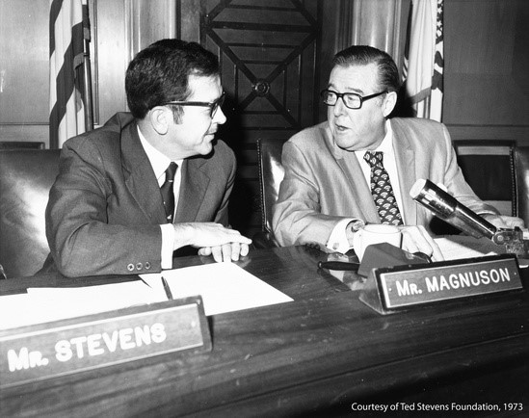

Senator Theodore (Ted) Stevens (Alaska, 1968-2009) and Senator (Washington State, 1955-1977) Warren Magnuson (
)

Under MSA, the eight US regional fisheries management councils determine the annual allowable catch for each fishery (Maximum Sustained Yield or MSY) and develop a Fishery Management Plan (FMP). Subsequently authors of the FMP determine Optimum Sustained Yield (OSY). OSY = MSY as modified by any relevant social, economic, or ecological factor, and must provide the “greatest overall benefit to the Nation, with particular reference to food production and recreational opportunities.”
Before MSA, foreign fleets could fish up to 12 nm offshore. In accordance with international law since 1983, Coastal States (in this context, we mean nations) have sovereign rights out to the limits of their Exclusive Economic Zones (200 nm) to explore, exploit, and conserve living and nonliving resources. These rights cover every aspect of marine environmental management, including transport, military, pollution, research, and fisheries management.
During 1976-1996, the eight US Regional Fishery Management Councils had broad discretion to meet the short-term needs of the fishing industry; the goal in this early period was Americanization due to increased pressure from foreign fleets. In keeping with the International Law of the Sea, in 1983 Reagan Proclaimed 200 nm EEZ for the United States.
By 1996, US fisheries had become depleted, and the American public became angry. In response, Congress enacted the 1996 Sustainable Fisheries Act (SFA, Public Law PL 104-294), which substantially revised FCMA to refocus efforts toward goals of conservation and ecosystem protection. The Sustainable Fisheries Act requires the eight regional fisheries management councils to make conservation (i.e. rebuilding of stocks) the nation’s the top priority.
It is important to note that fisheries conservation and ecosystem protection as a statutory mandate marks a significant departure from business as usual. Over the short duration of two decades, the post World War II period of scaled-up fishing (driven by protectionism and population-driven consumption) was transformed by lower yields and the practical need to regulate and conserve stocks. It was a national priority to put MSA in place in 1976, before the United Nations Convention on the Law of the Sea (Unit 6) was finalized by nations (including the US) in 1983, establishing the 200 nm EEZ as international customary law.

1996-2006
During the period following 1996, US fisheries management underwent a remarkable, if gradual, statutory (r)evolution to an enforceable conservation emphasis, with accountability and standards built in. The new management paradigm was made possible by technical and scientific advances in ocean and fisheries data availability and sophisticated research methods.
In 1996, Congress revised the MSA with the Sustainable Fisheries Act. The revision incorporated important new definitions, including “overfishing,” a set of ten enforceable National Standards, and a new mandate balancing industry with conservation requirements. Litigation, such as NRDC v Daley, 209 F.3d 747 (DC Cir 2000, discussed later in this Unit) clarified interpretations within the new requirement. The changes introduced in the Sustainable Fisheries Act also required greater management accountability (16 USC § 1854(e)(1)) via mandatory annual reporting to Congress by National Marine Fisheries Service (NMFS, NOAA Fisheries; recent reports are available at nmfs.noaa.gov) (inactive link as of 05/19/2021).
Under the new definitions, overfished means: existing below a prescribed biomass threshold. In a state of being overfished means: Being harvested at a rate above a prescribed fishing mortality threshold (16 USC § 1802(34)).
The term “optimum” … means the amount of fish which—
(A) will provide the greatest overall benefit to the Nation, particularly with respect to food production and recreational opportunities, taking into account the protection of marine ecosystems;
(B) is prescribed on the basis of the maximum sustainable yield from the fishery, as reduced by any relevant social, economic, or ecological factor; and
(C) in the case of an overfished fishery, provides for rebuilding to a level consistent with producing the maximum sustainable yield in such fishery.
MSA National Standards 1 and 2
The enforceable Ten US National Standards (16 USC § 1651; regulations at 50 CFR Chap. VI, Part 600, Subpart D, §600.305) state the following.
Any fishery management plan … shall be consistent with the following national standards:
1) … measures shall prevent overfishing while achieving, on a continuing basis, the optimum yield from each fishery for the US fishing industry.
(2) … measures shall be based upon the best scientific information available.
National Standard Two, requiring actions to be founded on best scientific information available, generates a lot of litigation. Resulting cases provide examples of how the federal courts’ interpretations of statutory terms and phrases can clarify legislative meanings.
Because of precedent (Motor Vehicles Mfrs Assoc., 463 US 29 1983) courts have required plaintiffs to demonstrate that the Councils and Agency relied on no scientific basis whatsoever, a very difficult claim for plaintiffs to prove. Nonetheless, in rare cases plaintiffs have been able to show that a fishery management plan was based purely on political motivations. In cases involving National Standard Two, courts have required that the Councils must expressly provide the scientific rationale they relied on for both conservation and allocation decisions.
MSA National Standards 3 and 4
(3) To the extent practicable, an individual stock of fish shall be managed as a unit throughout its range, and interrelated stocks shall be managed as a unit or in close coordination.
(4) Conservation and management measures shall not discriminate between residents of different States. If it becomes necessary to allocate or assign fishing privileges among various United States fishermen, such allocation shall be
(A) fair and equitable to all such fishermen;
(B) reasonably calculated to promote conservation; and
(C) carried out in such manner that no particular individual, corporation, or other entity acquires an excessive share of such privileges.
Note that 4(C) does not provide details on methods to prevent shares from concentrating in an individual or corporation, nor what to do if shares in a fishery do tend toward or result in a monopolistic entity. However, details to implement fairness could be embedded within individual fisheries’ quota agreements, or other programs for fairly distributing access privileges.
MSA National Standards 5 through 10
(5) Conservation and management measures shall, where practicable, consider efficiency in the utilization of fishery resources; except that no such measure shall have economic allocation as its sole purpose.
(6) Conservation and management measures shall take into account and allow for variations among, and contingencies in, fisheries, fishery resources, and catches.
(7) Conservation and management measures shall, where practicable, minimize costs and avoid unnecessary duplication.
(8) Conservation and management measures shall, consistent with the conservation requirements of this chapter (including the prevention of overfishing and rebuilding of overfished stocks), take into account the importance of fishery resources to fishing communities by utilizing economic and social data that meet the requirements of paragraph (2), in order to
(A) provide for the sustained participation of such communities, and
(B) to the extent practicable, minimize adverse economic impacts on such communities.
(9) Conservation and management measures shall, to the extent practicable,
(A) minimize bycatch and
(B) to the extent bycatch cannot be avoided, minimize the mortality of such bycatch.
(10) Conservation and management measures shall, to the extent practicable, promote the safety of human life at sea.

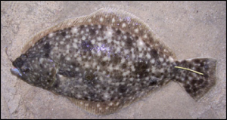

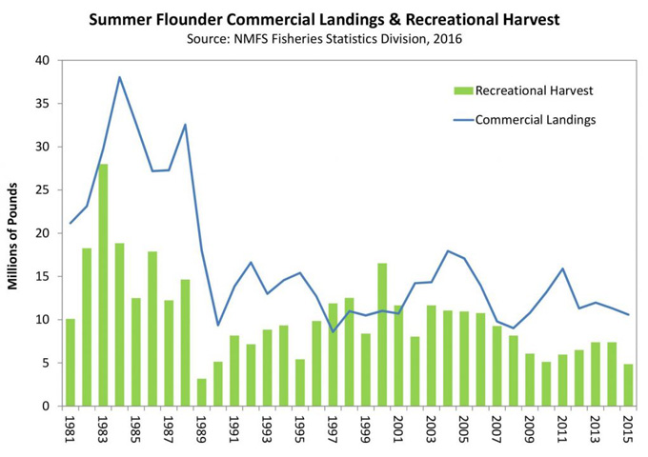

The case NRDC v Daley, 209 F.3d 747 (DC Cir 2000) involved National Standard One, which provides that conservation and management measures shall prevent overfishing while achieving, on a continuing basis, the optimum yield from each fishery.
How much certainty must the Regional Fisheries Management Councils have in order to assert that their proposed actions will end overfishing? In balancing between conservation and short-term cost avoidance, the two goals are not equal; conservation comes first. The Daley court held that in order to comply with the MSA, Councils must have >51% certainty that their proposed actions will end overfishing. In the Daley case NMFS (that reviews and authorizes the eight councils’ decisions) had argued that an 18% chance would be sufficient.
In the Daley case (2000): The court said, “The Government concedes, and we agree, that, under the Fishery Act, the Service (NMFS) must give priority to conservation measures. It is only when two different plans achieve similar conservation measures that the Service takes into consideration adverse economic consequences.”
The 2000 Daley court continued, “Where two alternatives achieve similar conservation goals, the alternative that minimizes the adverse impacts on fishing communities would be preferred.” The regulation that the court was interpreting is 50 CFR Section 600.345(b)(1)
That conservation is a mandatory priority over short-term cost avoidance was confirmed again in NRDC v. NMFS, 421 F.3d 872(9th Circuit 2005). Once again, the NMFS had lost—having claimed that the Pacific Council could establish a 47-year rebuilding period for the dark-blotched rockfish (sebastes crameri).
NMFS had underestimated the severity of the rockfish’s depletion. This triggered statutory language requiring the stock to be rebuilt in “as short a time as possible,” taken to be a 14-year period plus one mean generation time, except for the fact that the dark-blotched rockfish lives 33 years. The standard period by regulation must not exceed 10 years– with exceptions.
In summary, the statutory, regulatory and case law of 1996-2006 displays efforts to further refine the MSA, to prioritize conservation, and to make the law’s requirements to more concrete and transparent. The new mandate for best available science underlying FMPs requires Councils to explain the scientific bases for their decisions. This period also marks the first time MSA provisions included Essential Fish Habitat (EFH) and bycatch.

US Fisheries Management 2006-Present
This section presents a brief overview of the rise of science-based management, the reduction of fishing capacity to reverse overfishing, and the increasing prominence of an interesting new player: the rise of non-governmental organizations (NGOs) in at least two roles: first, as a convener and coordinator of scientific support, and second as legislative initiators and collaborators on fisheries and habitat conservation.
Fisheries management since 2006 represents the further development of the emphasis on conservation. In 2007, the reauthorized MSA was implemented to include further emphasis on scientific management, additional conservation and accountability mandates in all Fishery Management Plans (FMPs), Annual Catch Limits (ACLs), and the introduction of an option known as Limited Access Privilege Programs (LAPPs). The new provisions were required to be implemented in all FMPs by 2010 for all overfished species, and in 2011 in all others. FMPs are based on stock assessments.
Fishery management plans must specify objective and measurable criteria, or reference points, to determine when a stock is subject to overfishing or overfished. A scientific analysis of the abundance and composition of a fish stock and the rate of fishing mortality is called a stock assessment. Typically, a stock assessment undergoes peer review by independent scientists before it is accepted as the best scientific information available.
The councils use information from stock assessments to develop and recommend ACLs and other conservation and management measures. While catch limits are set annually, assessments are often done less frequently. To determine whether catch limits have successfully ended or prevented overfishing, NOAA Fisheries may use either the results of a stock assessment or a comparison of catch to the overfishing limit (OFL). If the catch to OFL comparison is used, an overfishing determination is made annually. If a stock assessment is used, due to timing of the next stock assessment, several years may pass before we are able to determine if catch limits successfully ended overfishing (Stocks Status 2016).
From 2007-on, all Fishery Management Plans (FMPs) required conservation mandates, as well as stated Annual Catch Limits (ACLs) designed to avoid overfishing. Data on the progress of ACLs to meet this goal are detailed annually in the MSA-mandated report to Congress. For 2016, for example, 92 percent of all stocks were successfully kept at or below the ACLs set for them. By law, the regional councils must investigate and take steps to correct management of stocks that exceeded ACLs (Stocks Status 2016).
The required Annual Catch Limits (16 U.S.C. § 1853(a)(15))are devised by each Fishery Management Council’s Scientific and Technical Committee. If the Committee does not recommend an ACL, a Council is still required to set one.
According to NOAA, the 2007 reauthorization required two kinds of Accountability Measures (AMs): in-season measures to prevent exceeding the Annual Catch Limit or ACL, and AMs to address any overage of the ACL. The ACL AMs include identification of operational factors that led to the overage, and a plan to mitigate biological harm to the stock, if any. Accountability with regard to ACLs is described in 16 USC § 1853(a)(15). Accountability with regard to the Annual Catch Limits (ACLs) is covered in 16 USC § 1853(a)(15). ACLs are mandatory limits.
Because of uncertainty, there is always a chance that overfishing could occur. To prevent chronic overfishing, the system of ACLs and Accountability Mandates (AMs) should be re-evaluated and modified if the ACL is exceeded more than once in 4 years.
Councils and NMFS can apply a higher performance standard if a stock is particularly vulnerable to the effects of overfishing. Annual Catch Limits (ACLs) must not exceed the recommendations of each council’s scientific and statistical committee or the peer review process (16 USC § 1852(h)(6)).
Determination of an ACL requires three types of data (fisheries data, biological data, and ecological data) followed by analysis:

Data and Analysis
Data:
- Fisheries Data
  - Age, size, sex and weight distributions
  - Geographic distributions
  - Catch and effort data/history
- Biological Data
  - Abundance
  - Growth rates
  - Where and what the species feeds on
  - Age and size at maturity
  - Life span
  - When, where, and how fish reproduce
  - Vulnerability to overfishing
- Ecological Data
  - Predator/prey relationships
  - Habitat requirements
  - Other species of fish that coexist within their “neighborhood”
  - Similarities to other, more extensively studied species
Analysis:
Scientists use a variety of information from various sources, including independent research such as National Oceanic and Atmospheric Administration (NOAA) surveys and academic reports; and “fishery dependent” sources such as reported catch data from fishermen’s logbooks, targeted and incidental catch reports from on-board observers, and dealer surveys. This information, combined with analytical methods, such as modeling, helps scientists recommend limits unique to each fish and fishery.

(Source: PEW Fact Sheet; Bringing Back the Fish 2013)
Limited Access Privilege Programs (LAPPs)
Limited Access Privilege Programs (LAPPs) are described in 16 USC § 1853a. LAPPs are an optional, and not mandatory tool (§ 1853a(a)). If a Regional Fishery Management Council elects to develop a LAPP, it must incorporate certain protections outlined in § 1853a.
LAPP Requirements:
Any limited access privilege program to harvest fish submitted by a Council or approved by the Secretary under this section shall—
(A) if established in a fishery that is over- fished or subject to a rebuilding plan, assist in its rebuilding;
(B) if established in a fishery that is determined by the Secretary or the Council to have over-capacity, contribute to reducing capacity;
(C) promote— (i) fishing safety; (ii) fishery conservation and management; and (iii) social and economic benefits (16 USC § 1853a(c)).
Communities are also eligible for LAPPs. To participate, a community must be located in a Council’s area and meet certain criteria. The community must consist of residents who are commercial or recreational fishermen, processors, or fishery-dependent businesses. Finally, the community must develop and submit a Community Sustainability Plan that addresses social and economic development needs. LAPPs and their requirements are covered in 16 USC § 1853a(c)3(A)(i).
The Rise of Best Available Science, and the Role of Nonprofit Organizations
Powerful nonprofit organizations became involved in fisheries conservation and have assumed a leading role in raising public awareness, bridging divides between sectors, and generating independent peer-reviewed reports. In a watershed moment in 2006, the Nature Conservancyand the Environmental Defense Fundpursued a buy-out of permits and vessels in the troubled Pacific groundfish fishery, in exchange for a binding agreement from the Pacific Regional Fishery Management Council to remove particular seafloor areas off central California from bottom trawling as part of the PRFMC Essential Fish Habitat amendment to the groundfish FMP. The final rules designating the EFH and creating the no-trawl zones are available at 71 Fed. Reg. 27408 (May 11, 2006).
At least two important NGO studies and reports from this period are worth noting.
- PEW Charitable Trusts 2013: The Law That’s Saving American Fisheries, The Magnuson-Stevens Fisheries Conservation and Management Act
- NRDC 2013: Bringing Back the Fish
The PEW report includes a list of elements of successful rebuilding programs (PEW)
- Well-defined objectives
- Finite timelines
- Established in an open and transparent process
- Credible, consistent, and transparent scientific monitoring
- Simple and easily understood metrics of status and success
- Predefined rules for triggering corrective management action
- Substantial, measurable reductions in fishing mortality at the onset of the plan

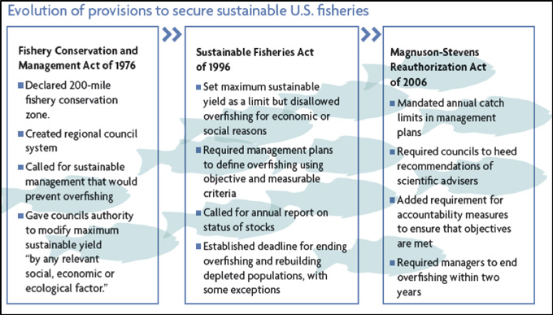

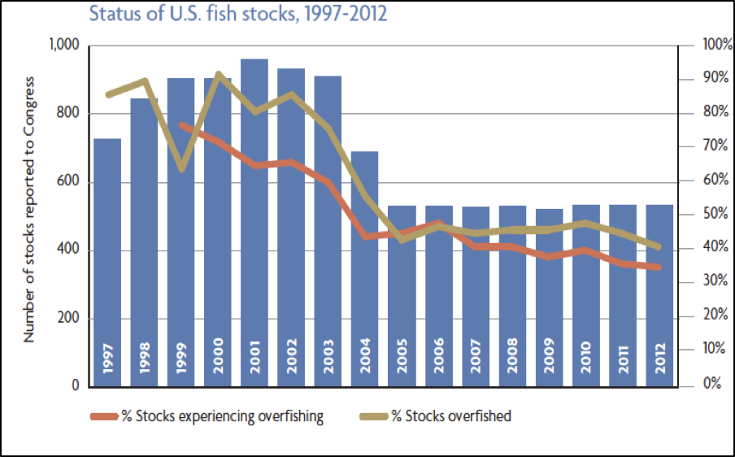

Science-based limits, combined with accountability to ensure that catches are consistent with restrictions, get results. The use of science-based limits is not a new idea; it has long proven effective for managing fisheries and rebuilding populations. Analyses from cases all over the world show that fish populations rebound when excess fishing mortality is reduced. Of 24 depleted stocks worldwide with formal rebuilding plans to reduce excess fishing mortality, all but one recovered.
The 2013 report by NRDC 2013 pointed out the following gaps.
- 30% of stocks have inadequate data
- Important stocks (river herring, shad, menhaden, Atlantic sturgeon) are not federally managed so not subject to rebuilding even though recognized as depleted
- NRDC Gaps seem to focus on inconsistencies and lack of information
- The report points out that unmanaged stocks may have state management plans that fall short of MSA standards (inconsistent management in state and federal waters)
- Internationally managed stocks are subject to less stringent rebuilding requirements (inconsistent management across governance structures)
- “more than 200 international stocks (including more than 50 that NMFS considers major stocks) identified as overfished are designated as having ‘unknown’ or ‘undefined’ overfished status”
The NRDC 2013 report estimates that 21 stocks (or 48% of overfished) are considered rebuilt.
Significant Rebuilding Progress (7 stocks or 16%) means that greater than or equal to 50% of the rebuilding target AND greater or equal to 25% increase since the start of the plan
Limited Rebuilding Progress (8 stocks or 18%) means that greater than or equal to 50% of the rebuilding target OR greater or equal to 25% increase since the start of the plan
Lack of Rebuilding Progress (8 stocks or 18%) means less than 50% of rebuilding target AND Less than 25% increase since the start of the plan

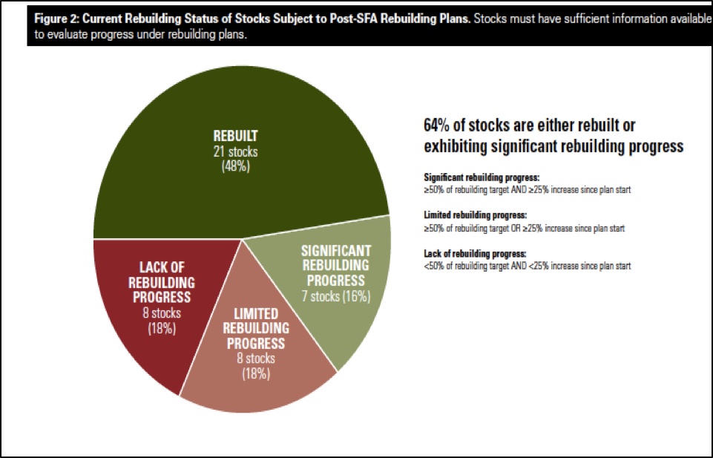

A 2018 NRDC update indicates that 40 federally managed species important to commercial and recreational fishermen are still overfished or at risk. However, the overall recovery shows that the 2007 revisions to MSA are working.

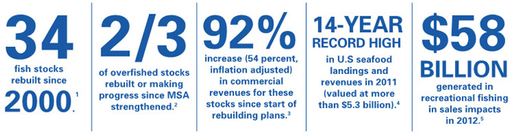

An appendix of Resources at the end of the book contains additional details relevant to fisheries (see resources for unit four).
Unit 5 will discuss regulatory aspects of a wide range of environmental impacts on oceans.

Unit 4 Study Questions
- For some stocks, little or no data exist. Theorize effective policy options for confronting uncertainty in establishing management plans for those stocks.
- What are potential methods of achieving (over time) greater consistency at management scales (state, federal, international)?
- Since 1976 when Congress passed MSA, one of the greatest movements has been toward stakeholder identification, outreach and inclusion. Who are the stakeholders in regard to the nation’s fisheries?

Unit Four Appendix

Unit 5 - Regulating Ocean Impacts

Regulating Ocean Impacts

Contents
Introduction
Overfishing and Fisheries Recovery
The Impact of Incidental Take, or Bycatch
Pollution
Ocean Acidification

Introduction
The various (and increasing) human uses of ocean resources can cause impacts. The application of federal environmental laws to impact reduction is effective at smaller scales, and indispensible but limited. Most legal and regulatory controls evolved to become relevant after damages have been done and come more from a redress or remedy perspective. Over time, as impacts to the ocean have become more complex and overlapping and the consequences chronic, proactive tools aimed toward awareness and prevention must be developed. The law is only one part of a toolbox that includes public involvement in education and outreach, sophisticated and nuanced long-term stakeholder processes, volunteer programs such as beach clean ups, habitat monitoring, and coastal restoration. This unit will present an overview of statutory approaches to a handful of ocean impacts including overfishing, bycatch, and examples of pollution sources.
Overfishing and Fisheries Recovery
Unit 4 described how the Magnuson-Stevens Act (MSA, 16 USC Ch. 38) and SFA (the 1996 amendments to the 1976 Magnuson Act) evolved to require science-based management through new accountability measures and the mandatory incorporation of the ten national standards (16 USC § 1651) in each fisheries management plan (FMP) produced by the eight US regional fishery management councils (review the eight councils here).
While US management under the MSA is achieving successes in many fisheries, the over-exploitation of fish stocks remains a significant threat to an important source of high-quality protein for humans, as well as an economic and cultural threat to coastal economies. Overfishing also poses a serious biological impact on marine ecosystems. Overfishing represents disruption of predator-prey and other food-web dynamics, and removal of biomass and nutrients from the biogeochemical cycle. In response, MSA requires Regional Fishery Management Councils to devise an effective FMP for every overfished stock; the FMP must contain concrete steps to rebuild the fishery.
At NOAA’s site detailing Essential Fish Habitat the EFH regulatory guidelines are posted (50 CFR Ch. VI Subpart J, Essential Fish Habitat). A review of these regulations provides a glimpse into the enormous detail that goes into determining, mapping, and improving the EFH required in every FMP.
Coordination is required at two levels (NMFS with federal and state agencies, and NMFS with the eight RFMCs—recall the Unit 3 discussion of administrative examples of EBM).
Declaring certain areas as essential fish habitat (EFH) is a major tool to rebuild fisheries, with west coast groundfish as only one example. Identifying and protecting EFH is an EBM-based strategy (Unit 3). EFH plans are reviewed every five years.
There are over 100 identified types of EFH covering all aquatic habitats. For example, rivers, wetlands, estuaries, coral and rocky reefs, kelp forests and seagrass beds are included. Note that some of these EFH categories are important land-based habitats—not all are ocean ecosystems. Here is the general regulatory definition of EFH (50 CFR §600.10).
Essential fish habitat (EFH) means those waters and substrate necessary to fish for spawning, breeding, feeding, or growth to maturity. For the purpose of interpreting the definition of essential fish habitat: Waters include aquatic areas and their associated physical, chemical, and biological properties that are used by fish and may include aquatic areas historically used by fish where appropriate; substrate includes sediment, hard bottom, structures underlying the waters, and associated biological communities; necessary means the habitat required to support a sustainable fishery and the managed species’ contribution to a healthy ecosystem; and spawning, breeding, feeding, or growth to maturity covers a species’ full life cycle.
For a concrete example, ten species of groundfish on the US west coast were overfished. Today, seven of the ten are declared rebuilt. For a feature about two newly recovered rockfish species, and photographs (darkblotched rockfish and bocaccio) see here.
Geographic delineations are described with precision in the EFH regulation specifically for Pacific Groundfish, see here (50 CFR 660.75). These habitats are mapped and available for viewing. To learn more, take a look at the EFH maps of Pacific Groundfish (the final rule, final Environmental Impact Statement (EIS), and Record of Decision (ROD) are also available here for this fishery).
The Impact of Incidental Take, or Bycatch
Incidental take, also called bycatch, refers to the mortality and discard of species (not just fish, but any ocean species including mammals and sea birds) that are unintentionally caught in the course of commercial fishing activities.
The statutory definition of bycatch is located in MSA Standard 9 (50 CFR Chapter VI Part 600(D).600.350). If marine mammals or endangered species are involved as bycatch, MMPA and ESA also apply since an illegal taking has occurred.
Bycatch represents a serious and persistent ocean impact. Innovations in policy and re-designed fishing gear, seasons and practices to reduce bycatch are still a national work in progress. NOAA Fisheries devised a National Bycatch Strategy, revised in 2016, that contains five main objectives.

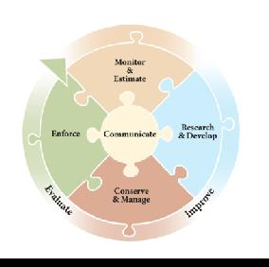

Figure 5.1
The national program emphasizes collaboration with states, other agencies, and stakeholders and includes implementation of fisheries observers. In many cases, fishermen themselves have designed new gear (in collaboration with engineers, scientists, and inventors) to eliminate or reduce bycatch within specific fisheries. Click to see a video (provided by an environmental NGO) that tells the story of a collaborative project to design a better trawl net that lets juvenile fish escape.
Globally, one annual estimate of bycatch is 8.5 million tonnes (or 40.4 percent of the annual catch estimate of 95.2 million tonnes, from the authors’ data). The authors note that using weight alone, hides the true impact and dire consequences of removing tonnes of juvenile fish from the system, thus the impact in terms of ecology (and fisheries future productivity) is far greater (Davies et al. 2009).

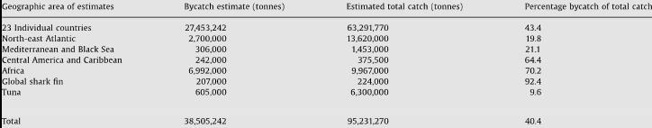

Reliable estimates of annual bycatch among US fleets are difficult to identify; previous data are reported from 2011-2013 (US National Bycatch Report 2016).
Moore et al. (2009) reviewed US fishing mortality to sea turtles, marine mammals and birds and found that while policy has led to significant improvement,
cumulative estimates are lacking for all taxa, but particularly for sea turtles and seabirds in most places where it occurs, observer coverage levels are insufficient to accurately characterize these rare bycatch events across fleets (Moore et al. 2009, p. 445).
As of August 2017, NOAA Fisheries (NMFS) awarded $2.3 M to eighteen different bycatch reduction research projects around the US. To learn more about this initiative, please visit (fisheries.noaa.gov/feature-story/2017-bycatch-reduction-engineering-program-awards).
Pollution
This section will present an overview of US pollution regulation in terms of approaches generally described as prevention and control (via Clean Water Act (CWA) Section 403 Ocean Discharge Criteria). Resources related to reduction and response (oil spill civil and criminal liability in CWA Section 311), or the domestic and international laws prohibiting ocean dumping are provided in Unit 5 Resources in the Appendix.
Marine pollution poses short- and long-term impacts on organisms, biodiversity, food webs (including benthic), and sometimes contains toxic contaminants. In some instances, the compounds were banned decades ago but remain as ‘legacy pollution’—the compound has already dispersed but persists in the environment such as river substrates or bay and ocean bottom sediments. Polychlorinated biphenyls, or PCBs are an example. Banned in the US in 1979 and around the same time in Canada, this contaminant has been shown to be toxic to humans and wildlife (see oceanservice.noaa.gov/facts/pcbs.html).
Another example, polycyclic aromatic hydrocarbons (PAHs), are a component of petroleum entering the sea from oil spills, terrestrial runoff, and other sources. Exposure to contaminated prey can lead to malformed embryos in mammals, and has been suspected in certain lung infections in dolphins following the New Horizon platform blowout (Venn-Watson et al. 2015).
Contaminants in the ocean largely come from terrestrial-based sources, including stormwater runoff and stream outflows that collect trash that blown by the wind. Plastics in the ocean (from land and ships) are an enormous threat to marine life for several reasons: fish, mammals and birds that ingest plastic mistaking it for prey face high mortality. Floating plastic objects are a vector for invasive species and pathogens. As they degrade in saltwater, plastics leach chemical compounds, as they degrade further they become smaller and smaller until they are what is called microplastics—plastic particulates that float in the water column. The increase of major storm events will only exacerbate the problem of plastics in the oceans.
Reducing the use of plastics, recycling them or disposing of them properly, through highly visible, consistent programs to keep plastics and all trash out of coastal watersheds and the ocean are objectives that are clearly achievable through community education, grassroots volunteer programs such as beach clean up events. Within coastal marinas, local ordinances with boater education and onsite recycling centers could be very beneficial. At the state level, regulations related to individual coastal state management plan priorities can help. The strongest intervention options toward a solution are most likely located within organized, focused efforts at the local level.
Many coastal states have marine debris action plans. The NOAA Office of Response and Restoration is a source for examples of published reports and technical memos from the coastal states (marinedebris.noaa.gov/reports-and-technical-memos). NOAA’s 2017 report on the accomplishments provides a snapshot of progress at the national level. During 2017,
More than 1600 metric tons of marine debris were removed
Three Marine Debris Emergency Response Guides were created for South Carolina, Georgia and Mississippi
More than 1800 teachers were reached, and more than 18,300 students
Forty-two new survey sites were added to the Monitoring and Assessment Project
The Program responded to debris cleanup from three hurricanes (Harvey, Irma, Maria)
NOAA 2017 Marine Debris Program Accomplishments Report

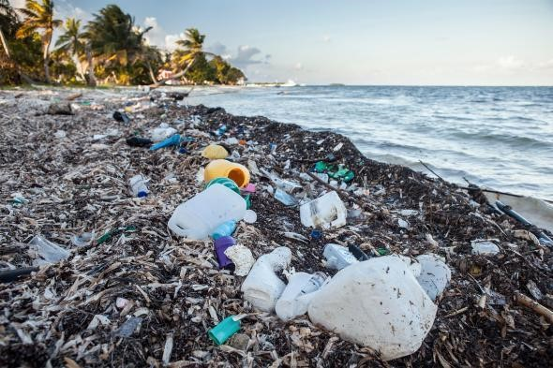

Figure 5.3 Plastic pollution, from Laura Parker, National Geographic,
, photo Waterframe, Alamy
However, flows that do not come from a pipe, a ship, or a floating platform (all regulated point sources) are nonpoint source pollution, which is (if regulated at all) a local concern to be touched on in Unit 9 (Coastal Management). Flows that come from pipes, ships, and platforms are regulated through permits, reviewed every five years, via the CWA provisions regarding ocean discharges (33 USC 1343; see below).
Within three miles of the coastline, water-quality criteria are established by EPA-authorized state water quality programs. Coastal water quality monitoring in conjunction with beaches and water recreation can be found on state coastal management agency websites. The EPA, under its mission to protect human health, also provides coastal water quality information and warnings to the public (epa.gov/beaches/find-information-about-your-beach). The grassroots nonprofit Surfrider Foundation also monitors coastal water quality and provides periodic reports online; the most recent Surfrider Report is from November 2017 (surfrider.org/coastal-blog/entry/2017-state-of-the-beach-report).
The CWA’s National Pollution Discharge Elimination System (NPDES) regulates point source (think end-of-pipe) ocean discharges beyond three-mile state waters with criteria set by the EPA. The ocean discharge permit program applies to around 300 types of facilities, including offshore oil and gas activities, and seafood processing.
EPA uses seven guidelines to determine whether or not to issue an ocean discharge permit. Permit applicants must submit analyses of their proposed discharges (biological, ecological, and chemical). EPA reviews the permit applications to evaluate whether the activity will unreasonably degrade the marine environment through an analysis of ten factors (in 40 CFR 125.122; see second table, below). If a proposed discharge meets the adjacent coastal state’s water quality standards, there is a presumption that the discharge will not cause an unreasonable degradation.
Clean Water Act NPDES Ocean Discharge Criteria

33 USC § 1343; see also Regulations at 40 CFR §§ 125.120 – 125.124

(c) Guidelines for determining degradation of waters
(1) The [EPA] Administrator shall, within one hundred and eighty days after October 18, 1972 (and from time to time thereafter), promulgate guidelines for determining the degradation of the waters of the territorial seas, the contiguous zone, and the oceans, which shall include:
(A) the effect of disposal of pollutants on human health or welfare, including but not limited to plankton, fish, shellfish, wildlife, shorelines, and beaches;
(B) the effect of disposal of pollutants on marine life including the transfer, concentration, and dispersal of pollutants or their by-products through biological, physical, and chemical processes; changes in marine ecosystem diversity, productivity, and stability; and species and community population changes;
(C) the effect of disposal, of pollutants on esthetic, recreation, and economic values;
(D) the persistence and permanence of the effects of disposal of pollutants;
(E) the effect of the disposal of varying rates, of particular volumes and
concentrations of pollutants;
(F) other possible locations and methods of disposal or recycling of pollutants including land-based alternatives; and
(G) the effect on alternate uses of the oceans, such as mineral exploitation and scientific study.
(2) In any event where insufficient information exists on any proposed discharge to make a reasonable judgment on any of the guidelines established pursuant to this subsection no permit shall be issued under section 1342 of this title.
NPDES Ocean Discharge Criteria,
Determination of unreasonable degradation of the marine environment
Regulation 40 CFR 125.122

(a) The [EPA] director shall determine whether a discharge will cause unreasonable degradation of the marine environment based on consideration of:

(1) The quantities, composition and potential for bioaccumulation or persistence of the pollutants to be discharged;

(2) The potential transport of such pollutants by biological, physical or chemical processes;

(3) The composition and vulnerability of the biological communities which may be exposed to such pollutants, including the presence of unique species or communities of species, the presence of species identified as endangered or threatened pursuant to the Endangered Species Act, or the presence of those species critical to the structure or function of the ecosystem, such as those important for the food chain;

(4) The importance of the receiving water area to the surrounding biological community, including the presence of spawning sites, nursery/forage areas, migratory pathways, or areas necessary for other functions or critical stages in the life cycle of an organism.

(5) The existence of special aquatic sites including, but not limited to marine sanctuaries and refuges, parks, national and historic monuments, national seashores, wilderness areas and coral reefs;

(6) The potential impacts on human health through direct and indirect pathways;

(7) Existing or potential recreational and commercial fishing, including fin fishing and shellfishing;

(8) Any applicable requirements of an approved Coastal Zone Management plan;

(9) Such other factors relating to the effects of the discharge as may be appropriate;

(10) Marine water quality criteria developed pursuant to section 304(a)(1).

Ocean Acidification
Acidification caused by fossil fuel burning is an urgent climate change impact on the pH of seawater and is a threat to all ocean systems and fisheries, particularly shellfish. Ocean acidification is caused by dissolved CO2, but made worse by warmer ocean temperatures. Outflows of stormwater, the volume of which is increasing due to more frequent and severe storm events, also contribute to acidification because they contain compounds including nutrients such as nitrate from agricultural fertilizer and manure, and deposition (both wet and dry) of nitrogen compounds from air pollution. As 170 nations move ahead implementing their commitments under the most recent Climate Accord, perhaps the best option presently is outreach and education, and to strengthen current regulatory approaches (US Clean Air Act and Clean Water Act) at the local, state, and regional levels regarding improving air quality, and reducing contaminants in stormwater runoff.
Acidification interferes with shell building by oysters, a commercially valuable resource. To get an idea of how changing biogeochemical cycles and ocean chemistry can impact shell building, review this interactive explanation from the Woods Hole Oceanographic Institution.
In regard to large, complex phenomena such as ocean acidification it is important to bring home its importance, to the greatest extent possible, in a local, personal context. Moreover, it is critical to educate and involve community members in actions to confront the problem. Kelly et al. (2013) found that data alone representing the environmental risk of ocean acidification was less effective at motivating decision-making leading to action than developing an effective, accompanying narrative—i.e. telling the story of the impact to give the data more meaning. The case study involved oyster production in the Whiskey Creek Shellfish Hatchery on the Oregon coast. The hatchery, according to the authors, produces approximately 75% of juvenile Pacific oysters for the million-dollar West Coast oyster aquaculture industry. When the hatchery began to experience up to 80% mortality of its larvae, it partnered with scientists and others to begin water quality monitoring, which revealed a strong correlation between the mortality periods and seasonal coastal upwelling of acidic bottom waters. In 2011, the Governor of Washington convened a Blue Ribbon Panel on Ocean Acidification that was widely inclusive of government, nongovernmental organizations, scientists, and the industry. Eventually, the Panel’s efforts led to a set of commitments by the state, “Washington’s Response to Ocean Acidification.”
Kelly et al. point out that narratives can link knowledge to action, partly because audiences remember narrative far more than information presented in an expository format). The authors note:
We suggest that this story gained critical traction because it featured identifiable and sympathetic characters—real people—with both the capacity and the willingness to share their story outside the boundaries of their community, and because their story was consistent with the effects predicted by a growing body of biophysical data. WC [the narrative] personified the economic impacts of one specific form of environmental change—ocean acidification—and did so in a credible and accessible way…[that] … was perceived to clearly link a specific environmental change to effects on real people, the small but important local industry that they support, and the provision of food from the sea. (Kelly et al. 2013)
An appendix of Resources at the end of the book contains supplemental information relevant to water quality problems discussed above as well as the regulation of other pollution impacts (ocean dumping, oil spills, and marine debris such as plastics, lost or discarded fishing gear sometimes called ‘ghost nets’; see resources for unit five).
Unit 6 will present important aspects of international fisheries management.

Unit 5 Study Questions
- Is there a connection between watershed management, drinking water, wastewater discharges, and ocean water quality?
- What are possible options for addressing marine debris from land? From offshore sources?
- Some regional approaches are showing signs of success in decreasing pollution to large water bodies, such as the Chesapeake Bay. The plan for restoring the Bay is a very long-term, ongoing effort, involving multiple and complex efforts to curb pollution from various land use activities, air pollution, and runoff from a 64,000 square mile watershed touching six states and the District of Columbia. The restoration chiefly involves coordination, collaboration, enforceable standards (pollution limits) under the umbrella of a CWA Total Maximum Daily Load (TMDL; see https://www.epa.gov/chesapeake-bay-tmdl). If this holistic, longterm approach can work in a geographic area this large and diverse, could it work elsewhere? What short- and long-term benefits might a cohesive, national coastal watershed effort have for ocean water quality? Recreation? Ecosystems? Fisheries?

Unit Five Appendix

Unit 6 - Introduction to International Fisheries Management

Introduction to International Fisheries Management

Contents
Introduction
Governance and Sustainability of World Fisheries
The United Nations Convention on the Law of the Sea (UNCLOS)
Conflict Management in the Convention

Introduction
The primary, holistic purpose of international law is to establish and set forth a set of internationally agreed-upon norms—the instruments are elaborated upon in international discussions with policy objectives reflected in agreements (treaties and conventions). International law is uniquely based on the tension, common interests and common goals among sovereign nations who are the parties to each agreement.
All international instruments, and those governing fishing perhaps most of all, evolved and transformed out of the ancient principle of freedom of the seas (mare liberum, see Unit One) put forth by Hugo Grotius and maintained by nations for centuries. The transition from the perspective of ocean resources as limitless—a free-for-all commons—to the current (and still developing) set of governance structures for a hungrier and more crowded planet, represents a remarkable change.
While nations make their own laws with which to govern themselves, international law emerges out of ambitious, vigorous global discussions and the need to determine goals and principles, equitable and sustainable guidelines for resource distribution and security of nations. Practices that were previously customary become codified in international conventions; codified conventions therefore reflect international custom. Finally, note that in international law nations are “states.” To avoid confusion, States (meaning countries) will be capitalized.
The purpose of this unit is to provide fisheries and wildlife and other natural resource and environmental management professionals and students with walking-around knowledge about how fisheries are managed at the international scale.
Governance and Sustainability of World Fisheries
The United States possesses legal and market-based tools to combat unsustainable and illegal fisheries from outside domestic waters. The 1971 Pelly Amendment to the Fishermen’s Protective Act, 22 USC 1971-79, and the Lacey Act of 1900 that makes it illegal to import and sell fish and shellfish illegally caught (16 USC 3372(a)(2)(A). Amendments to the Magnuson Stevens Act (2000, and 2002) added provisions to indirectly regulate the illegal shark fin trade (Shark Finning Prohibition Act of 2000, 16 USC 1857(1)(P); see also The Shark Conservation Act of 2010, 16 USC 1857(1)(P)). Under the Convention on International Trade in Endangered Species of Wild Fauna and Flora (CITES), 182 nations and the European Union (EU) protect approximately 35,000 species of plants and animals.
Certification schemes for sustainable fisheries offer another market-based approach. According to FAO’s Nicolas L. Gutierrez (2016), 30 percent of global stocks are overexploited, despite recoveries in some fisheries and some regions. Certification has early success. Seafood certification labeling can raise awareness and issue visibility, and create higher product values as an economic incentive. Gutierrez notes that well established programs such as the nonprofit Marine Stewardship Council (MSC, https://www.msc.org) have reached ten percent of global fisheries.
International fisheries are regulated by 17 Regional Fisheries Management Organizations (RFMOs), consortia of countries (coastal States, and distant water fishing nations or DWFN) collaborating based on financial and conservation interests, mainly in commercially valuable species but sometimes on ecosystem or habitat also. Not every ocean region is governed by any form of RFMO. RFMOs are diverse, focused on a single or multiple species. For example, five RFMOs manage tuna. Governed by treaties and other international agreements, some regions and nations participate in more than one organization. Each entity’s structure for decision-making is different, although all have a science committee that provides recommendations. Decisions result in plans for annual implementation plans that are consensus-based through voting. While RFMO decisions are binding, compliance varies; according to PEW Charitable Trusts (2012), these organizations could be strengthened by having stronger incentives, political weight, sustainable management mandates and authority for enforcement.

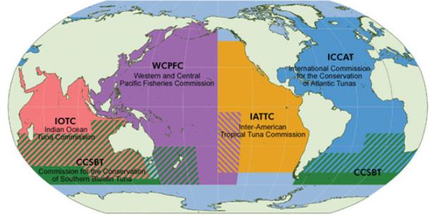

The World Bank (WB) and FAO studied and summarized the status and value of fisheries sustainability in the landmark report, Sunken Billions: The Economic Justification for Fisheries Reform, first published in 2009, and updated in 2017 (see Unit 6 Resources in appendix).
Within an era since the early 1990s that included stagnant and declining fisheries, the 2009 WB/FAO study pointed to a global fisheries crisis based on observations that despite falling catch, the era featured an “increase in the level of fishing by a factor of four.” Even in the face of a doubling of global fleet size and three-times the number of those involved in fishing, catches did not increase.
Uncertainties complicating sustainability include ongoing ocean changes attributable to climate (rising temperatures, changing currents, acidification, rising sea levels). The purpose of the WB/FAO study and 2017 update is to estimate, as accurately as possible, the costs and benefits of achieving sustainable global fisheries, to encourage fishing nations to understand and address the economic loss of $83 billion (2012) that declining fisheries represent (the loss to which the sunken billions report title refers).
The report states that if effort were reduced, the oceans living resources would have a chance to regenerate, leading to four improvements (fish biomass by a factor of 2.7, 13 percent increase in annual harvest, 24 percent increase in unit prices in part because of recovery of high-value species severely depleted, and annual net benefits increase from $3 billion to $86 billion).
Sunken Billions hypothesized two ways to generate recovery. Although unpopular and therefore impracticable, the first option listed in the report nonetheless provides useful comparison: fishing effort reduced to zero followed by maintaining effort at some level deemed optimal. The report estimates this method would recover over “600 million tons in five years and then taper off…” The report’s second hypothetical method is to reduce global fishing effort by five percent per year for a decade. The report estimates the second method would bring fisheries to the same level (600 million tons) in around 30 years.
An FAO report (State of World Fisheries and Aquaculture 2016) finds 31.4 percent of commercial fish stocks worldwide are presently fished at a level that is not sustainable, three times the 1974 level. Offset by aquaculture, worldwide fish consumption rose above 20 kilograms per year for the first time. The role of aquaculture is considerable: FAO reports that, in 2014, 35 countries (3.3 billion people, or 45 percent of world population) “produced more farmed than wild-caught fish.

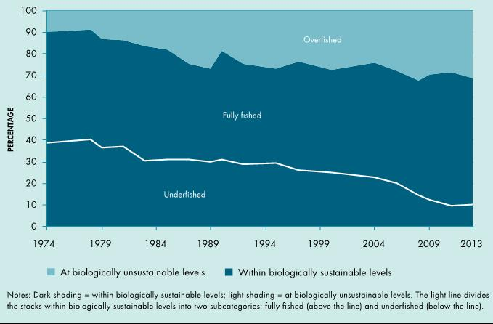

Figure 6.2
The RFMOs, as they gain scientific and compliance capacity, are uniquely positioned to lead fisheries recovery and sustainability. They are the backbone network of international fisheries management.
The United Nations Convention on the Law of the Sea (UNCLOS)
For convenience, the provisions of the Convention most pertinent to this unit are provided in the appendix of resources for Unit 6. They are:
Part V, EEZ Articles 61 – 68
Part VII The High Seas
- Conservation and Management Articles 116-120
- Environmental Protection including Pollution Articles 207-212
Enforcement Articles 213-22

UNCLOS is aptly known as the ocean’s constitution because it provides a holistic vision of cooperative ocean governance spanning the exploitation and management of living and nonliving resources, navigation, marine environmental protection, the resolution of disputes, and scientific research.
Over coming years, areas likely to be revised or expanded might include modernizing the Convention’s fisheries provisions, and the sections on deep seabed (“the Area” designated as part of the heritage of all humankind) issues, especially pertaining to mining of manganese and other valuable metals.
In reviewing the Convention’s sections on fisheries, you may notice the (now familiar) maximum sustained yield (MSY) metric. The Convention’s emphasis on MSY is becoming controversial among some international fisheries experts. The Convention is increasingly faced with complex realities of overfishing, itself a product of multiple forces (weak governance and enforcement, high product market values, fleet overcapacity, or ever-advancing capture technologies). Moreover, the oceans are undergoing profound change (increasing acidity, water temperature, melting ice). Management paradigms in wealthier nations, such as robust science-based management, and ecosystem-based management (EBM) could help inform more prudent decision-making. However, the funding, technology and capacity that could support contemporary tools to improve the concept of MSY toward decreasing overfishing can be lacking in developing nations.
The Convention’s myopic emphasis on the fish themselves (total allowable catch, size, quotas) completely overlooks enormous pressures represented by larger environmental and economic forces. Some experts would like to see MSY modernized and more nuanced to take into account important contemporary influences on global catch including data on global and regional fleet count, boat size, gear types, and fisheries subsidies, as well as area-based bans and moratoria (Hey, 2012).
Conflict Management in the Convention
UNCLOS provides four separate systems for dispute resolution; these feature forums that are third-party, formal, and compulsory. Article 287(1) states that parties in dispute may choose from the International Court of Justice (ICJ), the International Tribunal on the Law of the Sea (ITLOS, under Annex VI), a special arbitration form (Annex VII, the default forum) and a fourth tribunal (Annex VIII) that oversees fisheries, scientific, environmental, and navigation questions.
The following sites provide insights into current controversies.
International Court of Justice (ICJ, The Hague, Netherlands)
The International Tribunal on the Law of the Sea (ITLOS, Hamburg, Germany)
Unit 6 Resources (appendix) contains excerpts from UNCLOS that are relevant to international fisheries management and many other useful global fisheries references.
Unit 7 will present aspects of current problems in ocean management.
Notes: Hey E (2012), The Persistence of a Concept: Maximum Sustainable Yield, 27 The International Journal of Marine and Coastal Law, 763-771.

Unit 6 Study Questions
- Should nations that are meeting management and sustainability goals share technology and expertise with nations that are falling short? If so, what existing forums or processes do you recommend serving as vehicles for progress?
- What is at stake nationally and internationally in the case of declining and overfished species?
- While there are still important stocks being rebuilt, the United States and North America as a region, are among the most well regulated fisheries internationally, with notably smaller fleets. Based on what you know from the readings in Unit 4 and elsewhere, what key principles and tools might underlie these successes?
Unit Six Appendix

Unit 7 - Current Problems in American Ocean Management: Illegal, Unreported, and Unregulated (IUU) Fishing

Current Problems in American Ocean Management

Contents
Introduction
Enforcement
High Seas Task Force
Introduction
In Unit 5, we looked at examples of how law deals with some contemporary, urgent ocean impacts. Unit 6 shed light on how international fisheries are managed. Unit 6 will provide an overview of tools available to confront the major, complex and serious global problem of illegal fishing. The purpose of this unit is to set the stage by providing an introduction and overview to IUU fishing.
Estimates of IUU fishing vary from 15-30% of global catch, robbing the poorest coastal nations of upwards of $1 billion annually. The drivers include high seafood demand, high profits with lower perceived risks in the context of a product that historically defied detection of illegality. The United Nations Food and Agriculture Organization, FAO defines IUU here.
Illegal fishing refers to activities:
Conducted by national or foreign vessels in waters under the jurisdiction of a state, without the permission of that state, or in contravention of its laws and regulations;
Conducted by vessels flying the flag of states that are parties to a relevant regional fisheries management organization but operate in contravention of the conservation and management measures adopted by that organization and by which the States are bound, or relevant provisions of the applicable international law; or in violation
of national laws or international obligations, including those undertaken by cooperating states to a relevant regional fisheries management organization.
Unreported fishing refers to fishing activities:
Which have not been reported, or have been misreported, to the relevant national authority, in contravention of national laws and regulations; or activities
undertaken in the area of competence of a relevant Regional Fisheries Management Organization (RFMO), which have not been reported or have been misreported, in contravention of the reporting procedures of that organization.
Unregulated fishing refers to fishing activities:
In the area of application of a relevant RFMO that are conducted by vessels without nationality, or by those flying the flag of a state not party to that organization, or by a fishing entity, in a manner that is not consistent with or contravenes the conservation and management measures of that Organization; or in areas or for fish stocks in relation to which there are no applicable conservation or management measures and where such fishing activities are conducted in a manner inconsistent with State responsibilities for the conservation of living marine resources under international law.
The topic of IUU is constantly evolving. Governments, grassroots nonprofits, and even celebrities are becoming more involved (if you are intrigued, check out Global Fishing Watch, founded by Leonardo DiCaprio and Google http://globalfishingwatch.org).
As a beginning point, the 2006 reauthorizations to the Magnuson Stevens Fishery Conservation and Management Act included much-needed attention to stocks outside US waters. The reauthorizations provide the Commerce Secretary with the ability to monitor high seas fisheries, including stocks that are subject to international agreements and governing bodies. The 2006 updates initiated a suite of powerful improvements in international monitoring and information sharing, communication between enforcement agencies, and registry for vessels. The reauthorization established a process for the US to identify and then work with specific nations that have lax fisheries enforcement. Those countries may then take action to achieve greater compliance, and if successful then receive “certification” of their fisheries by the US.
To read the text of the MSA section on Illegal, Unregulated or Unreported (IUU) Fishing, go to 16 USC § 1826j):https://www.law.cornell.edu/uscode/text/16/1826j
For more about the strengthening of MSA’s enforcement provisions, explore here.
In conjunction with the 2006 MSA changes, the US focused on achieving greater cooperation with other nations through strengthening the Moratorium Protection Act (16 USC 1826d-k). The Secretary of Commerce reports progress to Congress every two years about consultations with countries with vessel offenses. The Moratorium Protection Act also provides for the Secretary, along with the Secretary of State and regional councils to undertake actions to improve international fisheries management. Within the organizations in which the US is a member, the US is authorized to urge regional fisheries organizations to do any of the following:
- Incorporate multilateral market-related measures against member or non-member governments whose vessels engage in IUU fishing.
- Seek adoption of lists that identify fishing vessels and vessel owners engaged in IUU fishing.
- Seek adoption of a centralized vessel monitoring system (VMS).
- Increase use of observers and technologies to monitor compliance with conservation and management measures.
- Seek adoption of stronger port State controls in all nations.
- Adopt shark conservation measures, including measures to prohibit removal of any of the fins of a shark (including the tail) and discarding the carcass of the shark at sea.
- Adopt and expand the use of market-related measures to combat IUU fishing, including import prohibitions, landing restrictions, and catch documentation schemes (CDSs).
The MSA definition of IUU fishing 16 USC 1826j(e)2(A-C):
(A) fishing activities that violate conservation and management measures required under an international fishery management agreement to which the United States is a party, including catch limits or quotas, capacity restrictions, bycatch reduction requirements, and shark conservation measures;
(B) overfishing of fish stocks shared by the United States, for which there are no applicable international conservation or management measures or in areas with no applicable international fishery management organization or agreement, that has adverse impacts on such stocks; and
(C) fishing activity that has an adverse impact on seamounts, hydrothermal vents, and cold water corals located beyond national jurisdiction, for which there are no applicable conservation or management measures or in areas with no applicable international fishery management organization or agreement.
Very relevant is the Secretary of Commerce’s duty to encourage other nations to adopt measures to prevent trade in fish products taken through IUU practices, bringing in important market forces relevant to traceability (putting systems in place at each step of the custody or supply chain that identify the fish in commerce from ocean to table).
According to Lewis and others (2017) seafood traceability is expanding as a tool to confront estimated IUU fishing losses of $10 to $23.5 billion per year (11 to 26 million tons, citing Agnew et al. 2009). As of January 2018, the new Seafood Import Monitoring Program will intercept at-risk seafood entering the US (see fisheries.noaa.gov/topic/international-affairs). The Monitoring Program will focus on eleven priority species: Atlantic and Pacific Cod, blue crab, mahi mahi, grouper, king crab, sea cucumbers, red snapper, sharks, swordfish and tunas. The monitoring will expand to shrimp, abalone and other species in the future.
Trade-related environmental measures (TREMs) can be more successful if accompanied by planning that begins with diplomacy and possible aid, and emphasizes a collaborative approach. Other tools used to combat IUU fishing have included prohibitions on landing, catch documentation requirements, import permits, direct bans on imports, and mandatory labeling schemes. For an example of traceability efforts, check out Fish Tracker Initiative that seeks to “align capital markets with sustainable fisheries management.”
The 2015 and 2017 Reports to Congress provide details about the accomplishments of the previous two years with regard to IUU fishing, bycatch (including seabirds), and shark conservation: https://www.fisheries.noaa.gov/international-affairs/identification-iuu-fishing-activities#magnuson-stevens-reauthorization-act-biennial-reports-to-congress
An interesting international case example of efforts to reduce IUU fishing in the Patagonian Toothfishery off Chile, is available at the site from the Commission for the Conservation of Antarctic Marine Living Resources (CCAMLR). CCAMLR’s conservation, licensing and enforcement program has had some success in reducing IUU fishing in this high-value fishery.

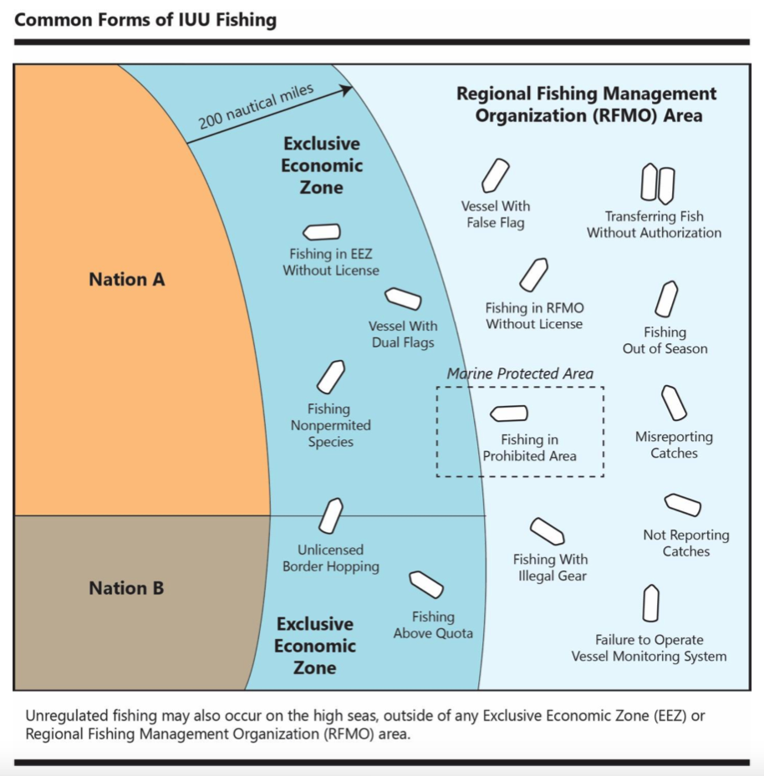

Figure 7.1: Graphic courtesy of
In addition to threatening an important supply of protein for the 4.3 billion people who depend on subsistence fisheries, IUU fishing also engages in devastating practices that include the use of dynamite, kerosene or fertilizer (“blast fishing”) or cyanide fishing, or gear that damages or destroys crucial habitats such as reefs. It is thought that IUU fishing disproportionately affects poor coastal communities.
In some cases, IUU fishing is directly linked to organized crime, with an unquantified portion tied to corruption (bribery of officials for example). In untold human cost, IUU often features forced labor, and is linked to human trafficking/slavery. IUU is known to contribute to piracy.
Finally, observers agree that climate change effects will reduce catch potential, captured in this graphic from IPCC (2014). The areas the most vulnerable reflect poor coastal countries (including Kenya, Madagascar, Mauritius, Seychelles) that rely on subsistence fishing. The following graphic illustrates potential changes in catch by 2060.

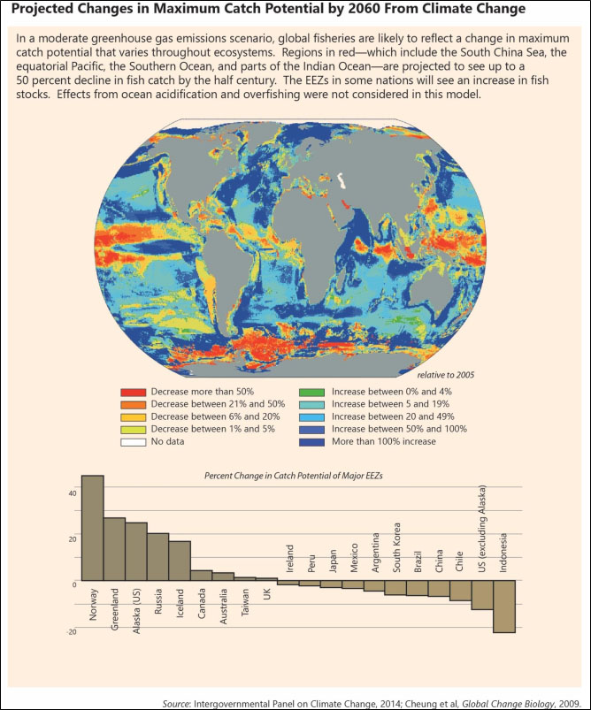

Enforcement
Enforcement on the high seas is challenging because of the vast area to be patrolled. Under UNCLOS, Coastal States are responsible for vessels flying their flag. However, while the vessels themselves are liable, the contours of flag State liability are ambiguous. A 2015 Advisory Opinion from the International Tribunal on the Law of the Sea (ITLOS) found that flag States must exercise due diligence. Closer to shore, coastal states must prevent IUU fishing. In international waters (beyond 200 nm) flag States have only general responsibilities to ensure normal regulation of vessels, compliance with applicable treaties, and adherence to best practices.
High Seas Task Force
In 2006, a task force made up of NGOs (World Wildlife Fund, International Union for the Conservation of Nature, and Columbia University’s Earth Institute) and government representatives from Australia, Canada, Chile, Namibia, New Zealand, and the United Kingdom published nine proposals within a report, Closing the Net: Stopping Illegal Fishing on the High Seas.
The proposals included specific action steps.
Proposal 1 International *MCS Network
Proposal 2 Global information system on high seas fishing vessels
Proposal 3 Participation in UNFSA and FAO compliance agreement
Proposal 4 Promote better high seas governance
Proposal 5 Adopt and promote guidelines on flag state performance
Proposal 6 Support greater use of port and import measures
Proposal 7 Fill critical gaps in scientific knowledge and assessment
Proposal 8 Address the needs of developing countries
Proposal 9 Promote better use of technological solutions
*International Monitoring, Control and Surveillance (MCS) Network for Fisheries Related Activities (imcsnet.org).
More recently, according to the Organization for Economic Cooperation and Development (OECD), the Task Force formed an independent panel of experts to create a governance model for the Regional Fisheries Management Organizations (RFMOs) to serve as a standard or benchmark for RFMO self-evaluation.
The panel published a set of best practices in 2007 (https://www.oecd.org/sd-roundtable/papersandpublications/39374297.pdf). The impressive document contains the statement that a flag state member of an RFMO should only authorize vessels to fish to the extent that it can effectively exercise its conservation and management responsibilities under UNCLOS, thereby tying compliance ensurance to initial licensing.
Unit 7 Resources in the appendix contains information relevant to IUU Fishing.
Unit 8 will look at how offshore energy leasing works.
Notes
Lewis SG, Boyle M (2017). The Expanding Role of Traceability in Seafood: Tools and Key Initiatives, 82 Journal of Food Science S1, A13 – A21.
Agnew D, Pearce J, Pramod G, Peatman T, Watson R, Beddington JR, Pitcher J (2009). Estimating the Worldwide Extent of Illegal Fishing. PLoS ONE 4(2):e4570. https://doi.org/10.1371/journal.pone.0004570.

Unit 7 Study Questions
- What conditions contribute to IUU fishing?
- If solving IUU fishing involves addressing those conditions, what kinds of tools are available in addition to law and policy?
- Technology-based solutions to monitoring IUU fishing and intercepting illegal catch are developing rapidly. Are they sufficient alone? Are social and economic interventions necessary?
Unit Seven Appendix

Unit 8 - U.S. Management of Offshore Energy

U.S. Management of Offshore Energy

Contents
Introduction
The Submerged Lands Act
The Outer Continental Shelf Lands Act
Offshore Renewable Energy: Wave, Wind, Current, Tidal Energies
Introduction
While most marine management professionals may never encounter energy leasing in their careers, understanding how US ocean energy leasing works is important for several reasons. Leasing, exploration, and extraction can be planned to avoid space conflicts with other ocean uses, these activities potentially impact our ocean ecosystems and resources, and we are consumers of minerals and energy whether it is oil, gas, or electricity potentially powered by wind, waves, tides, or currents.
The provisions of the Endangered Species Act (Unit 2) in Sections 7 and 9 apply to activities related to energy; offshore activities such as oil exploration and the construction of wind turbines require permits (from the Federal Energy Regulatory Commission (FERC) or the Bureau of Ocean Energy Management at the leasing phase (BOEM)) for incidental take, and such activities may not cause a threatened or endangered species to be jeopardized. Leasing within specific regions including portions of Artic seas may be covered by programmatic biological opinions.
This unit will briefly look at how the US manages the exploration and leasing of offshore energy resources (minerals, oil, gas, and alternatives such as wind, wave, tidal and current energy).
The Submerged Lands Act
In order to establish certainty following years of lawsuits between coastal states and the federal government about jurisdiction, in 1953 Congress passed the Submerged Lands Act (SLA, 43 USC §1301 et seq.) to simultaneously quitclaim most federal rights, and establish state rights, in the navigable waters and adjacent seabed within nearshore waters to the coastal states. The SLA applies to waters and submerged areas within three miles (except for the Gulf Coasts of Texas and Florida which extend to three marine leagues or 12 miles due to historic claims). The Act confers jurisdiction, management and stewardship responsibilities to the coastal states, with exceptions. The federal government reserves traditional authorities under with regard to “the use, development, improvement, or control by or under the Constitutional authority of Congress to regulate or improve navigation, or to provide for flood control, or the production of power…” (43 USC § 1311 (d)).
Undersea cable is an example of a seabed use requiring leases and permits. Applications include undersea communications cable, and electric cable used to connect offshore energy installations such as wind energy facilities to the mainland. During the project application and planning phase, companies must be authorized through seabed leases in order to install cable necessary to the project. Both examples (communication, energy) would require both federal (Bureau of Ocean Energy Management, within the US Department of the Interior) and state leases and permits since the cable covers the span of both seabeds.

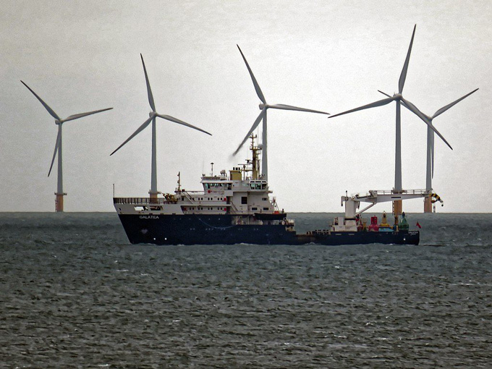

Figure 8.1 Cable ship deployed to support offshore wind energy generation and transmission to shore.
In state waters, one or more agencies in each coastal state will be involved in reviewing lease applications of the state’s seabed area. The financial proceeds from leases generate revenue for the state, although the fees are often modest. Proposed projects and activities requiring federal permits and licenses within state waters must be consistent with the state’s coastal zone management plan under the US Coastal Zone Management Act of 1972 (CZMA 16 USC Ch. 33 §1451 et seq.).
In Oregon, seabed regulation is divided between two agencies. The Oregon Division of State Lands (DSL) authorizes, permits, and oversees activities involving the seabed and Oregon Department of State Land Conservation and Development (DLCD) handles Coastal Zone Management Act (CZMA) Section 7 federal-state consistency review. The CZMA is covered in Unit 9 on US Coastal Management.
The Outer Continental Shelf Lands Act
Five-year leases for the exploration, development and production of minerals, oil and gas within three to 200 miles offshore are governed by Section 18 of the Outer Continental Shelf Lands Act of 1953 (OCSLA, 43 USC §§1331-1356). OCSLA Section (B) includes the recognition that offshore resource development can have adverse impacts on coastal states, and provides that a portion of the lease receipts from the OCS is available for coastal states and localities to use for mitigation of “adverse economic and environmental effects related to the development of such resources.” Section C provides that coastal states and local governments “are entitled to an opportunity to participate, to the extent consistent with the national interest, in the policy and planning decisions made by the Federal Government relating to exploration for, and development and production of, minerals of the Outer Continental Shelf.”
The term Outer Continental Shelf (OCS) pertains to all submerged lands seaward and outside of the area beneath navigable waters subject to US jurisdiction and control, a definition that adheres to the Law of the Sea (UNCLOS). The US State Department defines the extended shelf (or the ECS, beyond 200 miles from shore) as that part of the shelf beyond our EEZ, currently being studied and mapped here. A BOEM presentation features a useful flowchart (below) of steps in the pre-lease and post-lease phases of oil and gas exploration and development.
In 2016, the US generated around 91% of the energy consumed, with the remainder accounted for by net petroleum imports which have been decreasing for several years, a reduction that also implies fewer oil tankers importing foreign oil to US ports. Fossil fuels (natural gas, petroleum, and coal) still comprise most US energy production (US Energy Information Administration).

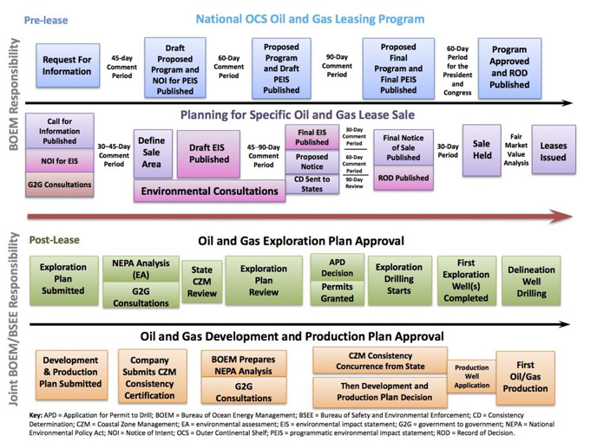

The national leasing program undergoes periodic changes due to the priorities of Congress and whatever political administration is in power. For example, in April 2017, Executive Order (13795) announced an expansion of offshore leasing to access increased domestic oil and gas supplies. The new leasing program will affect 2019-2024 and will replace all or part of the approved, previous 2017-2022 program. A one-page history of oil drilling (by the US Marine Mammal Commission) is available access it here. In contrast to recent calls for a massive expansion of US offshore areas to oil and gas drilling, in economic reality the chance of ever exploiting those areas may be small. A recent report summarized it this way. “Almost two-thirds of the nation’s oil reserves that companies can hope to drill for while still turning a profit lie in seas already open to drilling…The abundance of cheap oil and gas from onshore fracking in the United States has already diminished the incentive for companies to go drill in new offshore zones.” The article also notes the enormous risks and costs involved in investing in new offshore wells. (New York Times, 2018). For information on the longstanding moratorium on US West Coast (CA, OR, and WA) offshore drilling and former President Obama’s action to extend the West Coast moratoria, see here.
The final Programmatic Environmental Impact Statements (PEIS) for the original 2017-2022 oil and gas program, and the final Record of Decision (ROD) for the original plan, are available here. Any time a federal action (including granting permits or leases) poses any impacts that are economic, social, or environmental, the lead agency must prepare a mandatory Environmental Impact Statement (EIS), under the National Environmental Policy Act of 1969 (NEPA 42 USC §§4321 et seq.).



Figure 8.3 Offshore Oil Rig. From
Recall that all revenue-producing activities within coastal waters and the United States EEZ must, by law, conserve and protect ecosystems and natural resources as well as provide a fair market return to coastal states and the nation, since the oceans are common property and the state and federal government have a mandatory stewardship responsibility as the Trustee. This responsibility is embedded in the language of SLA and the OCSLA, and is the reason for detailed environmental review documentation.
Offshore Renewable Energy: Wave, Wind, Current, Tidal Energies
The SLA and OCSLA also pertain to offshore renewable energy, which consists of energy derived from wind, waves, tides, or currents. These renewables have varying pros and cons, cost per kW hour and other economic considerations, and empirical environmental data depending on location. However, over time the cost of many offshore renewables is decreasing as the designs become more efficient.
The Bureau of Ocean Energy Management oversees leasing and permits connected to wind power. This jurisdiction was granted in the Energy Act of 2006.
Wind energy is the most advanced and established so far, and the United States first offshore wind project came online through the Block Island Wind Farm in December 2016. As indicated in Unit 3 (Managing Through Specially Designated Areas) offshore energy siting is planned far in advance, after years of collecting scientific data on suitability or sensitivity of offshore ecosystems and input from stakeholders including fishermen and recreationalists, mapping and zoning of the substrate and overlying waters.
The facilities can serve as data collection sites on wildlife. Wind energy installations on land or at sea have potential impacts to wildlife. As of September 2017 the facility at Block Island (off Rhode Island) became one of 40 tracking stations on the East Coast for collecting data on migrating seabirds and bats using VHF technology in conjunction with US Fish and Wildlife Service.

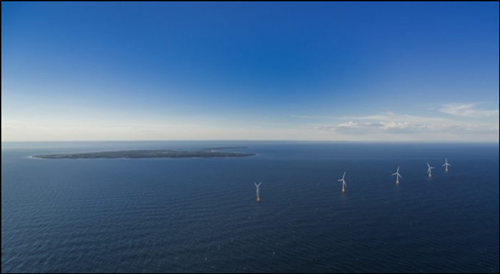

Figure 8.4:
While each individual project site will have its own EIS under NEPA, BOEM developed a programmatic EIS for the whole US offshore wind program in 2007. This PEIS is available at: boem.gov/Guide-To-EIS/.

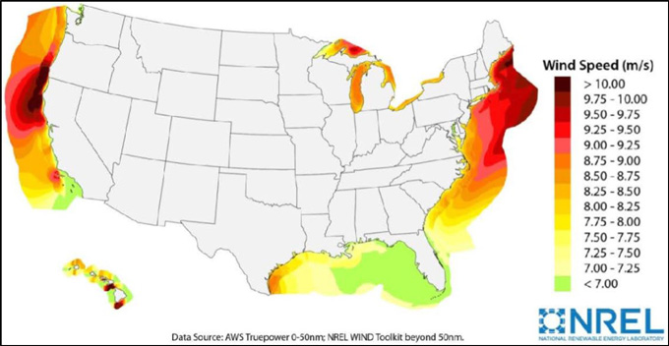

The regulations pertinent to leases for OCS renewables are located in 30 CFR Ch. V Subpart B, 500.200-585.437 (inactive link as of 05/19/2021). BOEM also provides information on the regulatory framework for offshore wind, and links to learn more about offshore wind, wave, current and even solar energy: boem.gov/Offshore-Wind-Energy/ (inactive link as of 05/19/2021).
At least fifteen coastal states (California, Delaware, Florida, Georgia, Hawaii, Maine, Maryland, Massachusetts, New Jersey, New York, North Carolina, Oregon, Rhode Island, South Carolina, and Virginia, in addition to regional proposals) had some offshore renewable energy projects under development at the end of 2017. A map and a list linked to specific information by state is available at: boem.gov/Renewable-Energy-State-Activities/. Offshore renewables are only one part of states’ renewable energy portfolio standards (REPS) that include other sources such as solar.
California, as a geographically large and populous (39.5 million) state, makes a useful illustration. The state has a 50% renewable energy goal by 2030. The website of the California Offshore Wind Energy Gateway features news, maps, and information about the state’s progress. California’s offshore wind resources are estimated to offer more than 158,000 Gigawatts (GW) of electricity (a single GW can power up to 350,000 homes). At this scale, clean power offers enormous implications for reducing carbon emissions and their impacts on marine and coastal ecosystems (including the potential for reducing ocean acidification) thus also holding promise for protecting coastal economies such as fisheries.

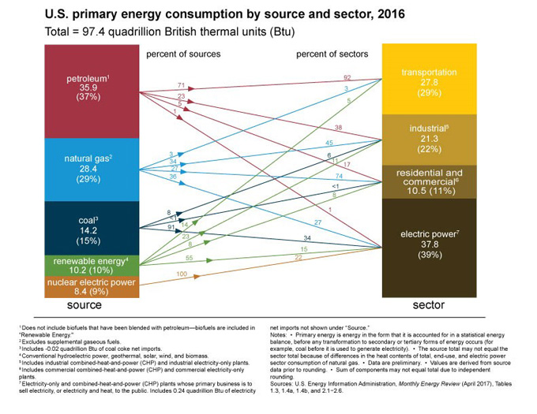

Figure 8.6
Energy generated by water (hydrokinetic) includes electricity from waves, tides, or currents. BOEM (and any coastal states involved) reviews seafloor lease applications for hydrokinetics. The Federal Energy Regulatory Commission (FERC) governs hydrokinetic energy installations under the Federal Power Act (FPA) of 1935 (16 USC Ch. 12). FERC reviews applications, siting and environmental documents for hydrokinetic pilot projects (three-year permits for trials) and 30-50 year licenses for proven technologies in accordance with state comprehensive plans as dictated by the FPA. To date, very few hydrokinetic projects have been licensed (see FERC Hydrokinetics site).
Unit 9 will present the framework for management of the framework and partnership between the federal government (through NOAA) and the 35 coastal states, which include the Great Lakes, for managing shorelines and resources in coastal waters.
Notes
Tabuchi H, Wallace T (2018) Trump Would Open Nearly All US Waters to Drilling. But Will They Drill? The New York Times, January 23, 2018. Comparing the oil exploration of three presidents, with maps: nytimes.com/interactive/2018/01/23/climate/trump-offshore-oil-drilling.html

Unit 8 Study Questions
- If the OCSLA anticipates participation of coastal states and localities in decision-making, what does this imply about levels of scrutiny for environmental review? What are some of the stakes for coastal states with proposed leasing in or adjacent to their waters? Why did Congress include these provisions in the statute?
Unit Eight Appendix

Unit 9 - Coastal Management in the United States

Coastal Management in the United States

Contents
Introduction
The Public-Private Mosaic
The Coastal Zone Management Act of 1972
The CZMA Nonpoint Source Pollution Provisions
Introduction
As discussed in Unit 1, the ocean economy worldwide is vast, diverse, and a major contributor (in the US alone, its worth was estimated at $117 billion with over 2 million jobs in 2000). Coastal areas contribute an even larger share of the US economy, more than $1 trillion or a tenth of the annual GDP, according to the US Commission on Ocean Policy (2004). In addition to rich biodiversity and valuable fisheries, ocean and coastal areas provide ecosystem services including climate moderation and protection from storms. Managing the interface of land and water is a complex work in progress. This unit examines the tools within the Coastal Zone Management Act of 1972.

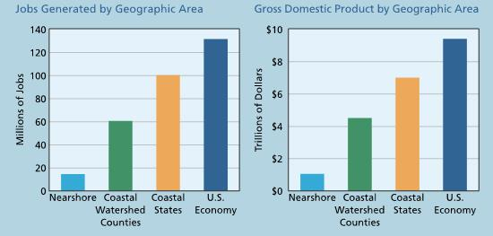

Figure 9.1 The Value of US Coasts
.
The Public-Private Mosaic
In contrast to the public oceans and coastal waters, the terrestrial coast is a complex patchwork of private and public lands. This mosaic of land use and the way it is managed individually and in aggregate has enormous implications on the biological intactness and quality of coastal forests, watersheds and the adjacent ocean, biodiversity, recreational opportunities, capacity to buffer the impacts of storms. Within and apart from the state-federal partnership tools within the CZMA, everyday local planning and land-use decisions matter and can have cumulative and long-ranging impact.
Although each state coastal management program (CMP) is unique, the programs address the broad spectrum of coastal issues identified as priorities by Congress in the CZMA. In reality, the national impact of the Coastal Zone Management Program is the result of many thousands of state and local decisions that impact the management and development of the coastal area. For example, a 2013 NOAA study analyzes the value of using “no-build areas” to protect the shoreftont, revealing the multitude of levels of government and methods used to advance shorefront protection.
Fletcher KM 2015

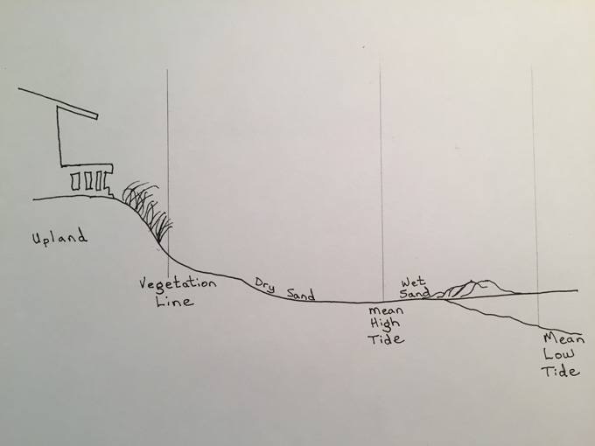

While public land beach divisions vary among coastal states, in general in the US common-law private ownership extends above the Mean High Tide (MHT) line, while the wet sand and submerged lands are vested in the state. In some states for historic reasons (Delaware, Maine, Massachusetts, Pennsylvania, Virginia) private rights may include the area to the Mean Low Tide (MLT) line. Coastal states hold legal title as public trustees to coastal waters and substrate and these rights are nontransferable.
Private landowners on waterways have special common law rights in conjunction with their property. Although the terms may be used interchangeably, littoral rights refer to rights pertaining to tidal waters; riparian rights refer to rights pertaining to freshwater. Such rights may include, for example, the right to build a dock or wharf. However, private and state rights are subordinate to important exceptions. The federal government retains two major interests in the coastal zone: navigation and navigation safety. Because of the federal navigation servitude, constructing a dock or wharf requires a permit authorized by the US Army Corps of Engineers.
Coastal states and the federal government interests and responsibilities in the coastal zone are increasingly visible and urgent. These priorities include public safety, flood control, hazard prevention and mitigation as illustrated by the impacts from recent hurricanes such as Harvey (August 17, 2017, $125 billion in damages), Katrina (August 2005, $108 billion in damages), Sandy (October 2012, that set the record for largest Atlantic hurricane) and Irene (September 2011). The major framework for coastal protection and the partnership is laid out in the Coastal Zone Management Act CZMA). The two most prominent features of the CZMA for the purposes of this Unit are the provisions regarding consistency with coastal CMPs, and the provisions on nonpoint source water pollution.
The Coastal Zone Management Act of 1972 (CZMA, 16 USC § 1451 et seq.)
The policy statement of CZMA contains a long list of Congressional priorities of resource protection, state assistance, and minimizing life and property loss, improving water quality, and improving public access (coast.noaa.gov/czm/act/sections/#303). Two pillars of the framework are state coastal management programs, which oversee and carry out their state coastal management plans (CMPs).
The 35 individual programs are reviewed, approved, and funded by NOAA’s Office of Ocean and Coastal Resource Management (OCRM). OCRM reviews state CMPs and progress on goals every five years, providing feedback for improvement. Early on, the federal funding provided a major incentive for participation; the annual funding allocations have decreased over time. A second incentive for states to maintain their programs is their right to weigh in on whether or not federally permitted activities should be authorized to take place off their coasts. States regularly review proposed activities to evaluate whether they are consistent with CMP enforceable policies.
The CZMA’s three main purposes are to encourage states to engage in proactive comprehensive planning in relation to the land and water uses in the coastal zone, to improve coordination and communication in governance (municipalities, Tribes, etc.), and to preserve, protect, and restore natural resources in the coastal zone.
In order to be valid, CMPs must include specific elements set forth in the statute (16 USC § 1455(d), see https://www.law.cornell.edu/uscode/text/16/1455). These elements form the basis of state management, and contain goals and priorities with which proposed activities requiring federal permits must comply under CZMA Section 307. Moreover, CMPs include all enforceable policies within a state’s coastal zone.
Basically all federal activities, or activities that require a federal permit inside or outside the coastal zone, may be reviewed if is reasonably foreseeable that the activity will affect any of the coastal state’s lands, waters, or natural resources. In addition, coastal states may elect to review an activity that is proposed in the waters off a neighboring state (interstate consistency). Anticipated effects may be direct or indirect in time and place. “Reasonably foreseeable” is a factual determination made on a case-by-case basis by the state agency conducting the review.
If a state objects to an activity, it is rare that the activity will proceed. First, if an activity of paramount federal interest, it may fall under a Presidential Exemption (meaning the activity is exempt from CZMA consistency review). Second, the Secretary of Commerce has but seldom uses his/her override discretion to override a coastal state’s objection to a permit. Such an override would be based on one of two grounds: that the proposed activity actually is consistent with the CZMA and CMP, or the activity is necessary due to national security.
Excerpt of Section 307(c)(1) through (3)(A)
(c) Consistency of Federal activities with State management programs; Presidential exemption; certification
(1)(A) Each Federal agency activity within or outside the coastal zone that affects any land or water use or natural resource of the coastal zone shall be carried out in a manner which is consistent to the maximum extent practicable with the enforceable policies of approved State management programs. A Federal agency activity shall be subject to this paragraph unless it is subject to paragraph (2) or (3).
(B) After any final judgment, decree, or order of any Federal court that is appealable under section 1291 or 1292 of Title 28, or under any other applicable provision of Federal law, that a specific Federal agency activity is not in compliance with subparagraph (A), and certification by the Secretary that mediation under subsection (h) of this section is not likely to result in such compliance, the President may, upon written request from the Secretary, exempt from compliance those elements of the Federal agency activity that are found by the Federal court to be inconsistent with an approved State program, if the President determines that the activity is in the paramount interest of the United States. No such exemption shall be granted on the basis of a lack of appropriations unless the President has specifically requested such appropriations as part of the budgetary process, and the Congress has failed to make available the requested appropriations.
(C) Each Federal agency carrying out an activity subject to paragraph (1) shall provide a consistency determination to the relevant State agency designated under section 1455(d)(6) of this title at the earliest practicable time, but in no case later than 90 days before final approval of the Federal activity unless both the Federal agency and the State agency agree to a different schedule.
(2) Any Federal agency which shall undertake any development project in the coastal zone of a state shall insure that the project is, to the maximum extent practicable, consistent with the enforceable policies of approved State management programs.
(3) (A) After final approval by the Secretary of a state’s management program, any applicant for a required Federal license or permit to conduct an activity, in or outside of the coastal zone, affecting any land or water use or natural resource of the coastal zone of that state shall provide in the application to the licensing or permitting agency a certification that the proposed activity complies with the enforceable policies of the state’s approved program and that such activity will be conducted in a manner consistent with the program. At the same time, the applicant shall furnish to the state or its designated agency a copy of the certification, with all necessary information and data. Each coastal state shall establish procedures for public notice in the case of all such certifications and, to the extent it deems appropriate, procedures for public hearings in connection therewith……[end of excerpt]
Two flow charts illustrate the CZMA Section 307 review process.

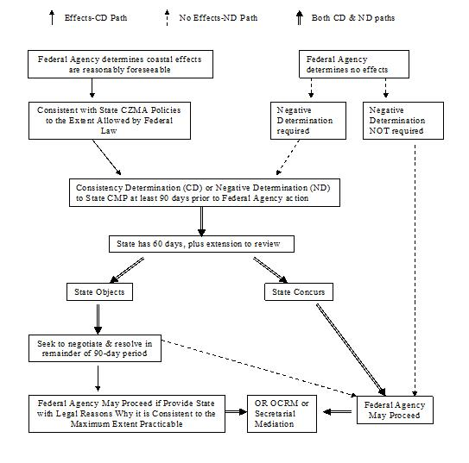

Figure 9.3 Chart illustrating federal agency activities under CZMA § 307(c)(1) (15 CFR part 930 subpart C) From

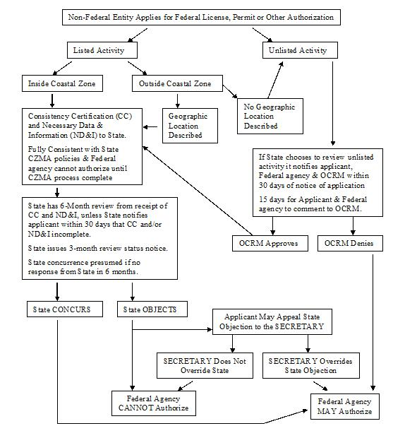

Figure 9.4 Chart illustrating flow of review activities for proposals requiring federal license or permit under CZMA § 307(c)(3)(A) (15 CFR 930, subpart D)
The CZMA Nonpoint Source Pollution Provisions
The 1990 CZMA reauthorization amendments (CZARA) initiated a program of grants to help states improve specific aspects of their programs (protection of wetlands, coastal development’s impacts and development in areas prone to hazards, public access, marine debris, resource planning, and energy siting. CZARA also introduced a program to help control nonpoint source pollution in the coastal zone.
Land use managers in the coastal zone have modest tools within the state’s CMP to help tailor where and what kind of development takes place. In this professional area, property rights challenges based on the Fifth Amendment claim of unlawful “taking” of private property in the public interest without just compensation are always a risk; managers working in this area must consult local and state regulations, their attorneys general and legal cases. There are two general guidelines to keep in mind. The first is that any permanent physical invasion of the land through a government action may be considered a taking. The second guideline is that a court of law may find an ordinance or a land-use decision, if it goes too far, a taking; this is often construed in economic terms (the ordinance or decision has severely interfered with the property holder’s “investment backed expectations,” meaning s/he had to have already completed significant steps and expenditures toward project completion, or the ordinance or decision has left the property holder with no marketable use of her/his property. On the other hand, for example, if a state or local government takes action to prevent coastal erosion through otherwise lawful and valid means, that may be well within the scope of a government action that avoids the risk of a takings claim.
Protection of water quality is a required element in CMPs. The 1990 CZMA amendments (CZARA section 6217) established the Coastal Nonpoint Source Pollution Program (CNSPP) that requires participating states to create programs to control coastal nonpoint source pollution as part of the CMPs. The new nonpoint source (NPS) provisions mirror the relevant provisions within the Clean Water Act (section 319) and the two programs are coordinated. Under the CNSPP, NOAA and the EPA jointly review state nonpoint source pollution programs, and approve (or conditionally approve, with steps and a timeline for achievement or completion). The incentives for states to have approved CNSPP plans are powerful. States that fail to do so lose critical federal funding (CZMA and CWA) to support their CMPs.
The Clean Water Act’s Total Maximum Daily Load (TMDL) provisions can be a useful tool in reducing and preventing coastal nonpoint source pollution, as pointed out in Unit 5 with regard to the expansive and complex sources within the Chesapeake Bay watershed. States periodically report the condition of their water bodies based on whether the waters meet water quality standards sufficient to support their designated uses, with the mandatory baseline being “fishable and swimmable” from the CWA. If waters fall short, the state must define and declare the specific impairments (sediment, biological oxygen demand (BOD), pH, fecal coliforms, for example).
The TMDL program implements a “waste load allocation” to collectively reduce contaminants proportionately from contributing point sources with NPDES permits in order to help recover water quality in an impaired water body. However, when application of the waste load allocation to point sources alone is insufficient to restore water quality, the TMDL can flexibly be extended to NPS regardless of source (air pollution, land runoff, for example).
While the developments since CZARA hold promise, the advancement and practicability of the TMDL and the CNSPP programs to reduce or prevent NPS will depend strongly on coastal state capacity and enforcement in terms of adequate funding, data, science and technical personnel in the field.
In addition to expanding efforts to improve water quality in watersheds adjacent to the coastal zone, states are focused on coastal management tools that include low-impact development, coastal setbacks for new development, and outreach and education on emergency preparedness and hazard mitigation.
Notes
Beach diagram by author, adapted from Kalo et al. (2007) Coastal and Ocean Law Cases and Materials, Third ed. (West Publishers) p. 1, which was adapted from Brower, Access to the Nation’s Beaches: Legal and Planning Perspectives 19-20, 60-61 (1978).
Unit 9 Resources contains additional information relevant to coastal management.
Unit 10 will examine tools and possibilities represented by marine restoration.

Unit 9 Study Questions
- If Professor Fletcher’s observation (quoted above) is accurate, coastal areas may suffer from death by a thousand cuts. Is this a problem of conceptual scale in decision-making? Theorize some tools and methods to support more broadly informed, holistic, and coordinated public decision outcomes for coastal development and coastal management at the local level (municipalities, counties, zoning ordinances).
- What are potential funding mechanisms to support coastal state efforts to stem NPS contaminants from their shores? At the outset, many development projects include upfront fees for sewer and stormwater hookup in order that counties and cities (thus taxpayers) are not solely burdened with these expenses. Are such fees or taxes, were they to be validly based on empirical water quality data derived before and after construction, one possible solution? What kinds of implications does coastal NPS have in the context of groundwater and drinking water, often scarce resources in coastal areas? Fisheries and shellfish? Public health? Recreation in the coastal zone? Property enjoyment and values (when areas suffer harmful algal blooms or beaches are regularly closed due to bacteria or pathogens such as E.coli?)
Unit Nine Appendix

Unit 10 - Restoring Marine Environments: The Roles of Innovative Regulatory, Planning and Human Dimensions Tools

Restoring Marine Environments

Contents
Introduction
Introduction
This unit examines nearshore systems’ value and the contemporary mosaic of tools to restore estuary and bay ecosystems, shorelines, fisheries and wildlife, drawing on concepts from the book’s previous units (EBM, MSP, fisheries recovery, ocean impacts, and so forth). Effective solutions require interdisciplinary and collaborative problem-solving skills you will use across your career in a wide range of professional settings
Reasons to understand management aspects of marine restoration are compelling. Nearshore environments are richest in biodiversity, provide irreplaceable functions and services, and are economically valuable. As with the other complex ocean issues presented in this book, in marine restoration planning, proactive and effective policy is key and early outreach to and involvement of communities and stakeholders is crucial.

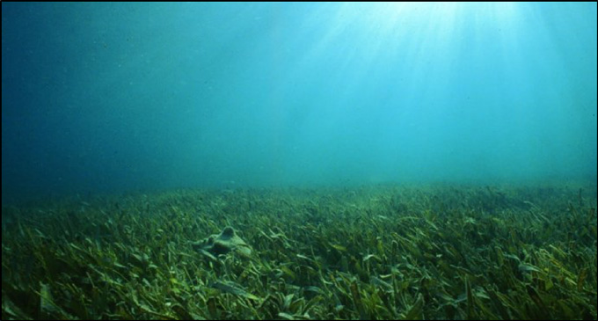

Figure 10.1 Turtle grass bed, Tampa Bay restoration, Smithsonian Ocean Portal
Humans are naturally drawn to water. Pressure from expanding human development invariably increases impacts on coastal ecosystems and the resources on which we depend. Seventy-five percent of Americans will live within 50 miles of the coast by 2075, according to Restore America’s Estuaries.
In the United States, counties directly on the shoreline constitute less than 10 percent of the total land area (not including Alaska), but account for 39 percent of the total population. From 1970 to 2010, the population of these counties increased by almost 40% and are projected to increase by an additional 10 million people or 8% by 2020. Coastal areas are substantially more crowded than the U.S. as a whole, and population density in coastal areas will continue to increase in the future. In fact, the population density of coastal shoreline counties is over six times greater than the corresponding inland counties.
NOAA National Ocean Service
While we want to protect our coasts and enjoy the amenities and support services they provide, these resources are under increasing pressures and global climate change. Between 1998 and 2009, for example, the US lost wetlands acreage larger than the state of Rhode Island. These are lands that had helped absorb and retain floodwaters and storm surge, filter drinking water, provide habitat for myriad animals, birds, and insects and nurseries for fish. According to the Center for American Progress, the US loses more than seven football fields of wetlands every hour (CAP Fact Sheet 2014).
The value of nearshore and estuarine ecological functions and ecosystem services can be difficult to accurately account for. Recent economic studies are helping bring these values into focus. The Center for American Progress’ (2014) Report notes:
An analysis of three federally funded projects reveals that investing in well designed coastal restoration can be highly cost effective, returning significantly more than the cost of the restoration project. Averaging the benefit-cost ratios across the three restoration projects studied, each dollar invested by taxpayers returns more than $15 in net economic benefits.
These benefits include buffering storm surges; safeguarding coastal homes and businesses; sequestering carbon and other pollutants; creating nursery habitat for commercially and recreationally important fish species; and restoring open space and wildlife that support recreation, tourism, and the culture of coastal communities. The benefits are not simply environmental; they are economic and social as well. They are particularly salient in lower-income communities, where individuals frequently rely on fisheries for employment and sustenance and lack the resources to construct costly—and frequently less effective—manmade flood barriers or water treatment facilities. (CAP 2014)
Coastal ecosystems also capture “blue carbon” –these systems (salt marshes, mangroves, seagrass beds, for example) sequester very old carbon at a rate that is ten times greater than other highly valuable planetary systems we normally think of as carbon sinks (forests), and they hold onto it for a very long time (Edwards et al. 2013).
The Restoration Center within NOAA published a report in May 2017, Socioeconomic Benefits of Habitat Restoration (see: ftp://ftp.library.noaa.gov/noaa_documents.lib/NMFS/TM_NMFS_OHC/TM_NMFS_OHC_1.pdf) . The goals of NOAA’s national restoration projects include fish passage, hydrologic reconnection (for example tidal wetlands), shellfish recovery, coral recovery, erosion prevention and control, stabilized shorelines, and other strategies such as removal of marine debris. A major purpose also includes stimulating economic growth in coastal communities, represented by 2,280 direct and indirect jobs, and subsequent increases in coastal tourism dollars spent.

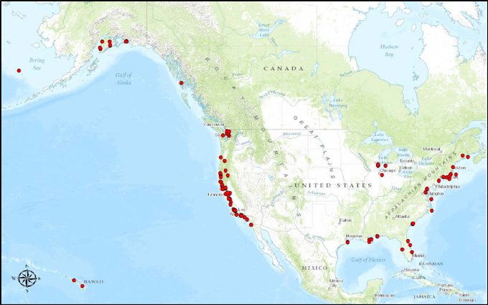

Figure 10.2 Completed US Restoration Projects, NOAA, from $167M American Recovery and Reinvestment Act funds
Congress allotted $167 million to NOAA from the American Reinvestment and Recovery Act of 2009 (ARRA) for the purpose of coastal restoration. The Congressional appropriation allowed 125 competitive projects to be funded. The results included 25,584 acres of restored habitat, 677 stream miles opened to allow fish to reach spawning grounds, and the removal of 433,397 tons of debris. The projects spent $154.1 million that, in turn, generated $260.5 million annually. The result was a value-added of $143.7 million in “new or expanded economic activity nationwide.” (NOAA 2017)

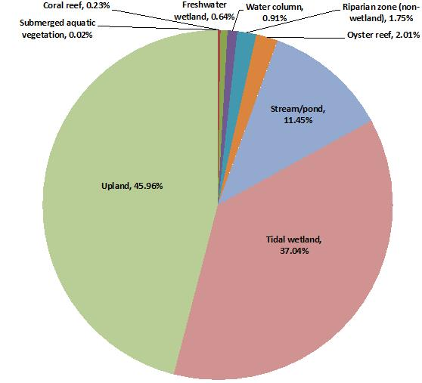

In analyzing a subgroup of NOAA restoration case studies, the Center for American Progress (CAP) found that the average benefit-cost ratio of restoring the coastal ecosystem at three sites was 15.36 (CAP Fact Sheet 2014).
Based on its findings of the results of NOAA’s restorations, the CAP made the following recommendations.
- Public and private sector entities should increase their investment in coastal restoration projects and fund ongoing monitoring of restored areas.
- Congress should enact and fund the National Endowment for the Oceans to provide a steady revenue stream for restoration.
- The state and federal agencies distributing BP oil spill related funds should invest in recovery projects that create employment and support long-term ecosystem recovery.
- Federal, state, and local coastal planners should give greater weight to natural solutions such as wetland restoration to help protect at-risk developed areas.
- The Environmental Protection Agency, U.S. Department of the Interior, and NOAA should work with the Economic Development Administration and the U.S. Department of Labor to develop new pathways into crafts, trades, and science, technology, engineering, and mathematics, or STEM, careers related to ecosystem restoration.
- NOAA and its partners should seek funding to apply the evaluation techniques used in this report to the other AR coastal restoration projects in order to provide a stronger foundation for future coastal land use decisions.
CAP 2014
While Congressional appropriations for coastal restoration ebb and flow across administrations at the national level, on the ground citizens, students, and scientists can help further the work of restoration in their own regions through becoming involved in shaping the future of their beaches, estuaries, and coasts and the plants and animals and other resources that enrich them.
Notes
Edwards PET, Sutton-Grier AE, Coyle GE (2013), Investing in Nature: Restoring Coastal Habitat Blue Infrastructure and Green Job Creation, 38 Marine Policy 65-71.
From NOAA’s Restoration Center, see report from May 2017, Socioeconomic Benefits of Habitat Restoration
ftp://ftp.library.noaa.gov/noaa_documents.lib/NMFS/TM_NMFS_OHC/TM_NMFS_OHC_1.pdf
Center for American Progress/OXFAM (2014), The Economic Benefits of Restoring Coastal Ecosystems,
https://www.americanprogress.org/issues/green/reports/2014/04/09/87438/the-economic-benefits-of-restoring-coastal-ecosystems/

The Resources for Unit 10 contain additional information relevant to marine restoration.
The final unit, Unit 11, will provide thoughts on the future of ocean management.

Unit 10 Study Questions
- The idea of an oceans endowment is intriguing and could gain traction. What are some other funding mechanisms that might be practical and popular in the shorter term?
- A restoration project is often long-term and can offer a “living laboratory” for STEM as well as law/policy and social science. The data that flow from these projects may be used to help inform projects in other regions. What kind of more formal role could education play in coastal restoration programs?
Unit Ten Appendix

Unit 11 – The Future of Ocean Management

The Future of Ocean Management

Contents
Introduction
The Trajectory of US Ocean Governance
On the Horizon
Introduction
How does a technologically advanced nation such as the United States achieve progressive stewardship and governance of its coasts and three million square miles of waters, seabed, and natural resources—not for the present alone but for the future? As the previous ten units’ explorations indicate, the US’ marine policies, laws and basis of scientific knowledge are continually expanding to become more sophisticated, responsive, and nuanced.
In managing our vast ocean wealth as with the country’s terrestrial resources, we seek to make decisions that are sustainable economically, socially, and ecologically (triple-bottom line sustainability) rather than short-sighted and selfish. The stark challenge before our and future generations is for our initial progress to keep pace with growing population and consumer demand, the increased uses of ocean space, and the complex problems we face on a planetary scale as we go about seeking to balance resource exploitation and profit with equitable provision of food, shelter, safety, cultural enrichment, energy, and opportunities for all people to learn and grow to our human potential (see the United Nations Universal Declaration on Human Rights, Unit 11 Resources).
The Trajectory of US Ocean Governance
The timeline encompassing the landmarks of the historic Stratton Commission Report, (Our Nation and the Sea (1964)) through the ambitious and comprehensive ocean commission reports in the early 2000s (PEW, America’s Living Oceans: Charting a Course for Sea Change, June 2003; US Ocean Commission, An Ocean Blueprint for the 21st Century, September 2004) is a single generation. Over the past half century we have taken stock of our enormous ocean wealth, our knowledge, and the achievements and gaps in public policy and the mosaic that is marine law. We have broadened our focus from urgent post-World War II concerns of fishing and food security, industrial development, foreign competition, and military strength to more comprehensively understand broader aspects of marine systems themselves, and the many thousands of benefits they provide, economic and otherwise. We are an ocean nation, as stated frequently, including in the PEW report’s executive summary. The growing awareness of this is, in itself, a powerful movement; we are also an ocean planet and part of an international commons.
Creative solutions in every field including ocean law and policy begin with awareness, connection, and imagination. One of the most important groundbreaking connections is viewing humans as part of the ecosystem, not apart. Law evolution, including in the Magnuson-Stevens Fisheries Act and others presented previously reflect this increased understanding. Another important connection, growing but as yet under-developed, is the realization that wherever we live our everyday choices influence the environment (that both immediately surrounds us, but also far away) including the coastal zone and the oceans. The chapters of this book are replete with examples, from sustainable seafood and other consumer choices, lawn and farm fertilizer practices, transportation and shipping and emissions, single-use plastics and beyond.
It is from the specific place each of us daily finds ourselves that awareness, connection, and imagination emerge to inform our forward movement as individuals, communities and a nation of ocean citizens, regardless of our backgrounds or professions. While problems are complex, immense and pressing, inspiration is available.

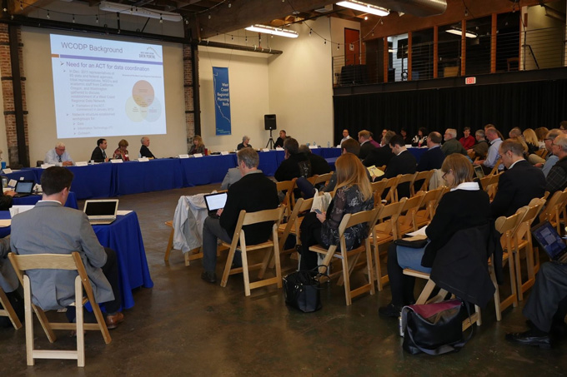

Figure 11.1 Participants meeting, West Coast Regional Ocean Planning Body (from
)
On the Horizon
The deeply informative major ocean policy initiatives of the early 2000s led to important and related ongoing projects (among many innovative goals): coordination and connectivity of coastal management to the larger ocean ecosystem. This led us to embrace ecosystem-based management nationally through ocean mapping and marine spatial planning nestled in five US coastal regions: the Northeast and the Mid-Atlantic (which have been developed, see this December 2016 news release and the links to the new regional planning units, nrdc.org/experts/alison-chase/national-ocean-policy-seven) as well as the evolving West Coast, the Caribbean and the Pacific Islands Planning Bodies (see links in resources for Unit Eleven). These bodies are not regulatory. The voluntary planning bodies support transparency and collaboration through sharing of knowledge, communication and coordination of policy needs and initiatives that are intended to support better decision making and decreased duplication and conflict between policies. The transparency and coordination are necessary to addressing the US ocean policy gaps and weaknesses that the two commissions identified.
In effect, the new planning bodies represent a distillation of the two ocean commisions’ multi-year investigations, evaluations, and findings. It is the regions that will advance the final the goals via their respective data portals and an integrated communication and decision-making framework for the members. Participants in the new regional planning bodies include coastal states, Tribes, federal agencies, the eight regional fisheries management councils, and marine stakeholders (including fishing, recreation, energy, transportation and shipping, telecommunications, and many others). While just beginning, the regional bodies’ efforts, to date, have already had success and represent a culmination of fifty years of policy development and finesse, much of which would not have been possible without advances in stakeholder engagement (ocean resource are our resources), leadership capacity development, ecosystem-based management and concomitant advances in science and technology including ocean observing.

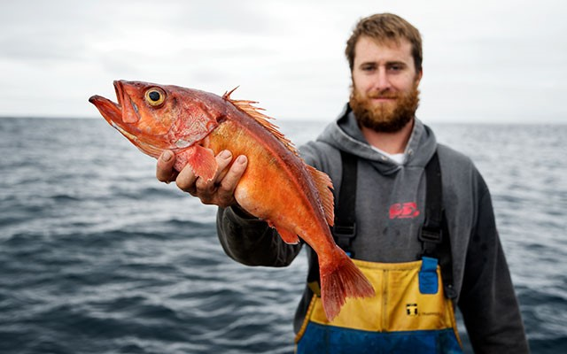

Figure 11.2 Fisherman with Rockfish (from
)
Achieving greater awareness of the consequences of shore-side decisions on the coastal ocean and beyond is a longer-term ambition. An important development used increasingly outside the United States is integrated coastal zone management (ICZM), a logical development in view of the fact that sixty percent of Earth’s population and 21 of 33 coastal mega cities are within the coastal zone (Zacharias 2014). ICZM is also a logical and holistic extension of ecosystem-based management that moves beyond strictly sector-based management to take account of the whole in a systems view of energy inputs, outputs and flows. Tools will evolve to incorporate urban systems, and more importantly their planning for growth, to support science-informed sustainability. (For example, see the Nature Conservancy, Our Oceans Our Future urban planning tool in Unit 11 Resources).
While solid achievements in marine law and policy remain to be accomplished at national and international levels, the hard work and confrontation of uncertainty and risk necessary to take a leadership role in marine management are worth it. The future of this endeavor has never had higher stakes, nor offered greater rewards in terms new discoveries and achievement in innovations in technology, outreach, and engagement between environmental professionals at all levels and ocean citizens from all walks of life.
Inspired by a photo snapped by Voyager 1 (1990) in which the Earth appeared as an infinitely tiny speck of light, astronomer Carl Sagan (1934-1996) saw our watery planet this way; in turn we are inspired:
That’s here. That’s home. That’s us. On it everyone you love, everyone you know, everyone you ever heard of, every human being who ever was, lived out their lives. The aggregate of our joy and suffering, thousands of confident religions, ideologies, and economic doctrines, every hunter and forager, every hero and coward, every creator and destroyer of civilization, every king and peasant, every young couple in love, every mother and father, hopeful child, inventor and explorer, every teacher of morals, every corrupt politician, every “superstar,” every “supreme leader,” every saint and sinner in the history of our species lived there – on a mote of dust suspended in a sunbeam.
Sagan, A Pale Blue Dot: A Vision of the Human in Space (1994)



Unit Eleven Appendix

1

Appendix of Unit Resources

UNIT ONE: Our Public Oceans (A Closer Look at Offshore Uses and Players)
Excerpt from State Management Example: Oregon Territorial Sea Plan (1994)
Adapted from https://www.oregon.gov/lcd/OCMP/Pages/Territorial-Sea-Plan.aspx
PART ONE: Ocean Management Framework
E. OCEAN MANAGEMENT AGENCIES
NOTE: The following descriptions of agency programs and authorities are limited to those that relate to ocean or coastal resources. These descriptions are necessarily brief and not comprehensive.
1. State Agencies
a. Oregon Department of Agriculture
The Department of Agriculture has three interests in the territorial sea. One is the leasing and regulatory functions for oysters (none is grown outside estuaries); the second is regulating the use of TBT (tri-butyltin), a chemical in antifouling paints used to retard the growth of marine life on boat hulls; the third is assisting in the marketing of seafood commodities via seafood-commodity commissions.
b. Oregon Department of Environmental Quality (DEQ)
The Department of Environmental Quality has overall authority for protecting water and air quality in the territorial sea. In addition to authority and responsibility to carry out state pollution laws, the DEQ is authorized to carry out federal pollution-control laws such as the Clean Water Act and regulate discharge of pollutants into marine waters under the federal National Pollutant Discharge Elimination System. DEQ has oil spill prevention and response responsibilities and evaluates state-law mandated oil spill contingency plans, manages oil spill response activities, and provides public education and outreach to volunteer responders. DEQ and its oversight body, the Environmental Quality Commission, has divided the state into water quality basins. Five such basins along the Oregon coast include marine and estuarine waters as well as fresh. “Marine waters” are defined by DEQ rules to mean “all oceanic, offshore waters outside the estuaries or bays and within the territorial limits” of the state. DEQ is also involved in reviewing dredge and fill permits for certification of water quality under Section 401 of the Clean Water Act. DEQ and the ODFW are jointly designated as trustee under state and federal law (CERCLA) to assess and recover compensation for environmental damages from oil spills, water pollution, etc.
c. Oregon Department of Fish and Wildlife (ODFW)
The Department of Fish and Wildlife has broad authority to develop protection programs for fish and wildlife and enforce fish and wildlife laws. The Fish and Wildlife Commission, ODFW’s oversight policy body, has adopted harvest regulations for intertidal animals, fish, and shellfish, including sea urchins. ODFW also has responsibilities for protecting marine mammals, including threatened or endangered species, and sea birds. ODFW provides an increasingly important role as the state’s “marine biological consultant” to other agencies and the Governor on ocean-related programs such as kelp leasing, dredge-material disposal, marine mineral exploration, and ocean discharge of wastes. ODFW and the DEQ are jointly designated as trustee under state and federal law (CERCLA) to assess and recover compensation for environmental damages from oil spills, water pollution, etc.
d. Oregon Department of Geology and Mineral Industries (DOGAMI)
The Department of Geology and Mineral Industries has three primary interests in territorial-sea management. One is regulatory authority over such operations as exploring for and extracting oil, gas, or geothermal resources in the territorial sea and coastal zone and hard minerals, such as sand and gravel, on upland sites. Another is advising the Division of State Lands when that agency issues permits for exploratory geological, geophysical, and seismic surveys in the territorial sea. A third is related to understanding and mitigating for geologic hazards and processes. DOGMI undertakes coastal-hazard assessments and studies for both chronic and catastrophic hazards and conducts programs aimed at reducing loss of life and property.
e. Department of Land Conservation and Development (DLCD)
The DLCD is designated by statute as the state’s Coastal Zone Management Agency for federal coastal management purposes, provides staff support to the Ocean Policy Advisory Council, and administers the state’s land-use program, including Statewide Planning Goal 19, Ocean Resources, and the other 18 statewide goals. DLCD has no direct regulatory authority for ocean resources but, through state-agency coordination requirements and through federal consistency requirements, is the coordinator among all coastal resource agencies to make sure their actions and programs are coordinated with each other, local governments, and the Oregon Coastal Management Program.
f. Oregon Parks and Recreation Department (OPRD)
The Oregon Parks and Recreation Department has several management interests in the Territorial Sea. The ocean beach law designates all of Oregon’s “ocean shore” as a state recreation area to be managed by OPRD. OPRD has regulatory authority over improvements such as sea walls, rip-rap, pipeline and cable crossings, and other construction within the area from the statutory vegetation (beach zone) line seaward to Extreme Low Tide. Within this “ocean shore,” PRD has concurrent jurisdiction with the DSL over submerged and submersible lands seaward of Mean High Water (the so-called “wet sands”). OPRD owns and manages many state parks on the upland adjacent to rocky-shore sites that provide access to rocky shores.
g. Oregon Division of State Lands (DSL)
The Division is the administrative arm of the State Land Board (composed of the Governor, Secretary of State, and Treasurer) which manages the assets (land and money) of the Common School fund and which holds in trust for the people of Oregon all lands under tidal and navigable waters, including rocky intertidal areas and submerged rocks and reefs in the state’s Territorial Sea. In these areas the Division has authority over removal and fill; kelp or seaweed harvest; shellfish harvest (except oysters); geological, geophysical, and seismic surveys;, oil, gas, and mineral leasing; and easements or other rights-of-entry for various uses.
h. Oregon State Marine Board
The Marine Board has authority to regulate boating activities in state waters, including the Territorial Sea. The Marine Board, through boater education and publications, can assist in education and awareness of wildlife resources affected by boating activity.
2. Federal Agencies
NOTE: The following descriptions of agency programs and authorities are limited to those that relate to ocean or coastal resources. These descriptions are necessarily brief and do not purport to be comprehensive.
a. United States Army Corps of Engineers (USACOE)
The Corps is responsible for building and maintaining coastal navigational projects, including jetties, navigation channels, and navigational structures under the Rivers and Harbors Act (33 USC 401 – 709b and 2201 – 2329). Material dredged from coastal ports is frequently disposed in ocean waters at sites designated by the Environmental Protection Agency (EPA). Placement of dredged materials at these ocean sites is regulated under sections 102 and 103 of the Marine Protection, Research, and Sanctuaries Act (MPRSA) administered by the EPA or the Corps under section 404 of the Clean Water Act (CWA). The Corps also has permit authority over work performed by others in navigable waters under section 10 of the Rivers and Harbors Act, Section 404 of the CWA, and section 103 of the MPRSA.
b. Federal Bureau of Land Management (BLM)
The BLM (within the U.S. Department of the Interior) owns and administers, on behalf of the public, several sites that include or are adjacent to ocean shore areas. These are Yaquina Head Outstanding Natural Area near Newport, the Coos Head (Cape Gregory) Lighthouse Reserve and Squaw Island near Coos Bay, New River Area of Critical Environmental Concern near Langlois, Cape Blanco Lighthouse Reserve, North Sisters Rock south of Port Orford, and Zwagg Island at Brookings.
c. The United States Coast Guard (USCG)
The US Coast Guard has several lines of authority and program activities that relate to Oregon’s territorial sea. The USCG (1) is the lead agency for oil-spill response and cleanup and is the on- scene coordinator for planning and response; (2) maintains search-and-rescue stations, including air stations at Warrenton (Astoria) and North Bend (Coos Bay); (3) has authority over buoys and markers to regulate vessel operations. The USCG has a program of routine Marine Environmental Patrols along the ocean shore to locate and ensure safe removal of any hazardous materials or debris that may be washed ashore.
d. The United States Environmental Protection Agency (USEPA)
The EPA is responsible for protecting marine water quality under several federal laws. The EPA and Oregon Department of Environmental Quality have entered into an agreement whereby the DEQ regulates all point-source (e.g. flowing from a structure such as a pipe) discharges into rivers, estuaries, and marine waters through the National Pollutant Discharge Elimination System (NPDES). EPA is also charged with carrying out the Marine Protection, Research, and Sanctuaries Act of 1972 (also known as the Ocean Dumping Act), the Marine Plastics Pollution Research and Control Act of 1987, and the National Marine Pollution Program. The EPA also administers the Clean Air Act of 1977.
e. U.S. Fish and Wildlife Service (USFWS)
The USFWS (within the U.S. Department of the Interior) administers three National Wildlife Refuges (NWR) in Oregon’s Territorial Sea: the Oregon Islands NWR, Cape Meares NWR, and Three Arch Rocks NWR. USFWS jurisdiction includes approximately 1,400 rocks and islands above state jurisdiction (Mean High Water), the so-called “dry” portion of the rocks and islands. In addition, USFWS co-administers the federal Endangered Species Act and administers several other federal laws related to marine wildlife and seabirds.
f. U.S. Forest Service (USFS)
The Forest Service, an agency of the U.S. Department of Agriculture, operates the Cape Perpetua Visitors Center. Linked to the visitor center are access trails, interpretive facilities, and visitor information programs related to the rocky intertidal areas adjacent to lands of the Siuslaw National Forest.
g. Bureau of Ocean Energy Management (BOEM) formerly the Minerals Management Service (MMS)
The Bureau of Ocean Energy is housed in the Department of the Interior. It has two functions of potential interest in Oregon’s territorial sea. One is locating and mapping the coastal baseline from which the state’s three-mile seaward boundary is drawn for purposes of offshore oil and gas leasing. The other is preparing and carrying out a program of oil and gas lease sales in federal waters of the Outer Continental Shelf and offering leases for marine mineral exploration and development in federal waters.
h. National Marine Fisheries Service (NMFS)
The National Marine Fisheries Service, a branch of the National Oceanic and Atmospheric Administration (NOAA) within the US Department of Commerce, has three interests in Oregon’s Territorial Sea. First, NMFS administers the Marine Mammal Protection Act that protects all seals, sea lions, whales, and other marine mammals that use Oregon’s ocean area. Second, NMFS co-administers the federal Endangered Species Act under which the Steller sea lion, which breeds on the Oregon coast, is protected. Third, NMFS regulates certain ocean fisheries under the Magnuson Marine Fisheries Conservation Act with consequent indirect effect on fishing activity in Oregon’s territorial sea.
i. National Ocean Service, Office of Ocean and Coastal Resources Management (OCRM)
OCRM, a relatively small agency in NOAA, administers the federal Coastal Zone Management Act (CZMA) of 1972, as subsequently amended. OCRM administers essential federal funds to state coastal management programs through both regular grants and special program enhancement grants. Oregon has made use of both grant programs to fund development of the Territorial Sea Management Plan. OCRM has responsibility within NOAA and the Department of Commerce for reviewing and approving state coastal management programs and subsequent amendments under the federal CZMA, and also administers the National Marine Sanctuary Program and National Estuarine Research Reserve Program.
3. Local Governments
a. Cities Thirteen cities border Oregon’s territorial sea. While coastal cities have very limited jurisdiction or authority over ocean shore resources or areas, they may play a role in protecting and managing rocky shore areas and resources through policies and decisions about land use on adjacent uplands.
b. Counties Seven Oregon counties border the Pacific Ocean: Notwithstanding the fact that county boundaries and jurisdiction extend westward to the limit of state waters, Oregon law [ORS 201.370(2)] specifically delegates the planning function for the Territorial Sea to the Ocean Policy Advisory Council and the Territorial Sea Plan. Like coastal cities, coastal counties can play a part in the management of some rocky shore sites; local land-use plans and ordinances can be used to implement protections.
The Oregon Ocean Policy Advisory Council (OPAC) is required by law to consult with local governments on ocean developments. These mandatory provisions are included in Part Two, Making Resource Use Decisions of the Territorial Sea Plan.
c. Coastal Port Districts Fifteen port districts on the Oregon coast are governmental entities with direct interests in the economy of the coast and, therefore, can play a key role in promoting development of Oregon’s ocean resources that is both economically and environmentally sound. Under Oregon law, the port districts do not directly hold land use planning responsibilities like those of counties or cities.

UNIT TWO: Management of Protected Marine Species

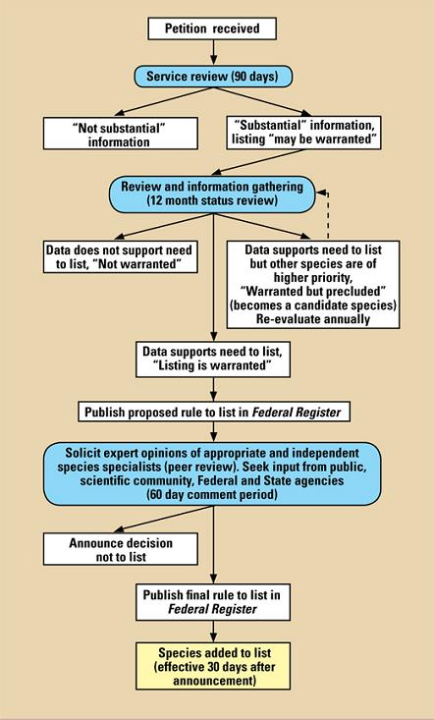

Illustration of ESA listing process,
Endangered Species Act of 1973 (ESA):
All available ESA Guidances: https://www.fisheries.noaa.gov/national/endangered-species-conservation/endangered-species-act-guidance-policies-and-regulations
NOAA/USFWS Policy Guidance concerning “Significant Portion of its Range” (SPR), June 27, 2014, available at
https://www.federalregister.gov/documents/2014/07/01/2014-15216/final-policy-on-interpretation-of-the-phrase-significant-portion-of-its-range-in-the-endangered
The SPR policy came into effect July 1, 2014 upon publication in the Federal Register (79 FR 37577) https://www.federalregister.gov/documents/2014/07/01/2014-15216/final-policy-on-interpretation-of-the-phrase-significant-portion-of-its-range-in-the-endangered
The revised critical habitat designation rule came into effect February 11, 2016, upon publication in the Federal Register (81 FR 7413)
https://www.federalregister.gov/documents/2016/02/11/2016-02680/listing-endangered-and-threatened-species-and-designating-critical-habitat-implementing-changes-to
Foley C.M., Lynch M.A., Thorne, L.H., Lynch H.J. 2017. Listing Foreign Species Under the Endangered Species Act: A Primer for Conservation Biologists. 67 BioScience 627-673 (doi:10.1093/biosci/bix027)

Marine Mammal Protection Act of 1973 (MMPA):
Marine mammals include cetaceans (whales, dolphins, porpoises) and pinnipeds (seals, sea lions, managed by NOAA/NMFS) as well as walrus, polar bears, otter, manatee, and dugong that are managed by USFWS. NOAA manages 119 species of marine mammals worldwide (not just in the United States alone). The USFWS manages eight species worldwide.
Information on conservation management practices, and the status of specific marine mammal species can be found information about each species, contained in this NOAA location:http://www.nmfs.noaa.gov/pr/species/mammals/.
MMPA: the full text of the law is available
The Regulations for the MMPA (50 CFR 216): http://www.nmfs.noaa.gov/pr/pdfs/laws/mmpa_regs_216.pdf (inactive link as of 05/19/2021)
The site maintained by the USFWS is useful because of the shared administration between the two agencies (USFWS and NOAA):
https://www.fws.gov/international/laws-treaties-agreements/us-conservation-laws/marine-mammal-protection-act.html.
NOAA Fisheries latest MMPA information (note the tab containing a glossary of terms): https://www.fisheries.noaa.gov/topic/laws-policies#marine-mammal-protection-act
MMPA Incidental Take Authorizations: https://www.fisheries.noaa.gov/node/23111
More on Pritzker case: credit http://elawreview.org/case-summaries/natural-resources-defense-council-inc-v-pritzker-828-f-3d-1125-9th-cir-2016/

UNIT THREE: Management of Specially Designated Areas
McLeod KL and Leslie HM, “Ways Forward,” in Ecosystem-Based Management for the Oceans, at p. 347 (Island Press, 2009).
For a more in-depth look at EBM in the marine context, browse the resources available at NOAA: http://ecosystems.noaa.gov/EBM101/WhatisEcosystem-BasedManagement.aspx.
Long RD, Charles A, Stephenson RL (2015) Key Principles of Marine Ecosystem-Based Management, 57 Marine Policy, (July 2015) 53-60
https://www.sciencedirect.com/science/article/pii/S0308597X1500024X
NOAA Ecosystem-Based Management, http://ecosystems.noaa.gov/EBM101/WhatisEcosystem-BasedManagement.aspx
NOAA IEA program: Preview EBM Fisheries management through IEA here: https://www.fisheries.noaa.gov/insight/ecosystem-based-fisheries-management
NOAA Fisheries EBM Policy, and EBM Roadmap (document links on right column)
NOAA Office of Science and Technology (highly recommended)
https://www.st.nmfs.noaa.gov/ecosystems/ebfm/creating-an-ebfm-management-policy
(Navigate to site, then scroll down)
https://www.fisheries.noaa.gov/topic/laws-policies#endangered-species-act
NOAA Office of Coastal Management, National Estuarine Research Reserves System,
https://coast.noaa.gov/nerrs/
More on United States Marine Protected Areas (MPAs)
https://marineprotectedareas.noaa.gov/aboutmpas/
Day JC (2017), Effective Public Participation is Fundamental for Marine Conservation—Lessons from a Large-Scale MPA, 45:6 Coastal Management 470-486, DOI: 10.1080/08920753.2017.1373452.
Green AL, Fernandes L, Almany G, Abesamis R, McLeod E, Aliño, White AT, Salm R, Tanzer J, Ressey RL (2014) Designing Marine Reserves for Fisheries Management, Biodiversity Conservation, and Climate Change Adaptation, 42:2 Coastal Management 143-159, DOI: 10.1080/08920753.2014.877763.
Kelleher, G. 1999. Guidelines for Marine Protected Areas. IUCN, Gland, Switzerland and Cambridge, UK. xxiv +107pp. https://portals.iucn.org/library/sites/library/files/documents/PAG-003.pdf
Fautin D., Dalton P., Incze L.S., Leong J.C., Pautzke C., Rosenberg A., Sandifer P., Sedberry G., Tunnell Jr. J.W., Abbott I., Brainard R.E., Brodeur M., Eldredge L.G., Feldman M., Moretzsohn F., Vroom P.S., Wainstein M., Wolff N. (2010) An Overview of Marine Biodiversity in the United States Waters, 5:8 PLoSOne, August 2010 (Creative Commons License; http://journals.plos.org/plosone/article?id=10.1371/journal.pone.0011914
NOAA, Digital Maps of World Large Marine Ecosystems (LME):
http://lme.edc.uri.edu/index.php/digital-maps (inactive link as of 05/21/2021)
For details on the application of the five LME assessment modules, see NOAA 2018:
http://lme.edc.uri.edu/index.php?option=com_content&view=category&layout=blog&id=15&Itemid=113 (inactive link as of 05/21/2021)
Antiquities Act (1906): Authorizes the President to declare by public proclamation historic landmarks, historic and prehistoric structures, and other objects of historic or scientific interest that are situated upon the lands owned or controlled by the Government of the United States to be national monuments, and may reserve as a part thereof parcels of land, the limits of which in all cases shall be confined to the smallest area compatible with proper care and management of the objects to be protected. Also permits for the examination of ruins, the excavation of archaeological sites, and the gathering of objects of antiquity upon the lands under their respective jurisdictions may be granted by the Secretaries of the Interior and Agriculture to institutions which they may deem properly qualified to conduct such examination, excavation, or gathering, subject to such rules and regulation as they may prescribe.

Coastal Zone Management Act (1972): A federal authority that establishes the Coastal Zone Management Program and the National Estuarine Research Reserves System, providing a framework for balanced decision-making.

Endangered Species Act (1973): The National Marine Fisheries Service and U.S. Fish and Wildlife Service decide whether to list species as threatened or endangered. Federal agencies must avoid jeopardy to and aid the recovery of listed species. Similar responsibilities apply to non-federal entities.

Fish And Wildlife Coordination Act (1934): Provides the basic authority for the U.S. Fish and Wildlife Service’s involvement in evaluating impacts to fish and wildlife from proposed water resource development projects. It requires that fish and wildlife resources receive equal consideration to other project features. It also requires that federal agencies that construct, license, or permit water resource development projects must first consult with the Fish and Wildlife Service (and the National Marine Fisheries Service in some instances) and state fish and wildlife agencies regarding the impacts on fish and wildlife resources and measures to mitigate these impacts.

Magnuson-Stevens Fishery Conservation and Management Act (1976; amended 2006): Calls for assessment and consideration of ecological, economic, and social impacts of fishing regulations on fishery participants and fishing communities in marine fishery management plans.

Marine Mammal Protection Act (1972): Established to protect and manage marine mammals and their products (e.g., the use of hides and meat). The primary authority for implementing the act belongs to the U.S. Fish and Wildlife Service and the National Marine Fisheries Service. The Act prohibits the “take” of marine mammals, which is defined as “to harass, hunt, capture or kill, or attempt to harass, hunt, capture or kill any marine mammal.” The term “harassment” is further defined as “any act of pursuit, torment or annoyance which has the potential to injure a marine mammal or marine mammal stock in the wild or has the potential to disturb a marine mammal or marine mammal stock in the wild by causing disruption of behavioral patterns, including, but not limited to, migration, breathing, nursing, breeding, feeding, or sheltering.”
National Marine Sanctuaries Act (1972): Authorizes the Secretary of Commerce to designate and manage areas of the marine environment with special national significance due to their conservation, recreational, ecological, historical, scientific, cultural, archeological, educational, or esthetic qualities as National Marine Sanctuaries. The primary objective of this law is to protect marine resources, such as coral reefs, sunken historical vessels, or unique habitats. The Act also directs the Secretary to facilitate all public and private uses of those resources that are compatible with the primary objective of resource protection. Sanctuaries are managed according to site-specific management plans prepared by the National Oceanic and Atmospheric Administration’s (NOAA) National Marine Sanctuary Program.
National Park Service Organic Act (1916): Established to promote and regulate the use of the federal areas known as national parks, monuments, and reservations hereinafter specified….”to conserve the scenery and the natural and historic objects and the wildlife therein and to provide for the enjoyment for the same in such manner and by such means as will leave them unimpaired for the enjoyment of future generations.”
National Historic Preservation Act (1966): Congress made the federal government a full partner and a leader in historic preservation: to “provide leadership” for preservation, “contribute to” and “give maximum encouragement” to preservation, and “foster conditions under which our modern society and our prehistoric and historic resources can exist in productive harmony.”
National Wildlife Refuge System Administration Act (1966): Provides for the administration and management of the national wildlife refuge system, including wildlife refuges, areas for the protection and conservation of fish and wildlife threatened with extinction, wildlife ranges, game ranges, wildlife management areas and waterfowl production areas.
Wilderness Act (1964): Set aside certain federal lands as wilderness areas. These areas, generally 5,000 acres or larger, are wild lands largely in their natural state. The act says that they are areas “…where the earth and its community of life are untrammeled by man, where man himself is a visitor who does not remain.” Four federal agencies of the United States government administer the National Wilderness Preservation System: the Bureau of Land Management, the U.S. Fish and Wildlife Service, the U.S. Forest Service, and the National Park Service.
Federal legislation relevant to creation of US Marine Protected Areas (note that many coastal states have passed their own ocean bills providing for MPAs and/or engaging in EBM-informed zoning or marine spatial planning in state waters; for example see Massachusetts, Rhode Island, Oregon, Washington, and California). Adapted from NOAA (https://marineprotectedareas.noaa.gov/aboutmpas/programs/federallegislation/

UNIT FOUR: Our Fisheries
NOAA, Fisheries Management in the United States
https://www.fisheries.noaa.gov/insight/fisheries-management-united-states
NOAA 2016 Stock Status Report to Congress, https://www.fisheries.noaa.gov/feature-story/status-stocks-2016
NOAA/NMFS’ resources dedicated to the Magnuson-Stevens Act are located on this site:
https://www.fisheries.noaa.gov/topic/laws-policies
Congressional Reauthorization Developments, Magnuson-Stevens Act https://www.westcoast.fisheries.noaa.gov/whatwedo/msa/magnuson_stevens_act.html (scroll down for recent hearings).
The PEW Charitable Trusts Report (2013), The Law That’s Saving American Fisheries
http://www.pewtrusts.org/en/research-and-analysis/reports/2013/05/06/the-law-thats-saving-american-fisheries-the-magnusonstevens-fishery-conservation-and-management-act
Natural Resources Defense Council Report (2013), Bringing Back the Fish (Sewell et al. 2013)
https://www.nrdc.org/sites/default/files/rebuilding-fisheries-report.pdf
Natural Resources Defense Council Fact Sheet (January 9, 2018), How the Magnuson-Stevens Act is Helping Rebuild US Fisheries (Masterson M and Adams A), https://www.nrdc.org/issues/stop-overfishing-and-restore-fisheries
Warlick A, Steiner E, Guldin M (2018), History of the West Coast Groundfish Trawl Fishery: Tracking Socioeconomic Characteristics Across Different Management Policies in a Multispecies Fishery, 93 Marine Policy 9-21.
NOAA Fisheries provides three regular reports.
Status of Stocks is an annual report to Congress on the status of U.S. fisheries and is required by the Magnuson- Stevens Fishery Conservation and Management Act. This report, which is published each spring, summarizes the number of stocks on the over shed, overfishing, and rebuilt lists for U.S. federally managed sh stocks and stock complexes. The report also shows trends over time, discusses the value and contributions of our partners, and highlights how management actions taken by NOAA Fisheries have improved the status of U.S. federally managed stocks. For example, the 2015 report shows the number of stocks listed as subject to over fishing or over shed remains near an all-time low. https://www.fisheries.noaa.gov/feature-story/status-stocks-2016
Fisheries of the United States, published each fall, has been produced in its various forms for more than 100 years. It is the NOAA Fisheries yearbook of shery statistics for the United States. It provides a snapshot of data, primarily at the national level, on U.S. recreational catch and commercial sheries landings and value. In addition, data are reported on U.S. aquaculture production, the U.S. seafood processing industry, imports and exports of shery-related products, and domestic supply and per capita consumption of shery products. The focus is not on economic analysis, although value of landings, processed products, and foreign trade are included.
https://www.fisheries.noaa.gov/national/commercial-fishing/fisheries-united-states
Fisheries Economics of the United States, published each fall, provides a detailed look at the economic performance of commercial and recreational fisheries and other marine-related sectors on a state, regional, and national basis. The economic impact of commercial and recreational fishing activities in the U.S. is also reported in terms of employment, sales, and value-added impacts. The report provides management highlights for each region that include a summary of stock status, updates on catch share programs, and other selected management issues. Economic performance indicators for catch share programs and non-catch share sheries are reported. https://www.fisheries.noaa.gov/national/commercial-fishing/fisheries-economics-united-states

UNIT FIVE: Regulating Ocean Impacts
Bycatch Resources
Benaka LR, Bullock D, Davis J, Seney EE, Winarsoo H (2016), NOAA Fisheries Report: US National Bycatch Report First Edition Update 2 (February 2016; Covering 2011-2013)
https://www.st.nmfs.noaa.gov/Assets/Observer-Program/bycatch-report-update-2/NBR%20First%20Edition%20Update%202_Final.pdf
Davies RWD, Cripps SJ, Nickson A, Porter G (2009), Defining and Estimating Global Marine Fisheries Bycatch, 33 Marine Policy pp. 661-672
United Nations Food and Agriculture Organization (FAO), Estimates of Global Fishery Bycatch and Discards, http://www.fao.org/docrep/003/t4890e/T4890E02.htm
Pelc RA, Max LM, Norden W, Roberts S, Silverstein R, Wilding SR, 2015. Further Action on Bycatch Could Boost United States Fisheries Performance, 56 Marine Policy pp. 56-60.
Resources on the species and locations of highest concern for bycatch and the efforts of World Wildlife Fund: http://wwf.panda.org/about_our_earth/blue_planet/problems/bycatch222/bycatch_victims/ (inactive link as of 05/19/2021)
Moore JE, Wallace BP, Lewison RL, Zˇydelis R, Cox TM, Crowder LB, 2009. A Review of Marine Mammal, Sea Turtle and Seabird Bycatch in USA Fisheries and the Role of Policy in Shaping Management, 33 Marine Policy pp. 435-451.
Global Fishing Watch, project mapping global fishing effort over time, including illegal fishing over 1.4 billion miles of ocean: https://environment.google/projects/fishing-watch/
Kroodsma DA, Mayorga J, Hochberg T, Miller NA, Boerder K, Ferretti F, Wilson A, Bergman B, White TD, Block BA, Woods P, Sullivan B, Costello C, Worm B, Tracking the Global Footprint of Fisheries, 359:6378 Science, pp. 904-908, 23 February 2018, DOI: 10.1126/science.aao5646
Marine Debris Resources
National Research Council, Committee on the Effectiveness of International and National Measures to Prevent and Reduce Marine Debris and Its Impacts, Ocean Studies Board, Division ofn Earth and Life Studies, Tackling Marine Debris in the 21st Century, 2009, National Academy of Sciences. Available to read online or download at no charge, https://www.nap.edu/catalog/12486/tackling-marine-debris-in-the-21st-century
Benscosme M., Keller M, Ortiz E, NBC News, March 10, 2018, Ghost Gear Clogging World’s Oceans is Having ‘Catastrophic’ Effect, Report Says, https://www.nbcnews.com/science/environment/ghost-gear-clogging-world-s-oceans-having-catastrophic-effect-report-n855321 Citing: World Animal Protection Report, Ghosts Beneath the Waves: Ghost Gear’s Catastrophic Impact on Our Oceans, and the Urgent Action Needed from Industry, https://www.worldanimalprotection.us.org/sites/default/files/us_files/ghosts_beneath_the_waves.pdf,
London, http://www.worldanimalprotection.org, 2018
Willis K, Hardesty BD, Kriwoken L, Wilcox C (2017), Differentiating Littering, Urban Runoff and Marine Transport as Sources of Marine Debris in Coastal and Estuarine Environments, Nature Scientific Reports,
https://www.nature.com/articles/srep44479
Keep an eye on these two citizen-driven, highly original, provocative, and entrepreneurial efforts to raise awareness of plastic pollution, and to actually confront it: The Washed Ashore Project, https://washedashore.org
The Ocean Cleanup Project: https://www.theoceancleanup.com
and its founder, Boylan Slat: https://youtu.be/du5d5PUrH0I
OtherPollution Resources
Resources and Ecosystem Sustainability, Tourist Opportunities, and Revived Economies of the Gulf Coast (RESTORE) Act (established trust fund from 80% of Deepwater Horizon spill to support Gulf restoration). Subtitle F of Public Law 112-141 (2012), available: https://www.treasury.gov/services/restore-act/Pages/home.aspx
In re Oil Spill by the Oil Rig ‘Deepwater Horizon,’ 841 F. Supp. 2d 988, 1003 (E.D. La. 2012),
https://www.leagle.com/decision/infdco20120127i67
Venn-Watson S, Colegrove KM, Litz J, Kinsel M, Terio K, et al. (2015) Adrenal Gland and Lung Lesions in Gulf of Mexico Common Bottlenose Dolphins (Tursiops truncatus) Found Dead following the Deepwater Horizon Oil Spill. PLOS ONE 10(5): e0126538. https://doi.org/10.1371/journal.pone.0126538
See also international provisions with regard to pollution and State responsibilities in the UNCLOS materials in Unit Six Resources.
Ocean Acidification
To learn more, investigate Chapter 4, Effects of Ocean Acidification on Marine Ecosystems, from the National Academy of Sciences book, Ocean Acidification: A National Strategy to Meet the Challenges of a Changing Ocean (2010).
Kelly RP, Caldwell MR (2013), Ten Ways States Can Combat Ocean Acidification (and Why They Should), 37 Harvard Environmental Law Review 57.
Kelly RP, Cooley SR, Klinger T (2013), Narratives Can Motivate Environmental Action: The Whiskey Creek Ocean Acidification Story, Ambio, Royal Swedish Academy of Sciences, DOI 10.1007/s13280-013-0442-2.
Kelly RP (2017), Ocean Acidification Policy: Applying the Lessons of Washington to California and Beyond, 7 Washington Journal of Environmental Law and Policy 1 (June 2017).
Washington Department of Ecology, Ocean Acidification
https://ecology.wa.gov/About-us/Our-role-in-the-community/Partnerships-committees/Ocean-acidification-Blue-Ribbon-panel
Copeland C (2016), Clean Water Act: A Summary of the Law, Congressional Research Service (CRS) October 18, 2016, https://fas.org/sgp/crs/misc/RL30030.pdf
Craig RK (2015), Dealing with Ocean Acidification: The Problem, The Clean Water Act, and State and Regional Approaches, 90 Washington Law Review 1583.
Statutory Authorities Dealing with Marine Pollution
1. The Clean Water Act of 1972 (CWA, 33 USC §§ 1251 – 1388)
Mission: to restore and maintain the chemical, physical and biological integrity of our nation’s waters (33 USC §1251(a)); prohibits discharge of any pollutant (33 USC §1311(a)).
Jurisdiction: navigable waters of the United States (historically, “contiguous zone,” zone 3-12 miles offshore, because Congress never amended the Act after creation of 200 mile EEZ;
however, the US asserts federal jurisdiction to control point source pollution throughout its EEZ.
Relevant Section(s):
§302 Water Quality Based Effluent Standards; applies inland and out to three miles
§303 States set water quality standards for their waters under a Total Maximum Daily Load (TMDL) approach; applies inland and out to three miles
§312 ballast water, sewage from armed forces vessels
§318 Certain types of aquaculture projects
§319 Nonpoint source pollution (inland and out to three miles; managed with NOAA)
§402-403 NPDES; EPA holds permitting authority 3-200 miles in states with delegated National Pollution Discharge Elimination System (NPDES) permit programs that regulate point sources.
NOTE: The EPA allows states and tribal authorities to assume NPDES program permitting authority. States’ jurisdiction stops, however, at three miles offshore.
§404 prohibits diking, draining, dumping without a permit, protects wetlands
(exemptions include normal silviculture and farming activities); §404 applies to state waters (out to three miles)
Vessels and floating platforms are included in the definition of point sources, governed by the National Pollution Discharge Elimination System (NPDES)
See also: NPDES Ocean Discharge Criteria (1980) (33 USC §1343; Regs: 40 CFR §§ 125.120 – 125.124) Useful passages include: c) Guidelines for determining degradation of waters.
See also the BEACH Act (The Beaches Environmental Assessment and Coast Health Act), which provides money to coastal states to monitor their waters for disease bearing organisms.
Responsible: EPA, US Army Corps of Engineers (USACE), NOAA
Available: https://www.law.cornell.edu/uscode/text/33/chapter-26
2. The Oil Pollution Act of 1990 (OPA, 33 USC §§ 2701 – 2762)
Mission: prohibits any discharge of oil (intentional or unintentional) including spills, leaks, pumping, pouring, emitting, emptying or dumping of oil
Jurisdiction: navigable waters of the United States and the territorial sea
Relevant Section(s): §10, often used with §404 CWA
Responsible: Bureau of Ocean Energy Management (BOEM, formerly the Minerals Management Service) within the US Department of the Interior
Available:https://www.boem.gov/uploadedFiles/BOEM/Oil_and_Gas_Energy_Program/Leasing/Regional_Leasing/Gulf_of_Mexico_Region/OSFR/OPA-90.pdf (inactive link as of 05/19/2021)
And amendments
https://www.boem.gov/uploadedFiles/BOEM/Oil_and_Gas_Energy_Program/Leasing/Regional_Leasing/Gulf_of_Mexico_Region/OSFR/opa_amd.pdf (inactive link as of 05/19/2021)
3. The Refuse Act/Rivers and Harbors Act of 1899 (33 USC § 403 et seq.)
United States Army Corps of Engineers (USACE)
Available: http://scholarship.law.duke.edu/cgi/viewcontent.cgi?article=2734&context=dlj
4. The United Nations Convention on the Law of the Sea of 1982 (UNCLOS)
Available: http://www.un.org/depts/los/convention_agreements/texts/unclos/unclos_e.pdf
Mission: international convention on conservation and living and nonliving resource use by nations;
articles listed are relevant to marine debris pollution
Jurisdiction: national and international waters
Relevant Sections: Articles 1, 192, 194, 197, 207, 210, 211, 216, 217, 218.
5. (MDRPRA, 33 USC § 1951 et seq.)
Available: https://coast.noaa.gov/data/Documents/OceanLawSearch/MarineDebrisResearchPreventionandReductionAct.pdf
Mission: establishes marine debris prevention and removal program within NOAA, directs US Coast Guard (USCG) to improve MARPOL Annex V implementation, authorizes a national data clearinghouse, and related activities (administrative Act)
–—Numbers 6 and 7 below both implement international treaties, and are coordinated with the United States’ Clean Water Act (CWA).
6. The Marine Protection, Research, and Sanctuaries Act of 1972 (MPRSA, also known as the Ocean Dumping Act, 33 USC Ch. 27 § 1401 – 1445)
[implements The London Convention of 1972, modified by the London Protocol 1996, see: http://www.imo.org/en/OurWork/Environment/LCLP/Pages/default.aspx (also called the Ocean Dumping Act) (inactive link as of 7/24/23)]
Mission: Prohibits dumping in ocean waters of any material transported from the US or on a US vessel or aircraft, without a permit
Jurisdiction: waters beyond the three mile zone (includes incineration, medical waste; excludes sewage; “material” defined at 33 USC §1402(c)
Relevant Section(s): §1412, Permits; Annex V (1987; regulates garbage pollution generated onboard ships or floating platforms; exceptions include unintended loss of fishing nets)
Responsible: EPA, USACE
Available: https://www.gpo.gov/fdsys/pkg/USCODE-2014-title33/pdf/USCODE-2014-title33-chap27.pdf
Or https://www.law.cornell.edu/uscode/text/33/chapter-27/subchapter-I
7. The Act to Prevent Pollution from Ships, amended by the Marine Plastic Pollution Research and Control Act of 1987 (MPPRCA; 33 USC § 1901 et seq.) [implements MARPOL Annex V];
Mission: to reduce pollution from ships (except dumping of waste)
Jurisdiction: In the US, all US flagged ships in US waters, in US ports or vessel terminals, or in foreign waters
Relevant Section(s): §101(a) requiring permits
Responsible: USEPA, USCG, USACE
Available: https://www.law.cornell.edu/uscode/text/33/chapter-33
MARPOL: http://www.imo.org/en/About/Conventions/ListOfConventions/Pages/International-Convention-for-the-Prevention-of-Pollution-from-Ships-(MARPOL).aspx (inactive link as of 7/24/23).

UNIT SIX: Introduction to International Fisheries Management
The Pelly Amendment, Section 8 of the Fishermen’s Protective Act,
https://www.fws.gov/international/laws-treaties-agreements/us-conservation-laws/pelly-amendment.html
The Lacey Act, https://www.fws.gov/international/laws-treaties-agreements/us-conservation-laws/lacey-act.html
The Convention on International Trade in Endangered Species of Wild Fauna and Flora (CITES),
https://www.fws.gov/international/cites/what-is-cites.html
Tsamenyi M, Manarangi-Trott L, Rajkumar S (2003), The International Legal Regime for Fisheries Management
https://unep.ch/etu/Fisheries%20Meeting/submittedPapers/MartinTsamenyiLaraManarangiTrottShilpaRajkumar.pdf (inactive link as of 7/24/23)
United Nations Atlas of the Oceans, The Food and Agriculture Organization (FAO) Code of Conduct for Responsible Fisheries (1995)
http://www.oceansatlas.org/subtopic/en/c/1415/
PEW Charitable Trusts materials on international fisheries sustainability and global goals,
http://www.pewtrusts.org/en/research-and-analysis/fact-sheets/2012/02/23/faq-what-is-a-regional-fishery-management-organization
Regional Fisheries Management Organizations (RFMOs)
https://ec.europa.eu/fisheries/cfp/international/rfmo_en
World Bank and FAO, The Sunken Billions Revisited: The Economic Justification for Fisheries Reform (2017), https://openknowledge.worldbank.org/bitstream/handle/10986/24056/9781464809194.pdf?sequence=8&isAllowed=y
United Nations Annual Report, The State of World Fisheries and Aquaculture
http://www.fao.org/fishery/sofia/en
Guteirrez NL, Defeo O, Bush SR, Butterworth DS, Roheim CA, Punt AE (2016), The Current Situation and Prospects of Fisheries Certification and Ecolabeling, 182 Fisheries Research pp. 1-6.
Relevant Provisions of the United Nations Convention on the Law of the Sea (UNCLOS)
Part V, EEZ Articles 61 – 68
Part VII The High Seas
Conservation and Management Articles 116-120
Environmental Protection including Pollution Articles 207-212
Enforcement Articles 213-222

Excerpts of Part VI, The Exclusive Economic Zone (EEZ) (Articles 61-68)
Article 61 Conservation of the living resources
- The coastal State shall determine the allowable catch of the living resources in its exclusive economic zone.
- The coastal State, taking into account the best scientific evidence available to it, shall ensure through proper conservation and management measures that the maintenance of the living resources in the exclusive economic zone is not endangered by over-exploitation. As appropriate, the coastal State and competent international organizations, whether subregional, regional or global, shall cooperate to this end.
- Such measures shall also be designed to maintain or restore populations of harvested species at levels which can produce the maximum sustainable yield, as qualified by relevant environmental and economic factors, including the economic needs of coastal fishing communities and the special requirements of developing States, and taking into account fishing patterns, the interdependence of stocks and any generally recommended international minimum standards, whether subregional, regional or global.
- In taking such measures the coastal State shall take into consideration the effects on species associated with or dependent upon harvested species with a view to maintaining or restoring populations of such associated or dependent species above levels at which their reproduction may become seriously threatened.
- Available scientific information, catch and fishing effort statistics, and other data relevant to the conservation of fish stocks shall be contributed and exchanged on a regular basis through competent international organizations, whether subregional, regional or global, where appropriate and with participation by all States concerned, including States whose nationals are allowed to fish in the exclusive economic zone.
Article 62 Utilization of the living resources
- The coastal State shall promote the objective of optimum utilization of the living resources in the exclusive economic zone without prejudice to article 61.
- The coastal State shall determine its capacity to harvest the living resources of the exclusive economic zone. Where the coastal State does not have the capacity to harvest the entire allowable catch, it shall, through agreements or other arrangements and pursuant to the terms, conditions, laws and regulations referred to in paragraph 4, give other States access to the surplus of the allowable catch, having particular regard to the provisions of articles 69 and 70, especially in relation to the developing States mentioned therein.
- In giving access to other States to its exclusive economic zone under this article, the coastal State shall take into account all relevant factors, including, inter alia, the significance of the living resources of the area to the economy of the coastal State concerned and its other national interests, the provisions of articles 69 and 70, the requirements of developing States in the subregion or region in harvesting part of the surplus and the need to minimize economic dislocation in States whose nationals have habitually fished in the zone or which have made substantial efforts in research and identification of stocks.
- Nationals of other States fishing in the exclusive economic zone shall comply with the conservation measures and with the other terms and conditions established in the laws and regulations of the coastal State. These laws and regulations shall be consistent with this Convention and may relate, inter alia, to the following:
  - (a) licensing of fishermen, fishing vessels and equipment, including payment of fees and other forms of remuneration, which, in the case of developing coastal States, may consist of adequate compensation in the field of financing, equipment and technology relating to the fishing industry;
  - (b) determining the species which may be caught, and fixing quotas of catch, whether in relation to particular stocks or groups of stocks or catch per vessel over a period of time or to the catch by nationals of any State during a specified period;
  - (c) regulating seasons and areas of fishing, the types, sizes and amount of gear, and the types, sizes and number of fishing vessels that may be used;
  - (d) fixing the age and size of fish and other species that may be caught;
  - (e) specifying information required of fishing vessels, including catch and effort statistics and vessel position reports;
  - (f) requiring, under the authorization and control of the coastal State, the conduct of specified fisheries research programmes and regulating the conduct of such research, including the sampling of catches, disposition of samples and reporting of associated scientific data;
  - (g) the placing of observers or trainees on board such vessels by the coastal State;
  - (h) the landing of all or any part of the catch by such vessels in the ports of the coastal State;
  - (i) terms and conditions relating to joint ventures or other cooperative arrangements;
  - (j) requirements for the training of personnel and the transfer of fisheries technology, including enhancement of the coastal State’s capability of undertaking fisheries research;
  - (k) enforcement procedures.

- Coastal States shall give due notice of conservation and management laws and regulations.
Article 63 Stocks occurring within the exclusive economic zones of two or more coastal States, or both within the exclusive economic zone and in an area beyond and adjacent to it
- Where the same stock or stocks of associated species occur within the exclusive economic zones of two or more coastal States, these States shall seek, either directly or through appropriate subregional or regional organizations, to agree upon the measures necessary to coordinate and ensure the conservation and development of such stocks without prejudice to the other provisions of this Part.
- Where the same stock or stocks of associated species occur both within the exclusive economic zone and in an area beyond and adjacent to the zone, the coastal State and the States fishing for such stocks in the adjacent area shall seek, either directly or through appropriate subregional or regional organizations, to agree upon the measures necessary for the conservation of these stocks in the adjacent area.
Article 64 Highly migratory species
- The coastal State and other States whose nationals fish in the region for the highly migratory species listed in Annex I shall cooperate directly or through appropriate international organizations with a view to ensuring conservation and promoting the objective of optimum utilization of such species throughout the region, both within and beyond the exclusive economic zone. In regions for which no appropriate international organization exists, the coastal State and other States whose nationals harvest these species in the region shall cooperate to establish such an organization and participate in its work.
- The provisions of paragraph 1 apply in addition to the other provisions of this Part.
Article 65 Marine mammals
Nothing in this Part restricts the right of a coastal State or the competence of an international organization, as appropriate, to prohibit, limit or regulate the exploitation of marine mammals more strictly than provided for in this Part. States shall cooperate with a view to the conservation of marine mammals and in the case of cetaceans shall in particular work through the appropriate international organizations for their conservation, management and study.
Article 66 Anadromous stocks
- States in whose rivers anadromous stocks originate shall have the primary interest in and responsibility for such stocks.
- The State of origin of anadromous stocks shall ensure their conservation by the establishment of appropriate regulatory measures for fishing in all waters landward of the outer limits of its exclusive economic zone and for fishing provided for in paragraph 3(b). The State of origin may, after consultations with the other States referred to in paragraphs 3 and 4 fishing these stocks, establish total allowable catches for stocks originating in its rivers.
  - (a) Fisheries for anadromous stocks shall be conducted only in waters landward of the outer limits of exclusive economic zones, except in cases where this provision would result in economic dislocation for a State other than the State of origin. With respect to such fishing beyond the outer limits of the exclusive economic zone, States concerned shall maintain consultations with a view to achieving agreement on terms and conditions of such fishing giving due regard to the conservation requirements and the needs of the State of origin in respect of these stocks.
  - (b) The State of origin shall cooperate in minimizing economic dislocation in such other States fishing these stocks, taking into account the normal catch and the mode of operations of such States, and all the areas in which such fishing has occurred.
  - (c) States referred to in subparagraph (b), participating by agreement with the State of origin in measures to renew anadromous stocks, particularly by expenditures for that purpose, shall be given special consideration by the State of origin in the harvesting of stocks originating in its rivers.
  - (d) Enforcement of regulations regarding anadromous stocks beyond the exclusive economic zone shall be by agreement between the State of origin and the other States concerned.

- In cases where anadromous stocks migrate into or through the waters landward of the outer limits of the exclusive economic zone of a State other than the State of origin, such State shall cooperate with the State of origin with regard to the conservation and management of such stocks.
- The State of origin of anadromous stocks and other States fishing these stocks shall make arrangements for the implementation of the provisions of this article, where appropriate, through regional organizations.
Article 67 Catadromous species
- A coastal State in whose waters catadromous species spend the greater part of their life cycle shall have responsibility for the management of these species and shall ensure the ingress and egress of migrating fish.
- Harvesting of catadromous species shall be conducted only in waters landward of the outer limits of exclusive economic zones. When conducted in exclusive economic zones, harvesting shall be subject to this article and the other provisions of this Convention concerning fishing in these zones.
- In cases where catadromous fish migrate through the exclusive economic zone of another State, whether as juvenile or maturing fish, the management, including harvesting, of such fish shall be regulated by agreement between the State mentioned in paragraph 1 and the other State concerned. Such agreement shall ensure the rational management of the species and take into account the responsibilities of the State mentioned in paragraph 1 for the maintenance of these species.
Article 68 Sedentary species
This Part does not apply to sedentary species as defined in article 77, paragraph 4.
Excerpts of Part VII, The High Seas, Section 2. Conservation and Management of The Living Resources of the High Seas (Articles 116-120)
SECTION 2. CONSERVATION AND MANAGEMENT OF THE LIVING RESOURCES OF THE HIGH SEAS
Article 116 Right to fish on the high seas
All States have the right for their nationals to engage in fishing on the high seas subject to:
(a) their treaty obligations; (b) the rights and duties as well as the interests of coastal States provided for, inter alia, in article 63, paragraph 2, and articles 64 to 67; and (c) the provisions of this section.
Article 117 Duty of States to adopt with respect to their nationals measures for the conservation of the living resources of the high seas
All States have the duty to take, or to cooperate with other States in taking, such measures for their respective nationals as may be necessary for the conservation of the living resources of the high seas.
Article 118 Cooperation of States in the conservation and management of living resources
States shall cooperate with each other in the conservation and management of living resources in the areas of the high seas. States whose nationals exploit identical living resources, or different living resources in the same area, shall enter into negotiations with a view to taking the measures necessary for the conservation of the living resources concerned. They shall,
Article 114 Breaking or injury by owners of a submarine cable or pipeline of another submarine cable or pipeline as appropriate, cooperate to establish subregional or regional fisheries organizations to this end.
Article 119 Conservation of the living resources of the high seas
- In determining the allowable catch and establishing other conservation measures for the living resources in the high seas, States shall: (a) take measures which are designed, on the best scientific evidence available to the States concerned, to maintain or restore populations of harvested species at levels which can produce the maximum sustainable yield, as qualified by relevant environmental and economic factors, including the special requirements of developing States, and taking into account fishing patterns, the interdependence of stocks and any generally recommended international minimum standards, whether subregional, regional or global; (b) take into consideration the effects on species associated with or dependent upon harvested species with a view to maintaining or restoring populations of such associated or dependent species above levels at which their reproduction may become seriously threatened.
- Available scientific information, catch and fishing effort statistics, and other data relevant to the conservation of fish stocks shall be contributed and exchanged on a regular basis through competent international organizations, whether sub-regional, regional or global, where appropriate and with participation by all States concerned.
- States concerned shall ensure that conservation measures and their implementation do not discriminate in form or in fact against the fishermen of any State.
Article 120 Marine mammals
Article 65 also applies to the conservation and management of marine mammals in the high seas.
Excerpts of Part XII, Protection and Preservation of the Marine Environment Pollution (Articles 204-212)
SECTION 4. MONITORING AND ENVIRONMENTAL ASSESSMENT
Article 204 Monitoring of the risks or effects of pollution
- States shall, consistent with the rights of other States, endeavour, as far as practicable, directly or through the competent international organizations, to observe, measure, evaluate and analyse, by recognized scientific methods, the risks or effects of pollution of the marine environment.
- In particular, States shall keep under surveillance the effects of any activities which they permit or in which they engage in order to determine whether these activities are likely to pollute the marine environment.
Article 205 Publication of reports
States shall publish reports of the results obtained pursuant to article 204 or provide such reports at appropriate intervals to the competent international organizations, which should make them available to all States.
SECTION 3. TECHNICAL ASSISTANCE
Article 202 Scientific and technical assistance to developing States
When States have reasonable grounds for believing that planned activities under their jurisdiction or control may cause substantial pollution of or significant and harmful changes to the marine environment, they shall, as far as practicable, assess the potential effects of such activities on the marine environment and shall communicate reports of the results of such assessments in the manner provided in article 205.
SECTION 5. INTERNATIONAL RULES AND NATIONAL LEGISLATION TO PREVENT, REDUCE AND CONTROL POLLUTION OF THE MARINE ENVIRONMENT
Article 207 Pollution from land-based sources
- States shall adopt laws and regulations to prevent, reduce and control pollution of the marine environment from land-based sources, including rivers, estuaries, pipelines and outfall structures, taking into account internationally agreed rules, standards and recommended practices and procedures.
- States shall take other measures as may be necessary to prevent, reduce and control such pollution.
- States shall endeavour to harmonize their policies in this connection at the appropriate regional level.
- States, acting especially through competent international organizations or diplomatic conference, shall endeavour to establish global and regional rules, standards and recommended practices and procedures to prevent, reduce and control pollution of the marine environment from land-based sources, taking into account characteristic regional features, the economic capacity of developing States and their need for economic development. Such rules, standards and recommended practices and procedures shall be re-examined from time to time as necessary.
- Laws, regulations, measures, rules, standards and recommended practices and procedures referred to in paragraphs 1, 2 and 4 shall include those designed to minimize, to the fullest extent possible, the release of toxic, harmful or noxious substances, especially those which are persistent, into the marine environment.
Article 208 Pollution from seabed activities subject to national jurisdiction
- Coastal States shall adopt laws and regulations to prevent, reduce and control pollution of the marine environment arising from or in connection with seabed activities subject to their jurisdiction and from artificial islands, installations and structures under their jurisdiction, pursuant to articles 60 and 80.
- States shall take other measures as may be necessary to prevent, reduce and control such pollution.
- Such laws, regulations and measures shall be no less effective than international rules, standards and recommended practices and procedures.
- States shall endeavour to harmonize their policies in this connection at the appropriate regional level.
- States, acting especially through competent international organizations or diplomatic conference, shall establish global and regional rules, standards and recommended practices and procedures to prevent, reduce and control pollution of the marine environment referred to in paragraph l. Such rules, standards and recommended practices and procedures shall be re-examined from time to time as necessary.
Article 209 Pollution from activities in the Area [the Deep Seabed]
- International rules, regulations and procedures shall be established in accordance with Part XI to prevent, reduce and control pollution of the marine environment from activities in the Area. Such rules, regulations and procedures shall be re-examined from time to time as necessary.
- Subject to the relevant provisions of this section, States shall adopt laws and regulations to prevent, reduce and control pollution of the marine environment from activities in the Area undertaken by vessels, installations, structures and other devices flying their flag or of their registry or operating under their authority, as the case may be. The requirements of such laws and regulations shall be no less effective than the international rules, regulations and procedures referred to in paragraph 1.
Article 210 Pollution by dumping
- States shall adopt laws and regulations to prevent, reduce and control pollution of the marine environment by dumping.
- States shall take other measures as may be necessary to prevent, reduce and control such pollution.
- Such laws, regulations and measures shall ensure that dumping is not carried out without the permission of the competent authorities of States.
- States, acting especially through competent international organizations or diplomatic conference, shall endeavour to establish global and regional rules, standards and recommended practices and procedures to prevent, reduce and control such pollution. Such rules, standards and recommended practices and procedures shall be re-examined from time to time as necessary.
- Dumping within the territorial sea and the exclusive economic zone or onto the continental shelf shall not be carried out without the express prior approval of the coastal State, which has the right to permit, regulate and control such dumping after due consideration of the matter with other States which by reason of their geographical situation may be adversely affected thereby.
- National laws, regulations and measures shall be no less effective in preventing, reducing and controlling such pollution than the global rules and standards.
Article 211 Pollution from vessels
- States, acting through the competent international organization or general diplomatic conference, shall establish international rules and standards to prevent, reduce and control pollution of the marine environment from vessels and promote the adoption, in the same manner, wherever appropriate, of routing systems designed to minimize the threat of accidents which might cause pollution of the marine environment, including the coastline, and pollution damage to the related interests of coastal States. Such rules and standards shall, in the same manner, be re-examined from time to time as necessary.
- States shall adopt laws and regulations for the prevention, reduction and control of pollution of the marine environment from vessels flying their flag or of their registry. Such laws and regulations shall at least have the same effect as that of generally accepted international rules and standards established through the competent international organization or general diplomatic conference.
- States which establish particular requirements for the prevention, reduction and control of pollution of the marine environment as a condition for the entry of foreign vessels into their ports or internal waters or for a call at their off-shore terminals shall give due publicity to such requirements and shall communicate them to the competent international organization. Whenever such requirements are established in identical form by two or more coastal States in an endeavour to harmonize policy, the communication shall indicate which States are participating in such cooperative arrangements. Every State shall require the master of a vessel flying its flag or of its registry, when navigating within the territorial sea of a State participating in such cooperative arrangements, to furnish, upon the request of that State, information as to whether it is proceeding to a State of the same region participating in such cooperative arrangements and, if so, to indicate whether it complies with the port entry requirements of that State. This article is without prejudice to the continued exercise by a vessel of its right of innocent passage or to the application of article 25, paragraph 2.
- Coastal States may, in the exercise of their sovereignty within their territorial sea, adopt laws and regulations for the prevention, reduction and control of marine pollution from foreign vessels, including vessels exercising the right of innocent passage. Such laws and regulations shall, in accordance with Part II, section 3, not hamper innocent passage of foreign vessels.
- Coastal States, for the purpose of enforcement as provided for in section 6, may in respect of their exclusive economic zones adopt laws and regulations for the prevention, reduction and control of pollution from vessels conforming to and giving effect to generally accepted international rules and standards established through the competent international organization or general diplomatic conference.
  - (a) Where the international rules and standards referred to in paragraph 1 are inadequate to meet special circumstances and coastal States have reasonable grounds for believing that a particular, clearly defined area of their respective exclusive economic zones is an area where the adoption of special mandatory measures for the prevention of pollution from vessels is required for recognized technical reasons in relation to its oceanographical and ecological conditions, as well as its utilization or the protection of its resources and the particular character of its traffic, the coastal States, after appropriate consultations through the competent international organization with any other States concerned, may, for that area, direct a communication to that organization, submitting scientific and technical evidence in support and information on necessary reception facilities. Within 12 months after receiving such a communication, the organization shall determine whether the conditions in that area correspond to the requirements set out above. If the organization so determines, the coastal States may, for that area, adopt laws and regulations for the prevention, reduction and control of pollution from vessels implementing such international rules and standards or navigational practices as are made applicable, through the organization, for special areas. These laws and regulations shall not become applicable to foreign vessels until 15 months after the submission of the communication to the organization.
  - (b) The coastal States shall publish the limits of any such particular, clearly defined area.
  - (c) If the coastal States intend to adopt additional laws and regulations for the same area for the prevention, reduction and control of pollution from vessels, they shall, when submitting the aforesaid communication, at the same time notify the organization thereof. Such additional laws and regulations may relate to discharges or navigational practices but shall not require foreign vessels to observe design, construction, manning or equipment standards other than generally accepted international rules and standards; they shall become applicable to foreign vessels 15 months after the submission of the communication to the organization, provided that the organization agrees within 12 months after the submission of the communication.

- The international rules and standards referred to in this article should include inter alia those relating to prompt notification to coastal States, whose coastline or related interests may be affected by incidents, including maritime casualties, which involve discharges or probability of discharges.
Article 212 Pollution from or through the atmosphere
- States shall adopt laws and regulations to prevent, reduce and control pollution of the marine environment from or through the atmosphere, applicable to the air space under their sovereignty and to vessels flying their flag or vessels or aircraft of their registry, taking into account internationally agreed rules, standards and recommended practices and procedures and the safety of air navigation.
- States shall take other measures as may be necessary to prevent, reduce and control such pollution.
- States, acting especially through competent international organizations or diplomatic conference, shall endeavour to establish global and regional rules, standards and recommended practices and procedures to prevent, reduce and control such pollution.
Excerpts (cont’d) of Part XII, Protection and Preservation of the Marine Environment Enforcement (Articles 213-222)
SECTION 6. ENFORCEMENT
Article 213 Enforcement with respect to pollution from land-based sources
States shall enforce their laws and regulations adopted in accordance with article 207 and shall adopt laws and regulations and take other measures necessary to implement applicable international rules and standards established through competent international organizations or diplomatic conference to prevent, reduce and control pollution of the marine environment from land-based sources. Article 214 Enforcement with respect to pollution from seabed activities States shall enforce their laws and regulations adopted in accordance with article 208 and shall adopt laws and regulations and take other measures necessary to implement applicable international rules and standards established through competent international organizations or diplomatic conference to prevent, reduce and control pollution of the marine environment arising from or in connection with seabed activities subject to their jurisdiction and from artificial islands, installations and structures under their jurisdiction, pursuant to articles 60 and 80.
Article 215 Enforcement with respect to pollution from activities in the Area
Enforcement of international rules, regulations and procedures established in accordance with Part XI to prevent, reduce and control pollution of the marine environment from activities in the Area shall be governed by that Part.
Article 216 Enforcement with respect to pollution by dumping

  - Laws and regulations adopted in accordance with this Convention and applicable international rules and standards established through competent international organizations or diplomatic conference for the prevention, reduction and control of pollution of the marine environment by dumping shall be enforced:
    - (a) by the coastal State with regard to dumping within its territorial sea or its exclusive economic zone or onto its continental shelf;
    - (b) by the flag State with regard to vessels flying its flag or vessels or aircraft of its registry;
    - (c) by any State with regard to acts of loading of wastes or other matter occurring within its territory or at its off-shore terminals.

- No State shall be obliged by virtue of this article to institute proceedings when another State has already instituted proceedings in accordance with this article.
Article 217 Enforcement by flag States
- States shall ensure compliance by vessels flying their flag or of their registry with applicable international rules and standards, established through the competent international organization or general diplomatic conference, and with their laws and regulations adopted in accordance with this Convention for the prevention, reduction and control of pollution of the marine environment from vessels and shall accordingly adopt laws and regulations and take other measures necessary for their implementation. Flag States shall provide for the effective enforcement of such rules, standards, laws and regulations, irrespective of where a violation occurs.
- States shall, in particular, take appropriate measures in order to ensure that vessels flying their flag or of their registry are prohibited from sailing, until they can proceed to sea in compliance with the requirements of the international rules and standards referred to in paragraph 1, including requirements in respect of design, construction, equipment and manning of vessels.
- States shall ensure that vessels flying their flag or of their registry carry on board certificates required by and issued pursuant to international rules and standards referred to in paragraph 1. States shall ensure that vessels flying their flag are periodically inspected in order to verify that such certificates are in conformity with the actual condition of the vessels. These certificates shall be accepted by other States as evidence of the condition of the vessels and shall be regarded as having the same force as certificates issued by them, unless there are clear grounds for believing that the condition of the vessel does not correspond substantially with the particulars of the certificates.
- If a vessel commits a violation of rules and standards established through the competent international organization or general diplomatic conference, the flag State, without prejudice to articles 218, 220 and 228, shall provide for immediate investigation and where appropriate institute proceedings in respect of the alleged violation irrespective of where the violation occurred or where the pollution caused by such violation has occurred or has been spotted.
- Flag States conducting an investigation of the violation may request the assis-tance of any other State whose cooperation could be useful in clarifying the circ-umstances of the case. States shall endeavour to meet appropriate requests of flag States.
- States shall, at the written request of any State, investigate any violation alleged to have been committed by vessels flying their flag. If satisfied that sufficient evidence is available to enable proceedings to be brought in respect of the alleged violation, flag States shall without delay institute such proceedings in accordance with their laws.
- Flag States shall promptly inform the requesting State and the competent international organization of the action taken and its outcome. Such information shall be available to all States.
- Penalties provided for by the laws and regulations of States for vessels flying their flag shall be adequate in severity to discourage violations wherever they occur.
Article 218 Enforcement by port States
- When a vessel is voluntarily within a port or at an off-shore terminal of a State, that State may undertake investigations and, where the evidence so warrants, institute proceedings in respect of any discharge from that vessel outside the internal waters, territorial sea or exclusive economic zone of that State in violation of applicable international rules and standards established through the competent international organization or general diplomatic conference.
- No proceedings pursuant to paragraph 1 shall be instituted in respect of a discharge violation in the internal waters, territorial sea or exclusive economic zone of another State unless requested by that State, the flag State, or a State damaged or threatened by the discharge violation, or unless the violation has caused or is likely to cause pollution in the internal waters, territorial sea or exclusive economic zone of the State instituting the proceedings.
- When a vessel is voluntarily within a port or at an off-shore terminal of a State, that State shall, as far as practicable, comply with requests from any State for investigation of a discharge violation referred to in paragraph 1, believed to have occurred in, caused, or threatened damage to the internal waters, territorial sea or exclusive economic zone of the requesting State. It shall likewise, as far as practicable, comply with requests from the flag State for investigation of such a violation, irrespective of where the violation occurred.
- The records of the investigation carried out by a port State pursuant to this article shall be transmitted upon request to the flag State or to the coastal State. Any proceedings instituted by the port State on the basis of such an investigation may, subject to section 7, be suspended at the request of the coastal State when the violation has occurred within its internal waters, territorial sea or exclusive economic zone. The evidence and records of the case, together with any bond or other financial security posted with the authorities of the port State, shall in that event be transmitted to the coastal State. Such transmittal shall preclude the continuation of proceedings in the port State.
Article 219 Measures relating to seaworthiness of vessels to avoid pollution
Subject to section 7, States which, upon request or on their own initiative, have ascertained that a vessel within one of their ports or at one of their off-shore terminals is in violation of applicable international rules and standards relating to seaworthiness of vessels and thereby threatens damage to the marine environment shall, as far as practicable, take administrative measures to prevent the vessel from sailing. Such States may permit the vessel to proceed only to the nearest appropriate repair yard and, upon removal of the causes of the violation, shall permit the vessel to continue immediately.
Article 220 Enforcement by coastal States
- When a vessel is voluntarily within a port or at an off-shore terminal of a State, that State may, subject to section 7, institute proceedings in respect of any violation of its laws and regulations adopted in accordance with this Convention or applicable international rules and standards for the prevention, reduction and control of pollution from vessels when the violation has occurred within the territorial sea or the exclusive economic zone of that State.
- Where there are clear grounds for believing that a vessel navigating in the territorial sea of a State has, during its passage therein, violated laws and regulations of that State adopted in accordance with this Convention or applicable international rules and standards for the prevention, reduction and control of pollution from vessels, that State, without prejudice to the application of the relevant provisions of Part II, section 3, may undertake physical inspection of the vessel relating to the violation and may, where the evidence so warrants, institute proceedings, including detention of the vessel, in accordance with its laws, subject to the provisions of section 7.
- Where there are clear grounds for believing that a vessel navigating in the exclusive economic zone or the territorial sea of a State has, in the exclusive economic zone, committed a violation of applicable international rules and standards for the prevention, reduction and control of pollution from vessels or laws and regulations of that State conforming and giving effect to such rules and standards, that State may require the vessel to give information regarding its identity and port of registry, its last and its next port of call and other relevant information required to establish whether a violation has occurred.
- States shall adopt laws and regulations and take other measures so that vessels flying their flag comply with requests for information pursuant to paragraph 3.
- Where there are clear grounds for believing that a vessel navigating in the exclusive economic zone or the territorial sea of a State has, in the exclusive economic zone, committed a violation referred to in paragraph 3 resulting in a substantial discharge causing or threatening significant pollution of the marine environment, that State may undertake physical inspection of the vessel for matters relating to the violation if the vessel has refused to give information or if the information supplied by the vessel is manifestly at variance with the evident factual situation and if the circumstances of the case justify such inspection.
- Where there is clear objective evidence that a vessel navigating in the exclusive economic zone or the territorial sea of a State has, in the exclusive economic zone, committed a violation referred to in paragraph 3 resulting in a discharge causing major damage or threat of major damage to the coastline or related interests of the coastal State, or to any resources of its territorial sea or exclusive economic zone, that State may, subject to section 7, provided that the evidence so warrants, institute proceedings, including detention of the vessel, in accordance with its laws.
- Notwithstanding the provisions of paragraph 6, whenever appropriate procedures have been established, either through the competent international organization or as otherwise agreed, whereby compliance with requirements for bonding or other appropriate financial security has been assured, the coastal State if bound by such procedures shall allow the vessel to proceed.
- The provisions of paragraphs 3, 4, 5, 6and 7 also apply in respect of national laws and regulations adopted pursuant to article 211, paragraph 6.
Article 221 Measures to avoid pollution arising from maritime casualties
- Nothing in this Part shall prejudice the right of States, pursuant to international law, both customary and conventional, to take and enforce measures beyond the territorial sea proportionate to the actual or threatened damage to protect their coastline or related interests, including fishing, from pollution or threat of pollution following upon a maritime casualty or acts relating to such a casualty, which may reasonably be expected to result in major harmful consequences.
- For the purposes of this article, “maritime casualty” means a collision of vessels, stranding or other incident of navigation, or other occurrence on board a vessel or external to it resulting in material damage or imminent threat of material damage to a vessel or cargo.
Article 222 Enforcement with respect to pollution from or through the atmosphere
States shall enforce, within the air space under their sovereignty or with regard to vessels flying their flag or vessels or aircraft of their registry, their laws and regulations adopted in accordance with article 212, paragraph 1, and with other provisions of this Convention and shall adopt laws and regulations and take other measures necessary to implement applicable international rules and standards established through competent international organizations or diplomatic conference to prevent, reduce and control pollution of the marine environment from or through the atmosphere, in conformity with all relevant international rules and standards concerning the safety of air navigation.
ANNEX I. HIGHLY MIGRATORY SPECIES
- Albacore tuna: Thunnus alalunga.
- Bluefin tuna: Thunnus thynnus.
- Bigeye tuna: Thunnus obesus.
- Skipjack tuna: Katsuwonus pelamis.
- Yellowfin tuna: Thunnus albacares.
- Blackfin tuna: Thunnus atlanticus.
- Little tuna: Euthynnus alletteratus; Euthynnus affinis.
- Southern bluefin tuna: Thunnus maccoyii.
- Frigate mackerel: Auxis thazard; Auxis rochei.
- Pomfrets: Family Bramidae.
- Marlins: Tetrapturus angustirostris; Tetrapturus belone; Tetrapturus pfluegeri; Tetrapturus albidus; Tetrapturus audax; Tetrapturus georgei; Makaira mazara; Makaira indica; Makaira nigricans.
- Sail-fishes: Istiophorus platypterus; Istiophorus albicans.
- Swordfish: Xiphias gladius.
- Sauries: Scomberesox saurus; Cololabis saira; Cololabis adocetus; Scomberesox saurus scombroides.
- Dolphin: Coryphaena hippurus; Coryphaena equiselis.
- Oceanic sharks: Hexanchus griseus; Cetorhinus maximus; Family Alopiidae; Rhincodon typus; Family Carcharhinidae; Family Sphyrnidae; Family Isurida.
- Cetaceans: Family Physeteridae; Family Balaenopteridae; Family Balaenidae; Family Eschrichtiidae; Family Monodontidae; Family Ziphiidae; Family Delphinidae.

UNIT SEVEN: Current Problems in US Ocean Management: Illegal, Unreported, and Unregulated Fishing (IUU Fishing)
Pramod G, Nakamura K, Pitcher TJ, Delagran L (2014), Estimates of Illegal and Unreported fish in Seafood Imports to the USA, 48 Marine Policy, 102-113.
Erceg D (2006), Deterring IUU Fishing Through State Control Over Nationals, 30:2 Marine Policy, 173-179.
Sumaila UR, Keith AH (2006), Global Scope and Economics of Illegal Fishing, 30:6 Marine Policy, 696-703.

UNIT EIGHT: US Management of Offshore Energy
The Submerged Lands Act of 1953 (43 USC §1301 et seq.)
https://www.law.cornell.edu/uscode/text/43/chapter-29/subchapter-II
Short YouTube Video, “How Undersea Cables are Laid,”
https://youtu.be/XQVzU_YQ3IQ. There is a longer documentary on YouTube, The History of the Transatlantic Cable: How to Connect the World Population, at http://www.youtube.com/watch?v=MVw9IEGumVc
The Outer Continental Shelf Lands Act of 1953 (43 USC §1331 et seq.)
https://www.law.cornell.edu/uscode/text/43/chapter-29/subchapter-III
Tabuchi H, Wallace T (2018) Trump Would Open Nearly All US Waters to Drilling. But Will They Drill?
The New York Times, January 23, 2018. Comparing the oil exploration of three presidents, with maps:
https://www.nytimes.com/interactive/2018/01/23/climate/trump-offshore-oil-drilling.html
Bureau of Ocean Energy Management (BOEM), Atlantic Oil and Gas Information,
https://www.boem.gov/Atlantic-Oil-and-Gas-Information/
This site is useful because it provides examples of federal agency data, environmental studies, maps and other information collected in support of programmatic environmental impact statements to support oil and gas exploration, renewables, marine minerals to comply with NEPA, ESA, MMPA and MSA.
Federal Energy Regulatory Commission, Hydrokinetic Energy
https://www.ferc.gov/industries-data/hydropower/licensing/hydrokinetic-projects
The Federal Power Act of 1935 (16 USC CH. 12)
https://www.law.cornell.edu/uscode/text/16/chapter-12
The Energy Policy Act of 2005 (Public Law 109-58)
https://www.gpo.gov/fdsys/pkg/PLAW-109publ58/content-detail.html

UNIT NINE: US Coastal Management
The Coastal Zone Management Act of 1972, 16 USC § 1451 et seq.
https://coast.noaa.gov/czm/media/CZMA_10_11_06.pdf (inactive link as of 05/19/2021)
Coastal Zone Management Act Reauthorization Amendments of 1990 (CZARA)
https://coast.noaa.gov/data/Documents/OceanLawSearch/CoastalZoneActReauthorizationAmendmentsof1990.pdf
NOAA Coastal Nonpoint Source Pollution Program
https://coast.noaa.gov/czm/pollutioncontrol/
EPA Coastal Nonpoint Source Pollution Program (jointly managed)
https://www.epa.gov/nps/coastal-zone-act-reauthorization-amendments-czara-section-6217
CZARA Section 6217 on Nonpoint Source Pollution Control Programs
16 USC § 1455b, https://coast.noaa.gov/czm/act/sections/#1455b
Fletcher KM (2015), Managing Coastal Development, Chapter Five in Ocean and Coastal Law and Policy, Baur DC, Eichenberg, T, Hancock Snusz G, and Sutton M, eds. (American Bar Association, Section of Environment, Energy, and Resources (Chicago).
NOAA Map of Continental United States Hurricane Strikes 1950-2011
https://www.nhc.noaa.gov/climo/images/conus_hurrStrikes_1950-2011.png
Bremer S, Glavovic B (2013), Mobilizing Knowledge for Coastal Governance: Re-Framing the Science-Policy Interface for Integrated Coastal Management, 41 Coastal Management, 39-56, DOI: 10.1080/08920753.2012.749751
Griggs G (2017), Coasts in Crisis: A Global Challenge, University of California Press,
ISBN: 9780520293625
Landry CE (2011), Coastal Erosion as a Natural Resource Management Problem: An Economic Perspective, 39 Coastal Management 259-281, DOI: 10.1080/08920753.2011.566121
Final Report of the US Commission on Ocean Policy
The Value of US Coasts (Final Report of the US Commission on Ocean Policy 2004
http://govinfo.library.unt.edu/oceancommission/documents/full_color_rpt/welcome.html#final
Appendix 6 of the Report, Review of US Ocean and Coastal Law: The Evolution of Ocean Governance Over Three Decades [Excerpt below]
http://govinfo.library.unt.edu/oceancommission/documents/full_color_rpt/append_6.pdf
Section 307(c)(3)(A) Consistency: Federally Licensed or Permit Activities
Any applicant for a required federal license or permit to conduct an activity, in or outside of the coastal zone, affecting any land or water use or natural resource of the coastal zone of that state shall provide in the application to the licensing or permitting agency a certification that the proposed activity complies with the enforceable policies of the state’s approved program and that such activity will be conducted in a manner consistent with the program (16 USC §1456(c)(3)(A)).
A private individual or business, state or local government agency, or any other type of nonfederal entity, applying to the federal government for a required permit or license or any other type of an approval or authorization, needs to follow the requirements of CZMA Section 307(c)(3)(A). All federal license or permit activities occurring in the coastal zone are deemed to affect coastal uses or resources, if the state coastal management program has listed the particular federal license, permit, or approval in its federally approved program document. For a listed activity occurring in the coastal zone, the applicant shall submit a consistency certification to the approving federal agency and the state. In addition to the certification, the applicant must provide the state with the necessary data and information required by NOAA’s regulations to allow the state to assess the project’s effects (15 CFR §930.54).
Within six months after receiving a copy of the consistency certification, the state is to notify the federal agency concerned that it concurs with or objects to such certification. If the state fails to submit a notification within the six month period, its concurrence is conclusively presumed. The federal agency may not grant the requested license or permit unless the state concurs or is conclusively presumed to concur with the certification (16 USC 1456(c)(3)(A). An aggrieved applicant may appeal the non-concurrence to the Secretary of Commerce and request an override of the state’s decision or the Secretary may initiate his or her own review (16 USC § 1456(c)(3)(A)-(B) and (d)).
If a state wants to review an unlisted activity, it must seek NOAA approval on a case-by-case basis (15 CFR § 930.54). For listed activities outside the coastal zone, the applicant must submit a consistency certification to the state and the federal agency if the activity falls within the geographic location described in the state program document for listed activities outside the coastal zone. For such activities where the state has not described the geographic location, the state must follow the unlisted activity procedure described above, if it wants to review the activity. (Adapted from Appendix 6)
NOAA Office for Coastal Management, links to coastal state management information for the 35 US coastal states and their coastal management plans (CMPs), https://coast.noaa.gov/czm/mystate/
State Management Example: Oregon Territorial Sea Plan (1994) Relevant to Offshore Siting of Industrial Facilities Such as Renewable Energy, Oregon Enforceable Policies Subject to Federal Consistency. https://www.oregon.gov/lcd/OCMP/Pages/Territorial-Sea-Plan.aspx
Andreen WL (2016), No Virtue Like Necessity: Dealing with Nonpoint Source Pollution and Environmental Flows in the Face of Climate Change, 34 Virginia Environmental Law Journal 255.
Hoornbeek JF, Yalamanchili S (2017), Watershed Based Tools for Reducing Nutrient Flows to Surface Waters: Addressing Nutrient Enrichment and Harmful Algal Blooms in the United States, 29 Fordham Environmental Law Review 50.
2018 Report on National Coastal Flood Vulnerability, NOAA National Ocean Service,
https://oceanservice.noaa.gov/news/mar18/coastal-flood-vulnerability.html
Selected US Supreme Court Cases, Fifth Amendment “Takings” Claims in the Coastal Zone
Lucas v. South Carolina Coastal Council, 505 US 1003 (1992)
Nollan v. California Coastal Commission, 483 US 825 (1987)
Dolan v. City of Tigard, 512 US 374 (1994)
Palazzolo v. Rhode Island, 533 US 606 (2001)
Kelo v. New London Development Corporation, 125 S Ct 2655 (2005)

UNIT TEN: Restoring Marine Environments: The Roles of Innovative Regulatory, Planning and Human Dimensions Tools
Useful Literature
Beck M. (2014) Social-Ecological Marine Restoration: A New Vision for Benefits for Nature – And People. National Geographic Blog, August 21, 2014.
https://blog.nationalgeographic.org/2014/08/21/social-ecological-marine-restoration-a-new-vision-of-benefits-for-nature-and-people/
Blomberg BN, Pollack JB, Montagna PA, Yoskowitz DW (2018), Evaluating the US Estuary Restoration Act to Inform Restoration Policy Implementation: A Case Study Focusing on Oyster Reef Projects, 91 Marine Policy 161-166.
Conathan M, Buchanan J, Polefka S (2014) The Economic Case for Restoring Coastal Ecosystems, The Center for American Progress,
https://cdn.americanprogress.org/wp-content/uploads/2014/04/CoastalRestoration_INTRO.pdf
Edwards PET, Sutton-Grier AE, Coyle GE (2013), Investing in Nature: Restoring Coastal Habitat Blue Infrastructure and Green Job Creation, 38 Marine Policy 65-71.
Greening H, Swann R, St. Pé, Testroet-Bergeron S, Allen R, Alderson M, Hecker J, Bernhardt SP (2018), Local Implementation of a National Program: The National Estuary Program Response Following the Deepwater Horizon Spill in the Gulf of Mexico, 87 Marine Policy 60-64.
Restoring and Protecting Marine Habitat: The Role of Engineering and Technology (1994), Chapter 8, Conclusions and Recommendations, National Academies Press, https://www.nap.edu/read/2213/chapter/10
Guerry AD (2005) Icarus and Daedalus: Conceptual and Tactical Lessons for Marine Ecosystem-Based Management, 3 Frontiers in Ecology and the Environment 202,
https://www.jstor.org/stable/3868464
Goreau TJ, Trench RK (2012), Innovative Methods of Marine Ecosystem Restoration, CRC Press, Taylor and Francis Group Boca Raton, London, New York, ISBN 9781466557734
Wasson K, Suarez B, Akhavan A, McCarthy E, Kildow J, Johnson KS, Fountain MC, Woolfolk A., Silberstein M., Pendleton L, Feliz D (2015), Lessons Learned from an Ecosystem-Based Management Approach to Restoration of a California Estuary, 58 Marine Policy 60-70.
From NOAA’s Restoration Center, see report from May 2017, Socioeconomic Benefits of Habitat Restoration
ftp://ftp.library.noaa.gov/noaa_documents.lib/NMFS/TM_NMFS_OHC/TM_NMFS_OHC_1.pdf
Center for American Progress/OXFAM (2014), The Economic Benefits of Restoring Coastal Ecosystems,
https://www.americanprogress.org/issues/green/reports/2014/04/09/87438/the-economic-benefits-of-restoring-coastal-ecosystems/
Biohabitats, http://www.biohabitats.com/newsletters/coastal-habitat-restoration/socioeconomic-benefits-of-coastal-habitat-restoration/
NOAA, The Estuary Restoration Act, and National Database of Restoration Projects,
https://www.fisheries.noaa.gov/national/habitat-conservation/estuary-restoration-act
Statute: Estuary Restoration, 33 USC 42, https://www.law.cornell.edu/uscode/text/33/chapter-42
Periodic national state-of-the-coast reports
The NOAA 2013 report on National Coastal Population (trends 1970-2020) is available here (inactive link as of 7/24/23).
EPA’s Coastal Condition Reports are available here.
This series became known as the National Coastal Condition Assessment.
The most recent EPA report is 2010, published 2016.
For The National Estuarine Research Reserve (NERR) Program see here.
Economics
Here are resources from NOAA Fisheries on the economic value of coastal and estuarine restoration.
While browsing on this site, click on some of the blue live links for fact sheets and a wide array of data summaries.
The Economic and Market Value of Coasts and Estuaries: What’s At Stake? Pendleton LH ed., Restore America’s Estuaries, 2008.
https://americaswetland.com/wp-content/uploads/2018/09/102008_RAEEconReport.pdf (inactive link as of 7/24/23)
(VIDEO RESOURCE) Habitat Restoration: An Economic Engine.
A 2017 report by NOAA fisheries provides a summary of the economic value of US fisheries.

UNIT ELEVEN: The Future of Ocean Management
The United Nations Universal Declaration on Human Rights (1948)
http://www.un.org/en/universal-declaration-human-rights/
United Nations, Report of the World Commission on Environment and Development (Brundtland Commission Report), Our Common Future (1992)
http://www.un-documents.net/our-common-future.pdf
The Millennium Ecosystem Report (2005)
https://www.millenniumassessment.org/en/index.html
University of Washington, Marine Ecosystems and Management MEAM Newsletter, https://meam.openchannels.org/meam
The Stratton Commission Report, Our Nation and the Sea (1964)
https://archive.org/details/ournationseaplan00unit
The PEW Charitable Trusts Report, America’s Living Oceans: Charting a Course for Sea Change (2003) http://www.pewtrusts.org/en/research-and-analysis/reports/2003/06/02/americas-living-oceans-charting-a-course-for-sea-change
The US Ocean Commission Report, An Ocean Blueprint for the 21st Century (2004)
https://govinfo.library.unt.edu/oceancommission/documents/full_color_rpt/000_ocean_full_report.pdf
The Implementation Plan (2009), archive, https://obamawhitehouse.archives.gov/administration/eop/oceans/policy
The Final Recommendations of the Interagency Task Force on Ocean Policy (2010)
https://www.nsf.gov/geo/opp/opp_advisory/briefings/nov2010/optf_finalrecs.pdf
News Releases (December 2016), First Two Regional Plans in Place,
https://www.nrdc.org/experts/alison-chase/national-ocean-policy-seven
The Nature Conservancy California Oceans Program
https://www.nature.org/ourinitiatives/regions/northamerica/unitedstates/california/howwework/california-oceans-program.xml
West Coast Regional Planning Body, http://www.westcoastmarineplanning.org
Caribbean Regional Ocean Partnership: https://marineplanning.org/wp-content/uploads/2018/03/PR_USVI_CROP-Outreach-Document_2015.pdf
Pacific Island Regional Planning Body, https://www.noaa.gov/regional-collaboration-network/regions-pacific-islands
The Nature Conservancy, Our Oceans, Our Future (and urban planning tool)
https://www.nature.org/ourinitiatives/urgentissues/oceans/index.htm
Film, Ocean Frontiers III: Leaders in Ocean Stewardshiop and the New Blue Economy,
https://ocean-frontiers.org/the-films/ocean-frontiers-3/
Mission Blue, https://mission-blue.org/about/
Stanford University, Center for Ocean Solutions, https://oceansolutions.stanford.edu
Grier A, Wowk K. (2015), Future of Our Coasts: The Potential for Natural and Hybrid Infrastructure to Enhance the Resilience of Our Coastal Communities, Economies, and Ecosystems, Science Direct 51 (137-148), http://www.sciencedirect.com/science/article/pii/S1462901115000799
Burroughs R (2011), Coastal Governance, Island Press (ISBN-13: 978-1-59726-484-6)
Maser C (2013), Decisionmaking for a Sustainable Environment: A Systemic Approach, CRC Press, Taylor and Francis Group (ISBN 978-1-4665-5216-6)
Zacharias M (2014), Chapter 10, Integrated Approaches to Ocean Management, in Marine Policy: An Introduction to Governance and International Law of the Oceans (Earthscan, Routledge, Taylor and Francis).

2

Creative Commons License
This work is licensed by Holly V. Campbell under a
Creative Commons Attribution-NonCommercial 4.0 International License (CC BY-NC)
You are free to:
Share — copy and redistribute the material in any medium or format
Adapt — remix, transform, and build upon the material
The licensor cannot revoke these freedoms as long as you follow the license terms.
Under the following terms:
Attribution — You must give appropriate credit, provide a link to the license, and indicate if
changes were made. You may do so in any reasonable manner, but not in any way that suggests
the licensor endorses you or your use.
NonCommercial — You may not use the material for commercial purposes.
No additional restrictions — You may not apply legal terms or technological measures that legally restrict others from doing anything the license permits.

3

Recommended Citations
APA outline:
Source from website:
- (Full last name, first initial of first name). (Date of publication). Title of source. Retrieved from https://www.someaddress.com/full/url/
Source from print:
- (Full last name, first initial of first name). (Date of publication). Title of source. Title of container (larger whole that the source is in, i.e. a chapter in a book), volume number, page numbers.
Examples
If retrieving from a webpage:
- Berndt, T. J. (2002). Friendship quality and social development. Retrieved from insert link.
If retrieving from a book:
- Berndt, T. J. (2002). Friendship quality and social development. Current Directions in Psychological Science, 11, 7-10.

MLA outline:
Author (last, first name). Title of source. Title of container (larger whole that the source is in, i.e. a chapter in a book), Other contributors, Version, Number, Publisher, Publication Date, Location (page numbers).
Examples
- Bagchi, Alaknanda. “Conflicting Nationalisms: The Voice of the Subaltern in Mahasweta Devi’s Bashai Tudu.” Tulsa Studies in Women’s Literature, vol. 15, no. 1, 1996, pp. 41-50.
- Said, Edward W. Culture and Imperialism. Knopf, 1994.

Chicago outline:
- Lastname, Firstname. “Title of Web Page.” Name of Website. Publishing organization, publication or revision date if available. Access date if no other date is available. URL .
- Last name, First name. Title of Book. Place of publication: Publisher, Year of publication.
Examples
- Davidson, Donald, Essays on Actions and Events. Oxford: Clarendon, 2001. https://bibliotecamathom.files.wordpress.com/2012/10/essays-on-actions-and-events.pdf.
- Kerouac, Jack. The Dharma Bums. New York: Viking Press, 1958.

4

Versioning
This page provides a record of changes made to this publication. Each set of edits is acknowledged with a 0.01 increase in the version number. The exported files, available on the homepage, reflect the most recent version.
If you find an error in this text, please fill out the form at bit.ly/33cz3Q1
Version | Date | Change Made | Location in text
0.1 | MM/DD/YYYY
0.11 | 08/27/2020 | Links to external sources updated | All

