Name: ___________________________________
Part I. Hemiptera Bauplan
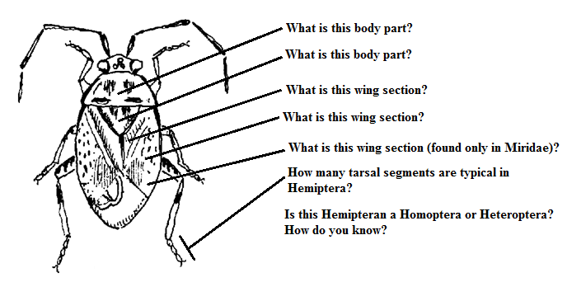
Part II. Hemiptera Ecology
1. The Brown Marmorated Stink Bug has received a great deal of attention as a recent invasive species across the US. OSU has done a great deal of work evaluating Natural Enemies of BMSB, but UC Nursery and Floriculture has great basic information on this invader. Read the information and answer the following:
a. What is the scientific name of this invader? _________________________________________
b. BMSB is very close in appearance to our native Rough Stink Bug. Give two reliable characteristics for telling these two insects apart on sight.

c. From where did this insect originate? ______________________________________________
d. Why has the BMSB been so successful invading new habitat in the US?

e. What natural enemies can control BMSB populations in its native region?

f. What natural enemies exist in Oregon that can aid in population management for BMSB? Where have they been found?
2. This week’s lab reading mentions Assassin bugs in the family Reduviidae as predators, but there are members of this family that are also pests to humans living in South America all the way north to the southern US states (CDC Weblink). What Reduviid is a pest to humans (common name is fine), and how?

3. Aphids are probably the most widespread and common pest in nearly every crop. List SIX natural enemies in the Western US that have been commercialized for aphid control (UC IPM PestNotes, Natural Enemies BioControl, Evergreen Growers Supply).
1. _____________________________________ 4. _____________________________________

2. _____________________________________ 5. _____________________________________

3. _____________________________________ 6. _____________________________________

