Name: ___________________________ _____
General Anatomy
Label the body axes on the following diagrams with the most appropriate of the the following terms: anterior, posterior, dorsal, ventral, medial, and lateral.
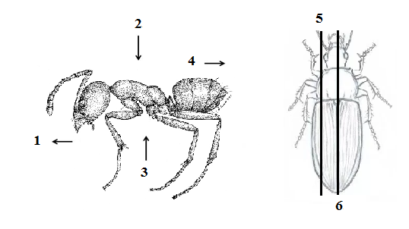
External Morphology: On the cockroach below, label the Antennae, head, T1, T2, T3, Abdomen segments 1 to terminus (9), cerci, legs, forewing, hindwing, lateral margin, anterior, posterior, costal wing margin, jugal lobe, and the prothoracic shield.

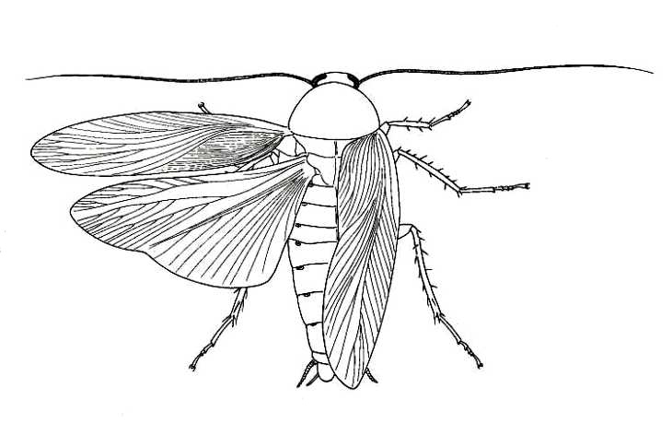
Beyond the general arthropod bauplan, there are many adaptations that allow the organisms to enhance its survival strategy by specific exploitation of habitat conditions, resources or even social interactions. Many of the physiological adaptations are easily seen externally, and allow a viewer to hypothesize ecological roles, life history, etc. Two of the simplest examples are modifications to the antennae and the legs.

What is the function of antennae? ________________________________________________________

Find two examples of modifications to antennae for a specific purpose. In the space provided, draw the antennal structure, give the name for the antennae type, an example of an insect with this antennal type, and describe the need for the adaptation based on the insect life history.

1. Antennal Type: _____________________________________
2. Example Insect: _____________________________________
3. Function: __________________________________________
____________________________________________________
____________________________________________________

1. Antennal Type: _____________________________________
2. Example Insect: _____________________________________
3. Function: __________________________________________
____________________________________________________
____________________________________________________
Draw (and label) the Coxa, Trochanter, Femur, Tibia, Tarsus, and Pre-Tarsus (claw) leg segments on an unmodified, typical insect leg (i.e. a cockroach or grasshopper foreleg).

As with the antennae above, find two examples of modifications to leg structures for a specific purpose. In the space provided on the next page, draw the leg structure for each, naming for the leg type and showing the segment modified, then give an example of an insect with this leg type, and describe the need for the adaptation based on the insect life history.

1. Leg Type/Segment Modified: __________________________
2. Example Insect: _____________________________________
3. Function: __________________________________________
____________________________________________________
____________________________________________________

1. Leg Type/Segment Modified: __________________________
2. Example Insect: _____________________________________
3. Function: __________________________________________
____________________________________________________
____________________________________________________

